Alicia's Speculations: Xi Wang's Silicon Valley Solo Exhibition
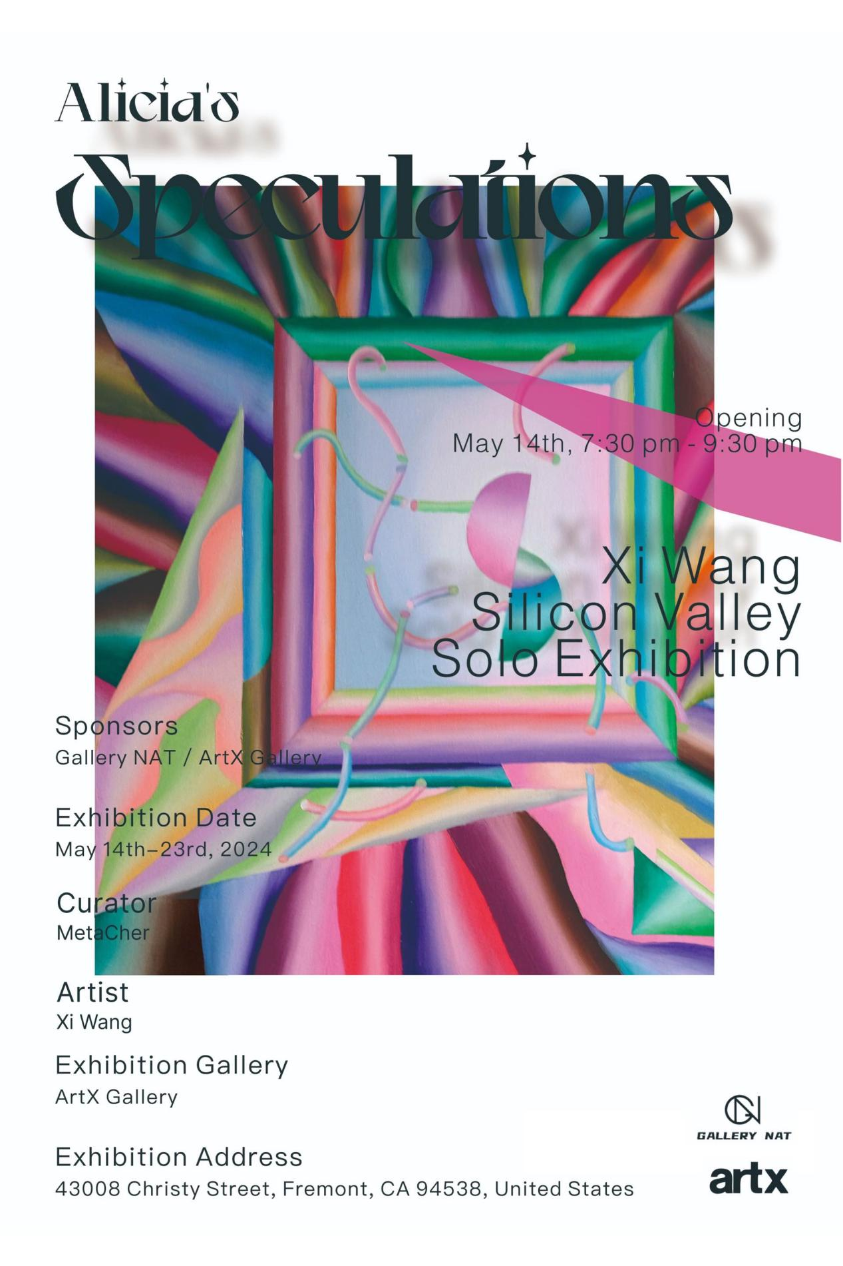

Exhibition Preface:
"Alicia's Speculations: Xi Wang's Silicon Valley Solo Exhibition"! This exhibition will lead you into an artistic realm filled with metaphysical contemplation and philosophical depth, presented by Chinese artist Xi Wang in collaboration with curator MetaCher.

As an artist with a background in philosophy, Xi Wang's creations are not only a pursuit of art but also a reflection on human existence and the future. In this exhibition, he will showcase his "Metaphysics" series of oil paintings, exploring abstract ruminations on genetic mutations encountered in the evolution of human society, individual capabilities, future competition, parallel universes, future humans, planetary migration, and the fate of ontological planetary life forms. This series of works encapsulates his profound reflections and speculations on the universe, humanity, and natural evolution over the present and the next 300-500 years. Inspired by childhood adventures in the outdoors of his native Hubei, in-depth studies of Western philosophy and Darwinian evolution during his graduate studies, and travels across multiple countries during his career, Xi Wang integrates these rich life experiences and philosophical reflections into each piece. Each stroke is a conscious reflection and depiction of a sanctuary for imagining the future centuries.

The "Metaphysics" series, with its abstract forms and profound connotations, transcends time and space, immersing viewers in the realm of thought. From celestial motions to the evolution of human society, from natural elements to human destiny, each work is a profound exploration of life, parallel universes, and the existence of humanity. With his unique artistic language, bold and rational analysis, and rigorous logical thinking, Xi Wang extrapolates the future evolution of humanity and the integration of society with material and nature. He interprets his understanding of the world and his vision of the future, presenting a series of powerful and philosophical canvases.

Simultaneously, in the "Alicia's Speculations" exhibition, Xi Wang embarks on another journey of imagination, blurring the boundaries between reality and fantasy, existence and oblivion. His "Angela's Fables" series offers a glimpse into an alternative reality where physical laws are distorted, and reality is nothing but a fragile illusion.

As an international artist and curator, Xi Wang's honors and achievements span the globe, from major exhibitions in London and Paris to intimate showcases in Shanghai and Beijing. His creations not only demonstrate the power of art and the value of aesthetics but also embody a profound concern and reflection on human civilization and the future.

Exhibition theme
Alicia's Speculations: Xi Wang's Silicon Valley Solo Exhibition

Sponsors
Gallery NAT / ArtX Gallery

Opening Time
May 14, 2024, 7:30 PM - 9:30 PM

Exhibition Date
May 14-23, 2024

Curator
Metacher

Artist
Xi Wang

Exhibition Gallery:
ArtX Gallery

Exhibition address
ArtX Gallery, 43008 Christy street, Fremont, CA94538 United States

Exhibition Artworks Display:
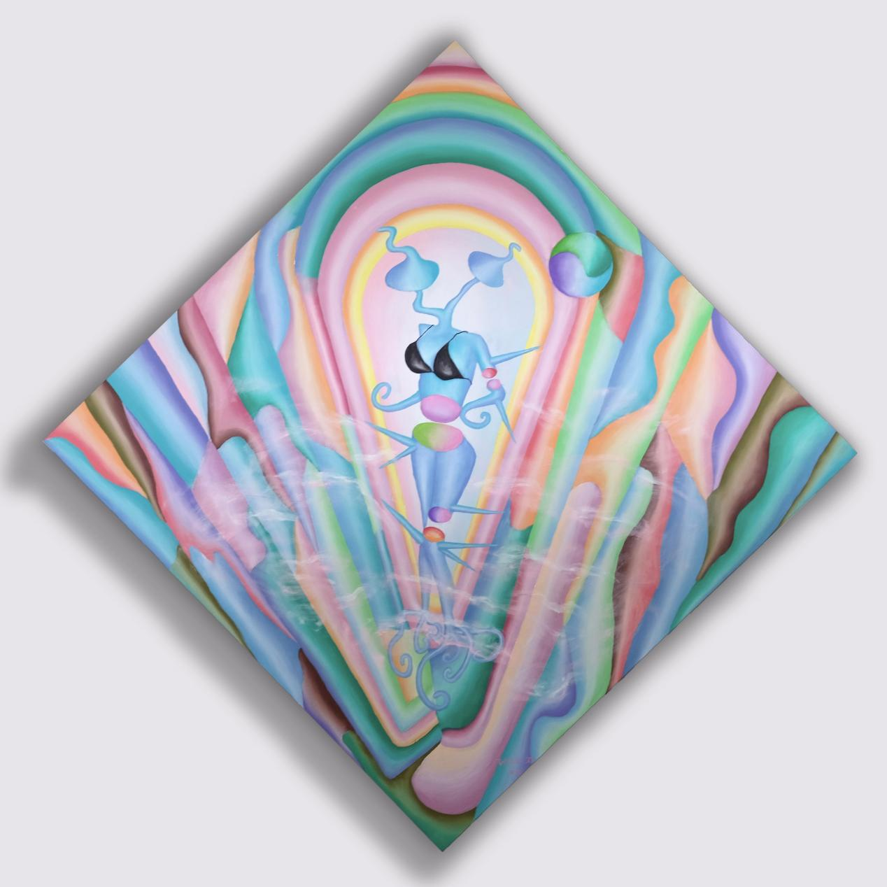
XI WANG "Metaphysics - Two-Headed Beauty" 100×100cm Canvas oil painting
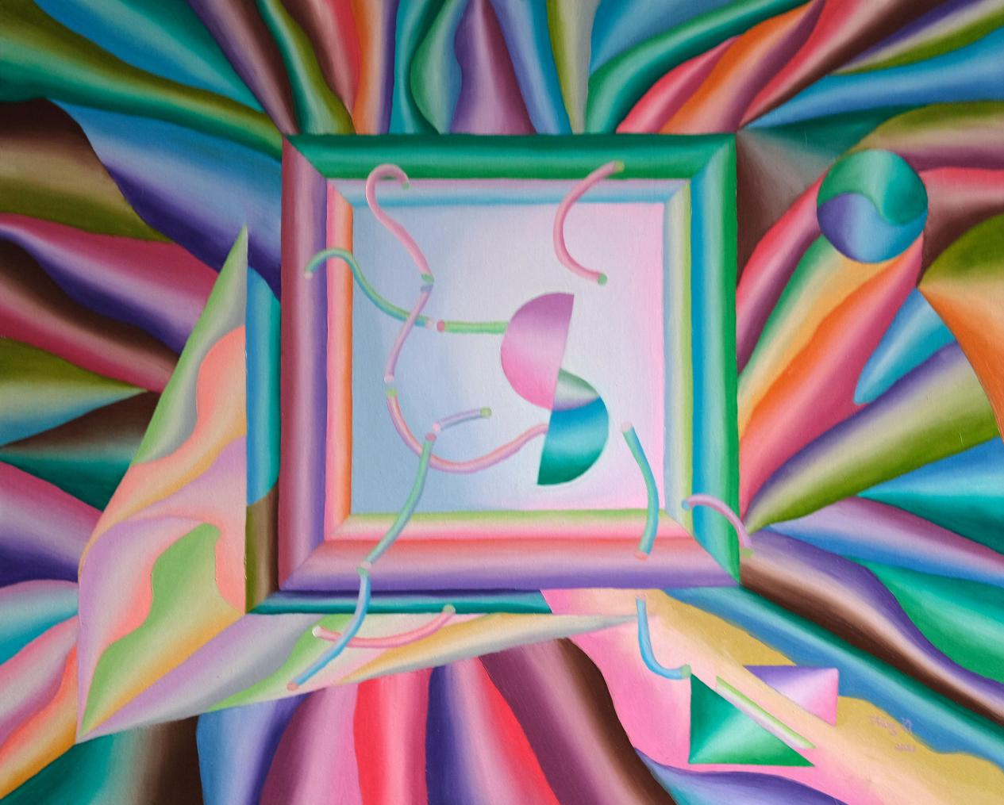
XI WANG "Metaphysics - Moon" 100×80cm Canvas oil painting

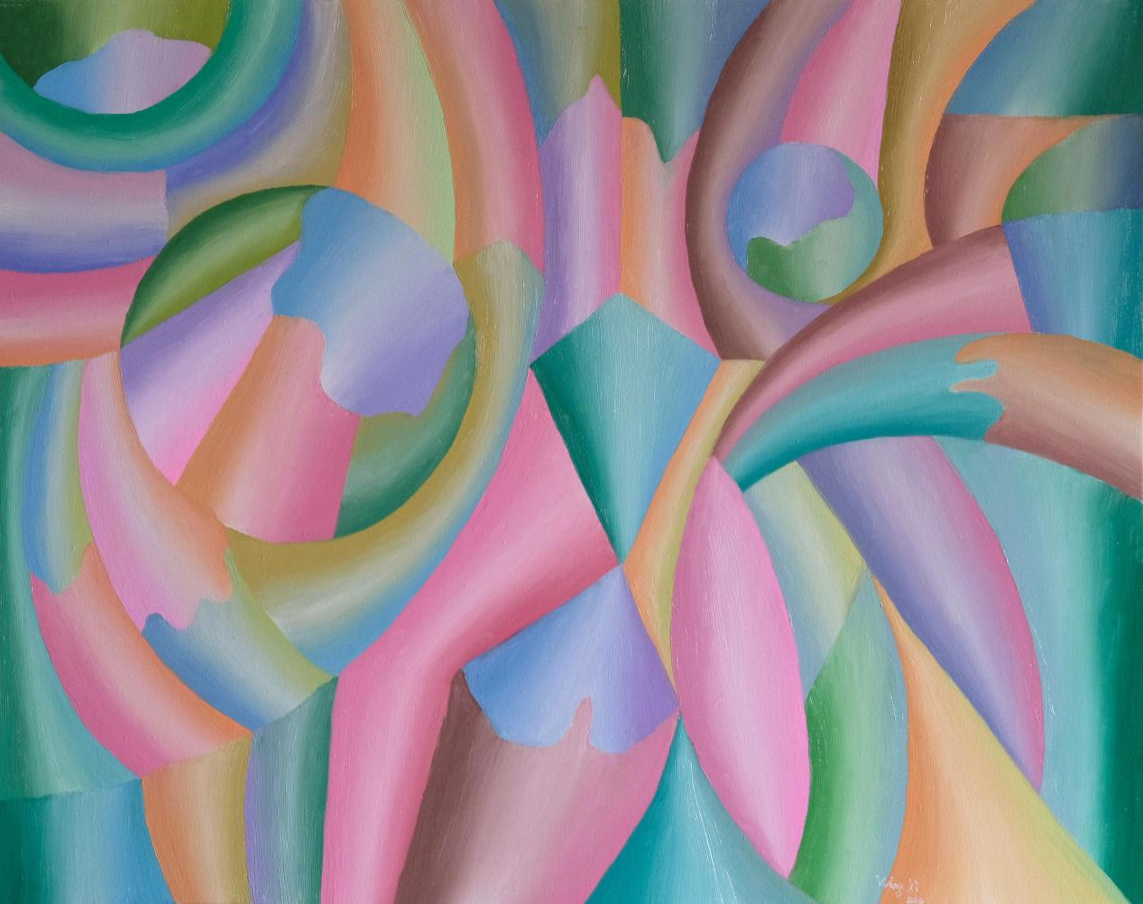
XI WANG "Metaphysics - The Origin of the Universe" 100×80cm Canvas oil painting
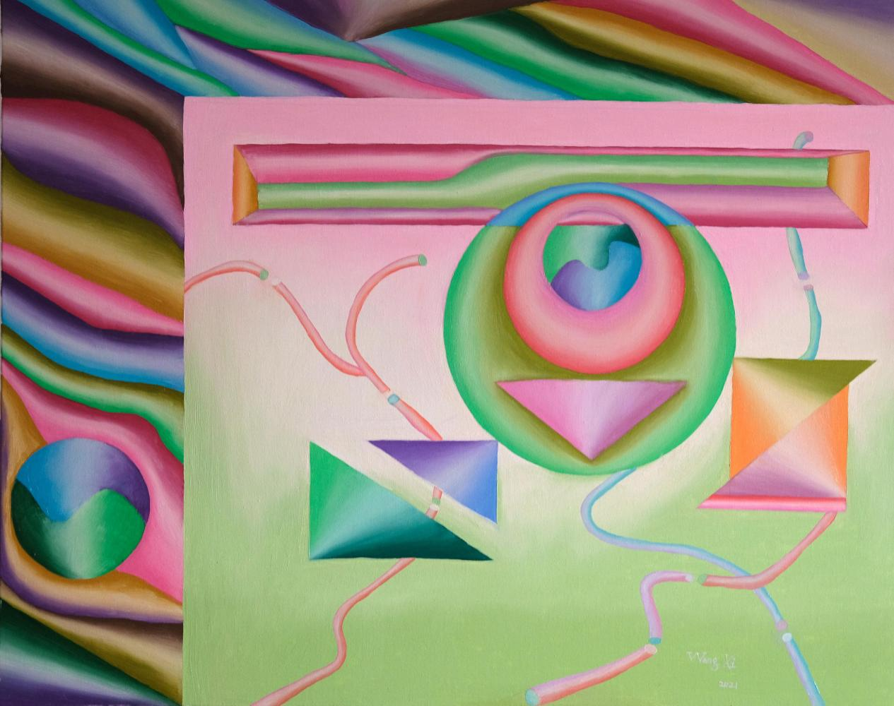
XI WANG "Metaphysics - Dislocation" 100×80cm Canvas oil painting
XI WANG "Metaphysics - The Law of Air Waves"90×60cm Canvas oil painting

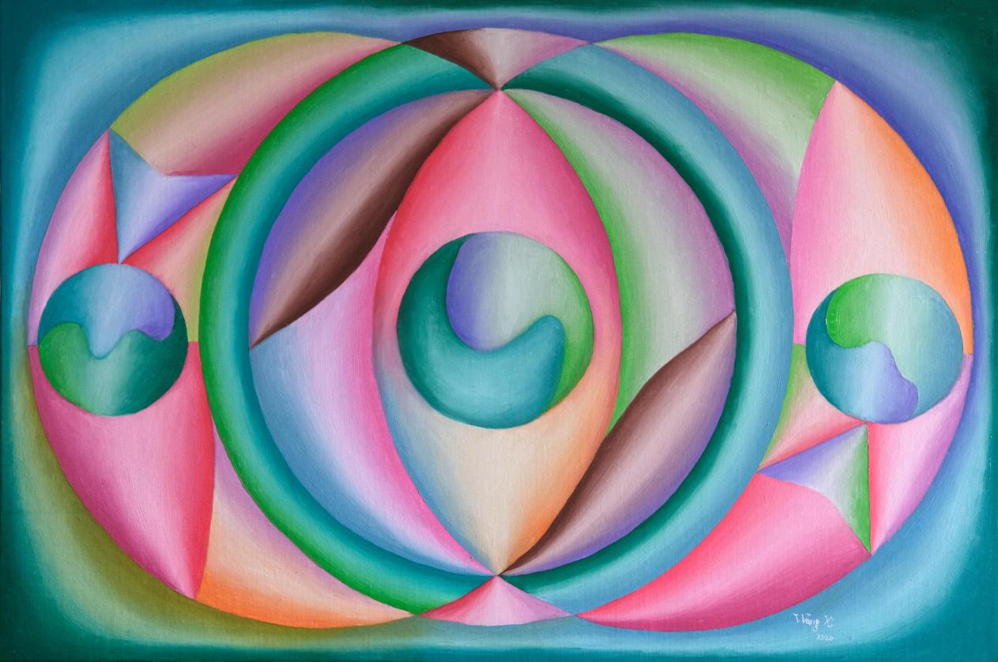
XI WANG "Metaphysics - Three Balls"90×60cm Canvas oil painting
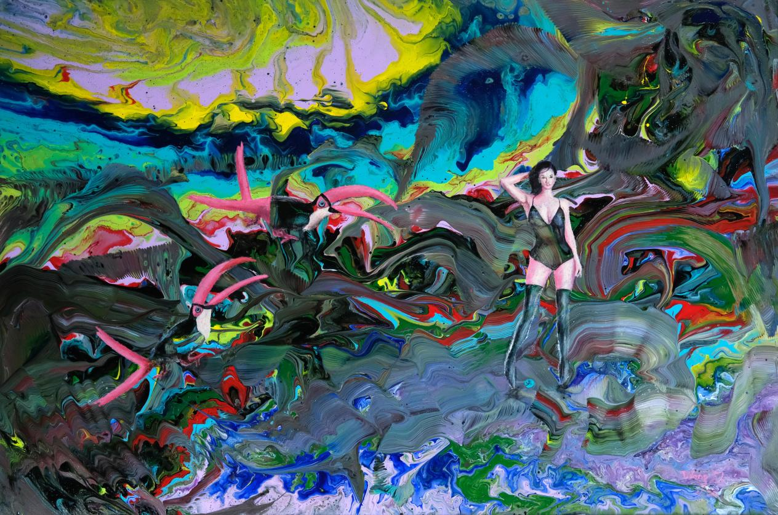
XI WANG "Angela's Fable" Series I 90×60cm Canvas acrylic painting

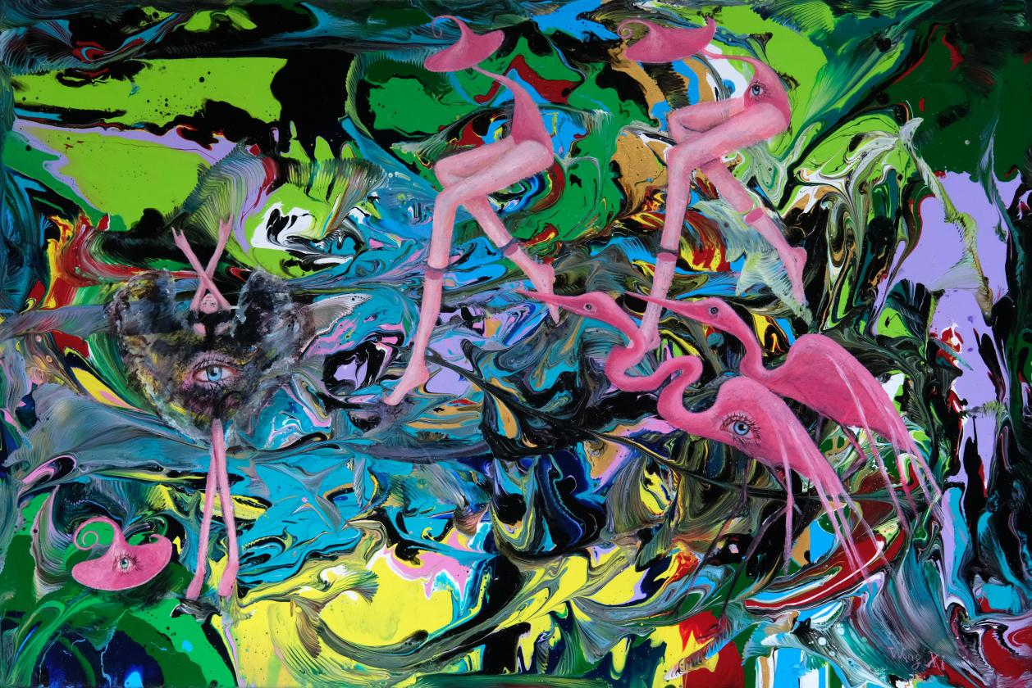
XI WANG "Angela's Fable" Series II 90×60cm Canvas acrylic painting

