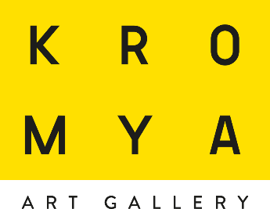

presents
Camera 6

RAW MATERIALS: LIGHT curated by Matteo Galbiati

November 30 - January 24, 2020 opening
on Saturday, November 30, at 5 pm

On Saturday, November 30, on the occasion of OPEN GALLERY #18 XMAS EDITION, Kromya Art Gallery opens Raw Materials: Light, an exhibition on the maestros who found their forms of artistic expression on the interaction between light and matter.

The show will be the first in a series of exhibitions that focus on the "matter" that is rooted in the Materie prime. Artisti italiani contemporanei tra terra e luce ("Raw Materials. Contemporary Italian Artists between Earth and Light") that took place at Rocca Roverasca in Senigallia, from September 6 to October 27, which was organized with the collaboration of Kromya.

Featured artists include Grazia Varisco, Paolo Scirpa, Fabrizio Corneli, Carlo Bernardini and Nicola Evangelisti. Grazia Varisco was one of the founders of Gruppo T in the '60s; since the beginning of her career, she has been interested in light as a constantly varying phenomenon that is made of slow or compressed periods of time. Between 1961 and 1968, she created the Schemi luminosi variabili series of works, which consist in a series of kinetic-luminous objects she created for the Arte programmata exhibition that took place at the Olivetti Showroom in Milan, in 1962.
Paolo Scirpa focuses on a dimension in which light and space are the immaterial and spectacular protagonists. The artist is more interested in representing "ideal" light than real light; in order to portray his idea of infinity through light, he uses light tubes and mirrors to create structures/sculptures that often unfold in intricate mazes and give an idea of depth.

Fabrizio Corneli's expressive idiom explores the dialectic play between light and shadow through amazing effects of refraction, decomposition and anamorphosis that engage the observer in a pure perceptual experience. By capturing light through optical spheres, copper slabs and glass bubbles filled with water, the artist explores the manifold expressive possibilities of light, creating elusive and evanescent presences.

Carlo Bernardini's work is focused on the perception of space, which he explores through a ray of light that penetrates a reality that waits to be revealed. His installations create hypothetical spaces that are surrounded by luminescent perimeters; these real virtual environments allow the observer to imagine light as an invisible wall, the limit of plane surfaces. Light sketches a drawing in space, which changes depending on the observer's point of view and his movements.

Nicola Evangelisti, an important exponent of Italian Light Art, founds his artistic experimentations on science; his art is mainly characterized by the use of artificial light. This theme, as well as that of cosmology, is explored through installations, light-boxes, photography and videos. In 2001, mirroring surfaces have become his favourite material for the creation of a number of series of sculptures and light installations that show his unique signs of light.

Curator Matteo Galbiati and the artists will attend the opening and participate in it.
Kromya Art Gallery
Viale Franscini, 11 - 6900 Lugano - Svizzera
Tel. +41919227000 info@kromyartgallery.com
www.kromyartgallery.com

