COMUNICATO STAMPA/INVITO

Inaugurazione sabato 23 dicembre 2017 alle ore 19.00

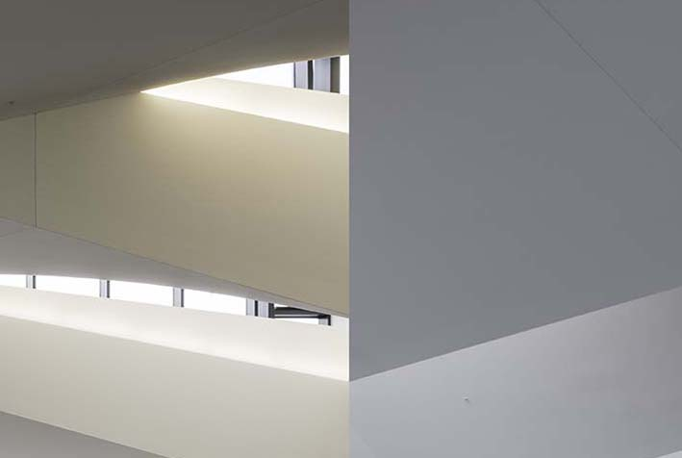

GUARDANDO ATTRAVERSO IL DITTICO
Nader Tehrani-NADAAA

a cura di Manuela De Leonardis

dal 23 dicembre 2017 al 4 gennaio 2018

Guardando attraverso il dittico è un esercizio intellettuale, affidato al linguaggio fotografico, intorno ad una “veduta inversa di una struttura attiva in superficie”.

Come afferma Tehrani-NADAAA, “il formato acquisisce anche una certa latitudine attraverso l’associazione, diventa un’immagine orientata al paesaggio senza effettivamente estendere d’orizzonte di un’immagine nell’altra.”

L’edificio architettonico a cui si riferisce il dittico in cui l’arte e l’architettura sono in sintonia con la geometria e l’atmosfera è il pluripremiato DFALD - the University of Toronto’s Daniels Faculty of Architecture, Landscape and Design, realizzato da NADAAA, aperto al pubblico nell’autunno 2017.

(Manuela De Leonardis)

Nader Tehrani (London 1963, lives and works between Boston and New York) is the Dean of the Irwin S. Chanin School of Architecture at the Cooper Union in New York. Nader Tehrani is also Principal of NADAAA, a practice dedicated to the advancement of design innovation, interdisciplinary collaboration, and an intensive dialogue with the construction industry. He was previously a professor of architecture at MIT, where he served as the Head of the Department from 2010-2014. As the principal and founder of Office dA, Tehrani’s work has been recognized with notable awards, including the Cooper Hewitt National Design Award in Architecture (2007), the United States Artists Fellowship in Architecture and Design (2007), and the American Academy of Arts and Letters Award in Architecture (2002). He has also received the Harleston Parker Award for the Northeastern University Multi-faith Spiritual Center (2002) and the Hobson Award for the Georgia Institute of Technology Hinman Research Building (2012). Throughout his career, Tehrani has received seventeen Progressive Architecture Awards as well as numerous AIA, Boston Society of Architects and ID awards. For the past five years in a row NADAAA has placed in the top three design firms in the U.S. in Architect Magazine’s Top 50 Design ranking. Currently, Tehrani is serving as the William A. Bernoudy Architect in Residence at the American Academy in Rome.

L’esposizione resterà aperta fino al 4 gennaio 2018.
Orario: dal lunedì al sabato: 11.00/23.00
Info: (+39) 06.678.14.27
Progetto grafico di Mauro Aquilanti

Bibliothè Contemporary Art
Via Celsa, 4/5 – 00186 Roma
http://www.bibliothe.guru
.

