**Chaos Code**

**2025 New York International Art Competition**

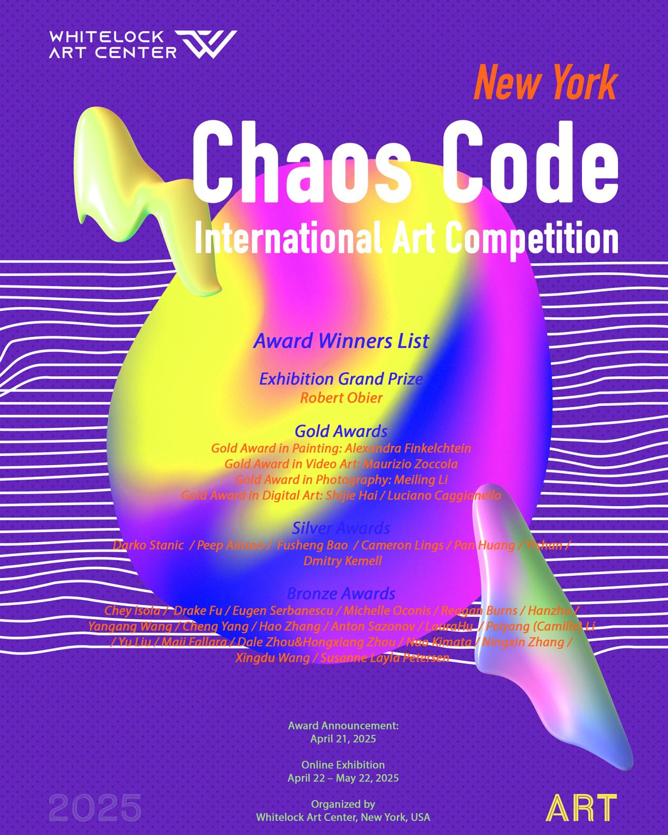

On April 21, 2025, the Whitelock Art Center in New York officially announced that Chaos Code – 2025 New York International Art Competition will be exhibited online from April 22 to May 22. The winners of this year’s international art competition will be formally revealed through mainstream and major art media outlets.

Titled Chaos Code, this year’s competition and exhibition critically and experimentally explore the unprecedented identity dilemmas individuals face in an era of rapid digital transformation. Chaos and order, freedom and control are intertwined within artistic creation. One of the central questions posed by the exhibition is: how can artists navigate and redefine creative possibilities at the shifting boundaries of culture and technology? In this hyper-digitalized world, what does it truly mean to be human? As technology accelerates, can art still preserve its core of freedom and independence? These questions serve as a foundation for the exhibition’s inquiry into contemporary social issues, blending critique with innovation and regeneration.

The competition received submissions from over a thousand artists worldwide. A peer-review scoring system was adopted, with a rigorous double-blind process applied to both preliminary and final rounds. The jury panel—composed of professionals from renowned art institutions, curatorial teams, art critics, and internationally acclaimed artists—ensured the evaluation was both professional and authoritative.

The artists awarded the Grand Exhibition Prize, Gold, Silver, and Bronze Awards hail from the United States, the United Kingdom, Canada, China, Italy, Japan, Denmark, Israel, Kazakhstan, Bosnia and Herzegovina, Romania, and Estonia. The Grand Exhibition Prize was selected from among the Gold Award recipients, granted to the highest-scoring artist in recognition of their outstanding artistic innovation and international impact.

**Award Winners List:**

**Exhibition Grand Prize**: Robert Obier

**Gold Awards**:

Gold Award in Painting: Alexandra Finkelchtein

Gold Award in Video Art: Maurizio Zoccola

Gold Award in Photography: Meiling Li

Gold Award in Digital Art: Shijie Hai / Luciano Caggianello

**Silver Awards**:

Darko Stanic / Peep Ainsoo / Fusheng Bao / Cameron Lings / Pan Huang / Yishan / Dmitry Kemell

**Bronze Awards:**

Chey Isola / Drake Fu / Eugen Serbanescu / Michelle Oconis / Reagan Burns / Hanzhu / Yangang Wang / Cheng Yang / Hao Zhang / Anton Sazonov / LauraHu / Peiyang (Camille) Li / Yu Liu / Maii Fallara / Dale Zhou&Hongxiang Zhou / Nao Kimata / Ningxin Zhang / Xingdu Wang / Susanne Layla Petersen

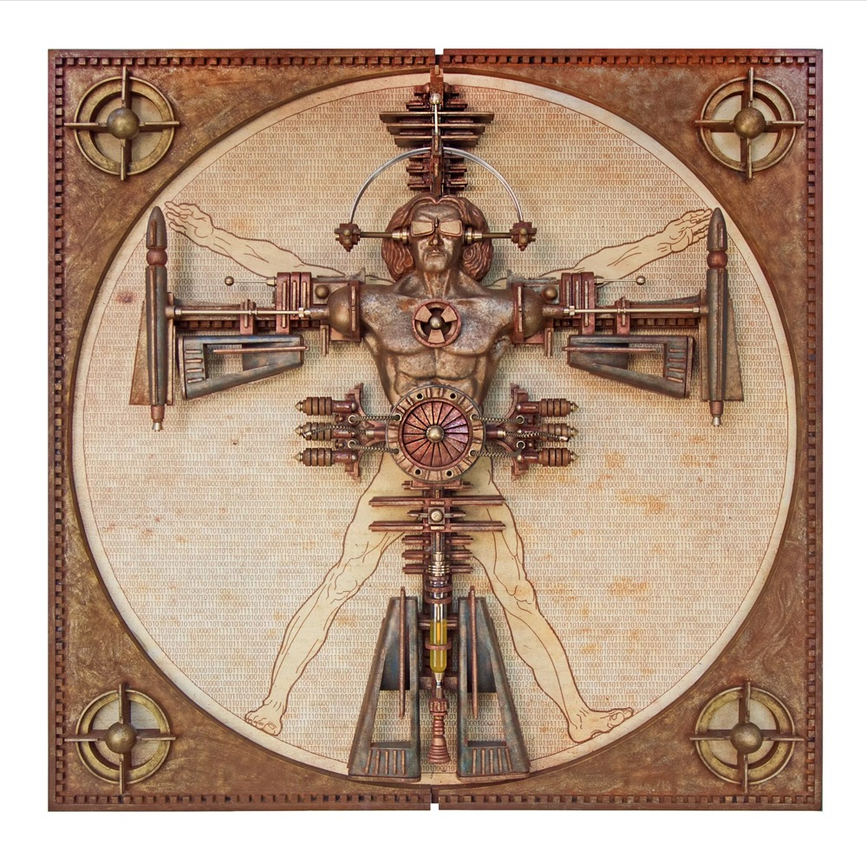

Robert Obier “Renaissance Man 2.0 - (Science#2)”

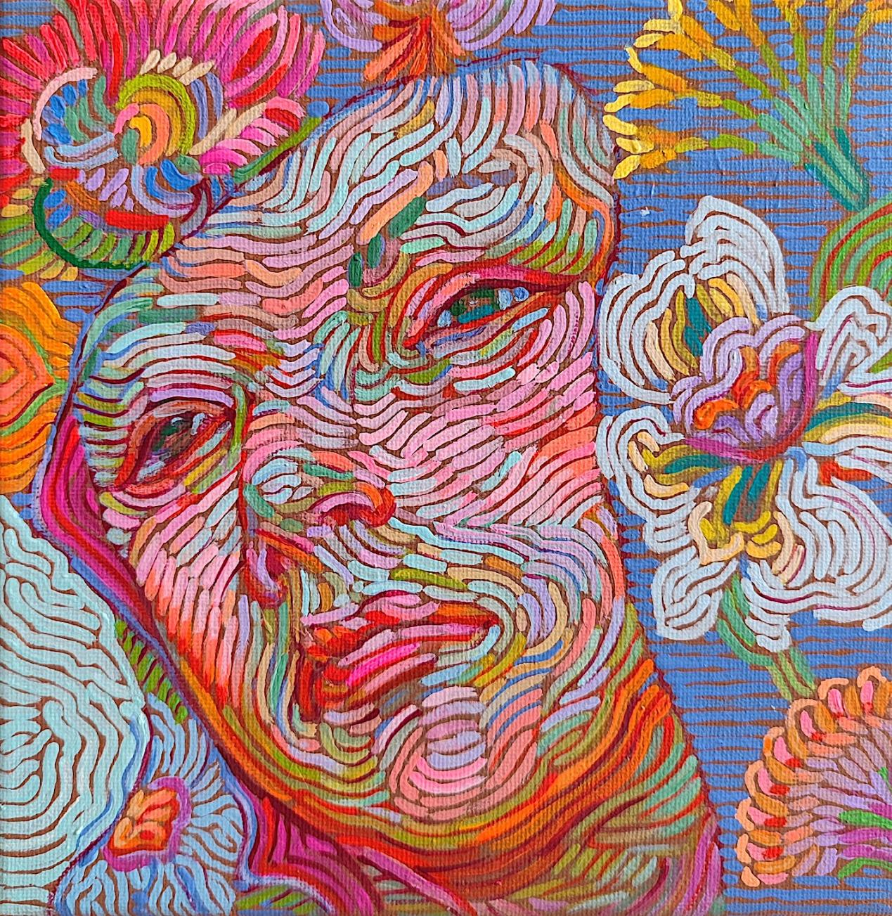

Alexandra Finkelchtein“Girl Looking Away”

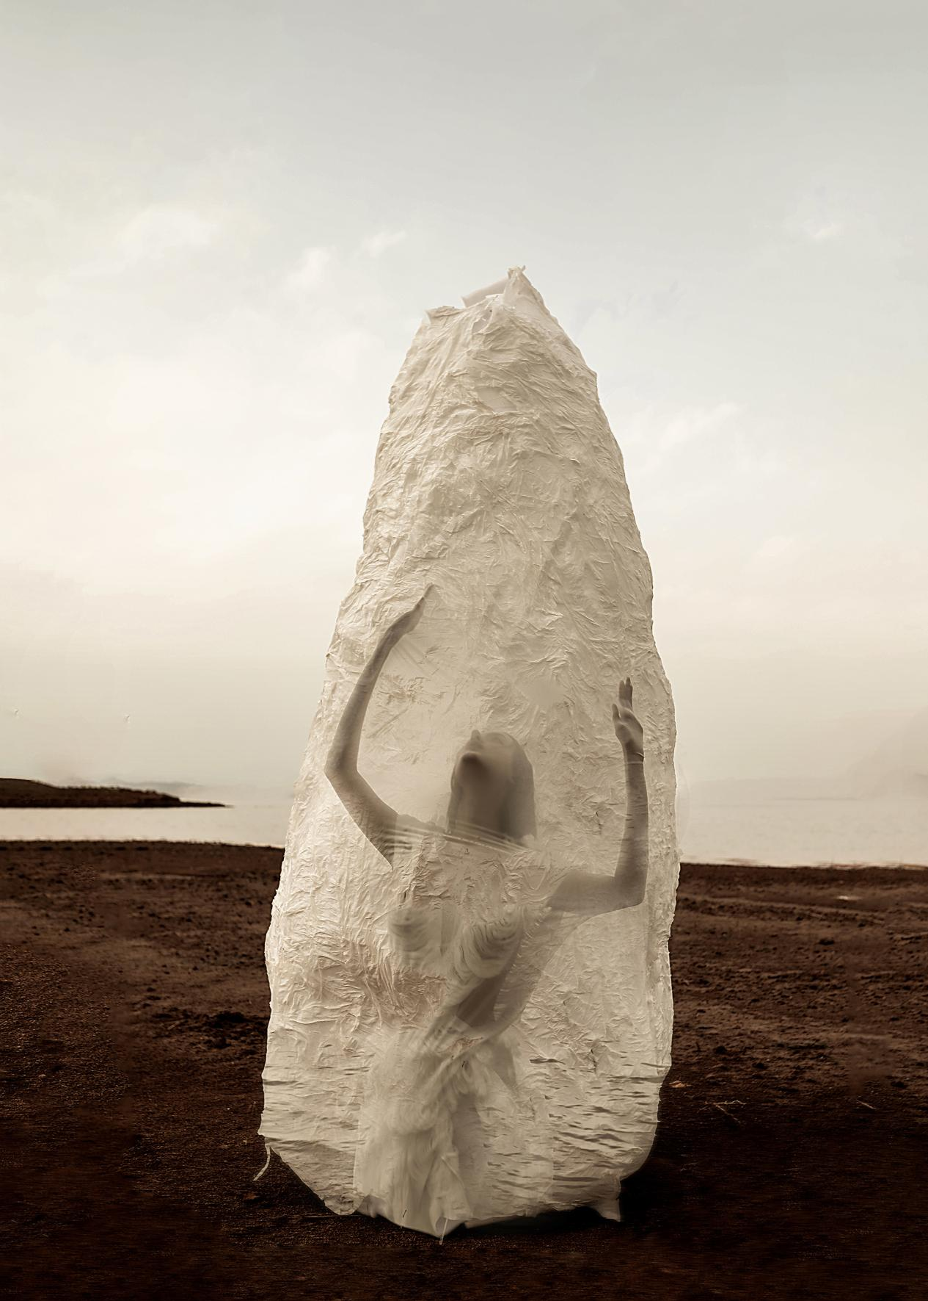

Photography by Meiling Li, Cocoon Series 3

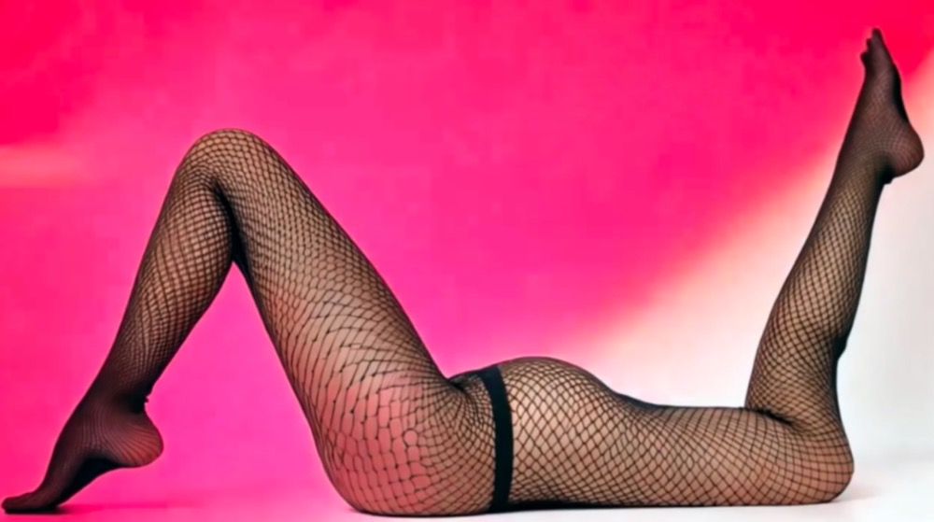

Maurizio Zoccola (GlitchA/V Project)

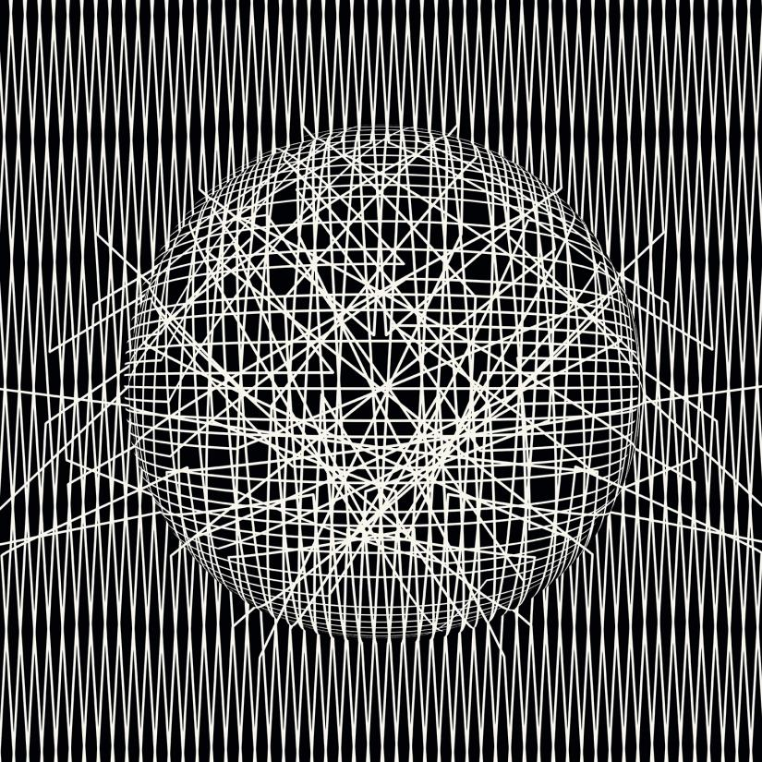

INTERCONNECTIONS 90x90_LUCIANO CAGGIANELLO