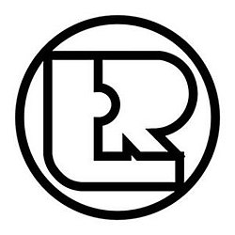
Blue in Mind
Sergio Armaroli | Steve Piccolo | Elliott Sharp
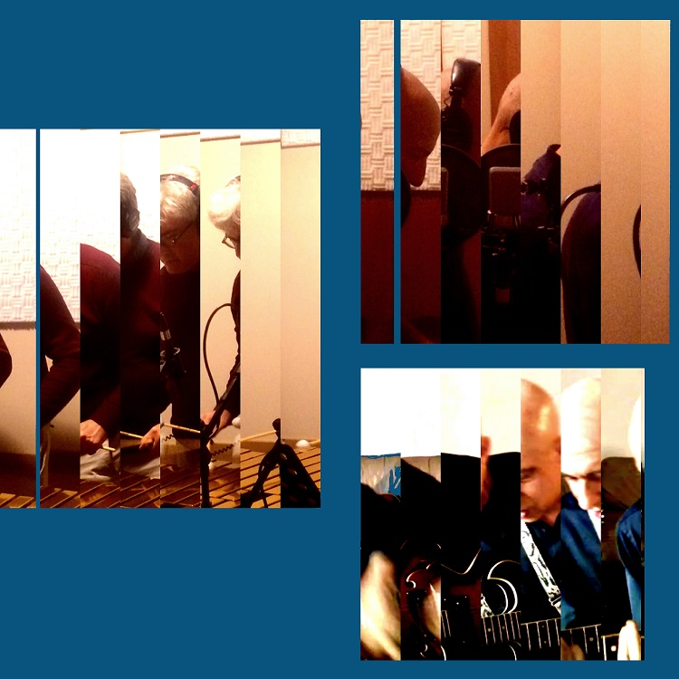
Teatro Arsenale, Milano | 22 ottobre 2021, ore 21
in collaborazione con ERRATUM
Venerdì 22 ottobre alle ore 21 presso il Teatro Arsenale di Milano si terrà la presentazione del CD Blue in Mind di Sergio Armaroli, Steve Piccolo ed Elliott Sharp per Leo Records, progetto realizzato in collaborazione con ERRATUM di Milano. Nel corso della serata gli artisti si esibiranno in concerto.
«The more things devolve, the more music starts to take on a role or impression of refuge, escape, solace, retreat, which is perhaps anything but irrational… Both as a player and as a listener. We didn’t know, though of course we should have expected, that we would have so much to be blue about. Fortunately, that truly unique invention of lament with a vital urge to transform into light, well, it still and always works somehow, even when the world seems to be bent on self-destruction. Refuge, shelter, retreat… It might also be the air purifiers in the recording studio, the extra oxygen, the spotless surfaces, the reassuring lack of windows. The similarity to a proverbial padded room. Does all that get into the music, like a good contagion? Maybe… just maybe». by ©Steve Piccolo

Blue in Mind
Sergio Armaroli | Steve Piccolo | Elliott Sharp
22 ottobre 2021, ore 21
Teatro Arsenale, Via Cesare Correnti 11, 20123 Milano
Per informazioni sull’evento: +39.02.8321999, promozione@teatroarsenale.it
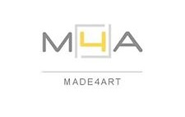
Comunicazione a cura di

MADE4ART | Comunicazione e servizi per l’arte e la cultura
www.made4art.it | press@made4art.it

