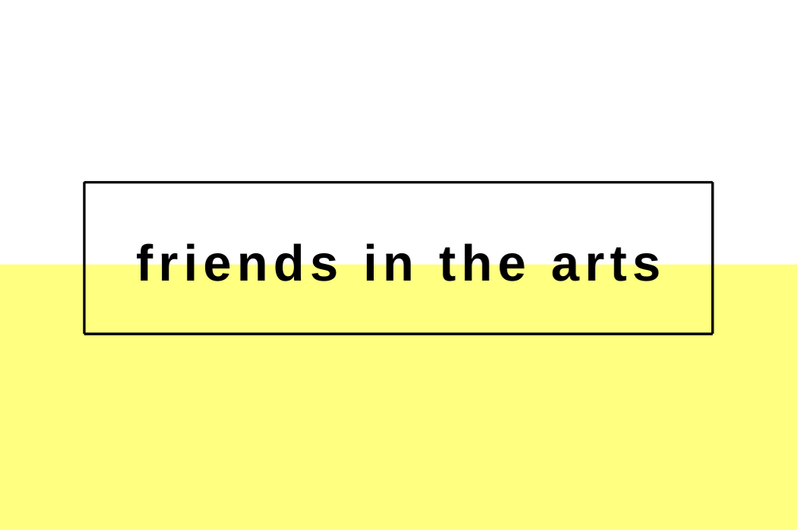

Friends In The Arts: new platform full of
opportunities in the arts arrives

Lisbon, October 27, 2020 – The digital platform Friends In The Arts (FITA) has just launched and aims to facilitate the search for jobs, opportunities and collaborations in the world of the arts.

The idea came from Francisca Gigante, curator and cultural programmer who, after having worked for cultural entities of national and international renown, such as the Peggy Guggenheim Collection (Venice), the Venice Biennale and MAAT (Lisbon), recognized the frequent inaccessibility of the artistic environment, lack of democratization in the sector and training and quality in working conditions.

“Friends in The Arts was built between Venice and Lisbon. FITA’s goal is to be an agent of change in the field of the arts, demystifying, decentralizing and opening doors to opportunities in the world of arts and culture. We are connecting constellations: talented people looking for jobs with people working in organizations that want to find talented professionals in the international artistic and cultural sphere”, says Francisca Gigante, responsible for FITA.

FITA currently offers three types of services:
- “Job Catalog”, with exclusive job offers for those looking for opportunities in the arts, from artists, curators, designers, to producers or architects, nationally and internationally.
- “CV Helpdesk”, to support applications, through the construction or adaptation of Curriculum Vitae/ Resumé and letters of motivation to the needs of each professional, helping them to stand out in their respective vacancies.
- “One-to-One Talk”, a personalized mentoring with interviews about the career plan with clear and important guidelines on the path and goals of their own professional life.

Exclusive and updated job offers
The platform offers two subscription options – monthly (€2,99) and annual (€29,99) – granting access to the catalog of job opportunities in the art world.

FITA also presents exclusive content and tips on how to succeed in job interviews and recommendations to unlock the opening of doors in the world of the arts.

Developed by the curator and cultural programmer Francisca Gigante, the platform features an artistic investigation by Madalena Corrêa Mendes, legal advice from Matilde Gigante as well as the web experience and digital support of Shifter X.

The platform presents opportunities in organizations such as the Guggenheim, The Lisbon Consortium, European Cultural Academy, Atopos Gallery Venice, Canadian Art, Fondation d’Entreprise Martell, among others. More information is available on friendsinthearts.net/.

About Friends In The Arts
Launched in October 2020, Friends In The Arts is a digital platform established for facilitating the search for job placements, opportunities, internships, open calls, fellowships, scholarships, residencies, awards, workshops and conferences in the art world.

www.friendsinthearts.net
info@friendsinthearts.net

