Combining Culture and Technology, the Taiwan Pavilion Shines at the London Design Biennale
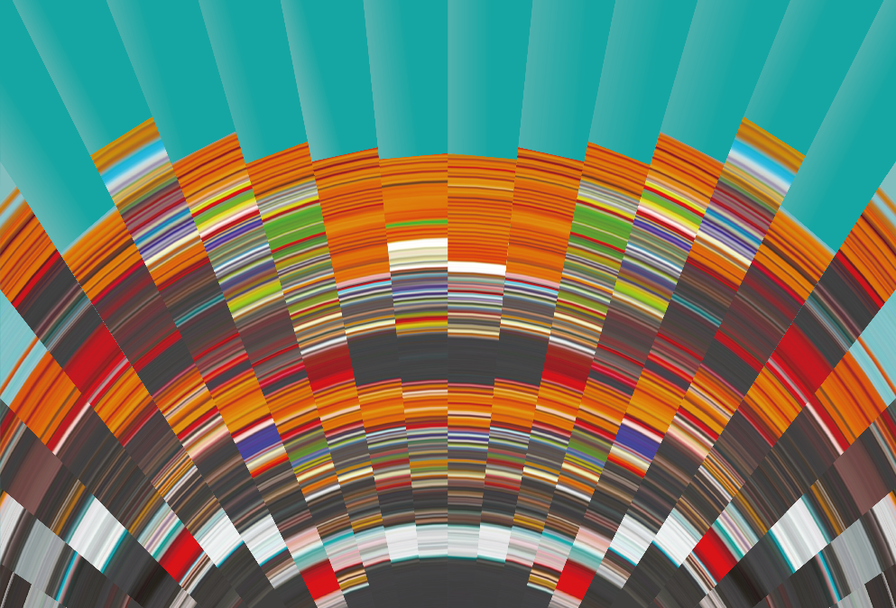
Sponsored by Taiwan’s Ministry of Culture, planned by the Taiwan Design Research Institute (TDRI) and designed and implemented by design agency Bito, the exhibition Swingphony is presented at the Taiwan Pavilion at the London Design Biennale this year.
The Taiwan Pavilion team uses Swingphony as the main concept behind its interpretation of the London Design Biennale’s theme - Resonance. The inspiration comes from the diversity of religions in Taiwan, combined with a phenomenon from physics – The Schumann Resonances.
In terms of religion, Taiwan is one of the most diverse countries in the world. Taiwanese citizens practice Buddhism, Taoism, Christianity, Mormonism, Catholicism, Islam, Eastern Orthodoxy, Judaism, the practices of the Unification Church, and Hinduism, as well as native sects such as Yiguandao and others. But, no matter what religion people practice, praying, chanting and meditation are significant elements.

The Schumann Resonance is global electromagnetic resonance phenomenon named after physicist Winfried Otto Schumann who predicted it mathematically in 1952. It is calculated on a series of global electromagnetic resonances, generated and excited by lightning discharges in the cavity formed by the Earth's surface and the ionosphere, and is widely used in predicting lightning, earthquakes and most recently, climate change. Often referred to as “the heartbeat of the Earth” the frequency of the Shumann Resonances is 7.83Hz.

The activities of communal chanting, praying and meditation are proven to increase Alpha Waves - the brain waves most commonly recommended for reducing stress. And the frequency of the Alpha Wave is between 8 and 12 Hz, almost the same as The Shumann Resonance. The aim of Swingphony is to enable visitors to understand the Alpha Wave, harness natural electromagnetic resonances, and experience communal sound rhythms in order to illuminate the power of unity in a fragmented world.
Taiwan’s control of the Covid-19 virus in its borders is headlined as one of the best in the world. At 0.042 deaths per 100,000 people, it is far less than the rest of the industrialised world. Two elements of success that the Taiwan authorities would like to share, are their focus on positive energy or ‘good vibes’ and the willingness of all members of society to act together for common benefit.

Groups of seven people at a time enter the Taiwan Pavilion into a dark room with only a lit-up table in the centre. They are given one metronome each and invited to set it to any speed. All metronomes will start to swing at various speeds, then gradually begin to swing at the same speed under the same frequency. When this happens after around 15 seconds, the room will be lit by lanterns hanging on the wall, which are activated by the synchronized frequency. The lanterns symbolise Taiwanese temples. A short video starts at the same time, creating an immersive experience for the audience. The message of Swingphony is that how no matter the differences between each individual, we can all connect with others and develop a balanced relationship with society and beyond that, the entire world.
Swingphony is expected to generate discussions not only between those from the design and art industries, but also among the general public in the UK.

Via this exhibition, the Taiwan Pavilion highlights how everyone can make an impact in society, and how a synchronised rhythm inspires belief in the possibility of bringing peace to the world.
ENDS
Notes to Editors
London Design Biennale
Established in 2016, London Design Biennale promotes international collaboration and the global role of design. It has become one of the most influential events in the

industry. The third edition of London Design Biennale is taking place from 1st June to 27th June 2021. It is expected to showcase the world’s most exciting and ambitious designers, innovators and cultural bodies’ works to the UK’s capital. Participants respond to the theme, Resonance, which considers the ripple effect of ground-breaking design concepts on the way we live, and the choices we make.
This year the London Design Biennale is curated by Artistic Director Es Devlin, who is a well-known artist and stage designer. Under his leadership, London Design Biennale has invited participants from around 50 countries and regions, including Taiwan, Argentina, Austria, Canada, Chile, France, Ghana, Guatemala, Hong Kong, India, Indonesia, Israel, Mexico, Norway, Pakistan, Poland, Venezuela, etc. All participants contribute to the London Design Biennale through installation arts or art performances with original, creative, and progressive perspectives, which will broaden people’s horizons and lead them to reflect how design influences our society.
Resonance has a deeper meaning in the current climate, as it not only refers to the power of change generated from each individual, but also implies that people can conquer the covid pandemic by working together.
Taiwan Pavilion at LDB
The Taiwan Pavilion
Directed by the Taiwan Design Research Institute (TDRI), the Taiwan Pavilion has become a hybrid of humanities and technology. TDRI first invited Quanta Computers, the leading Taiwanese technology company, along with the Physics Department of National Taiwan University, to join the project’s core team and participate in the initial discussions. TDRI then nominated the internationally famous design agency Bito, to create the theme and establish a comprehensive strategy for the exhibition. Bito gathered inspiration from iconic Taiwanese temples and the various religious activities in Taiwan, as well as the influential physics theory “The Schumann Resonances”, to create an exhibition which captures the spirits of both the humanities and technology.
Bito

Bito, the creator of Swingphony, is an international award-winning design agency, having won The Art Directors Club Award (New York) and The Red Dot Design Award (Germany). Swingphony is led by Bito’s Creative Director, Keng-Ming Liu, who formed an interdisciplinary team of film directors, graphic designers, digital artists, illustrators, animators and copy writers, in order to fulfil the Taiwan Pavilion’s mission as part of The London Design Biennale by bringing a unique and positive interpretation of Resonance, which we hope will raise the possibility of making the world a better place.
Bito is available for media interviews via video call.
Media Contact: Jessica Wood jessica@artsmediacontacts.co.uk /+ 44 (0)7939 226988

Swingphony: https://www.londondesignbiennale.com/participant/taiwan-1

Mon-Sun 11.00-19.15
London Design Biennale Taiwan Pavilion
Somerset House Strand
London
WC2R 1LA
United Kingdom

