**The Boundary Between Dream and Reality**

**2024 International Art Competition, New York, USA**

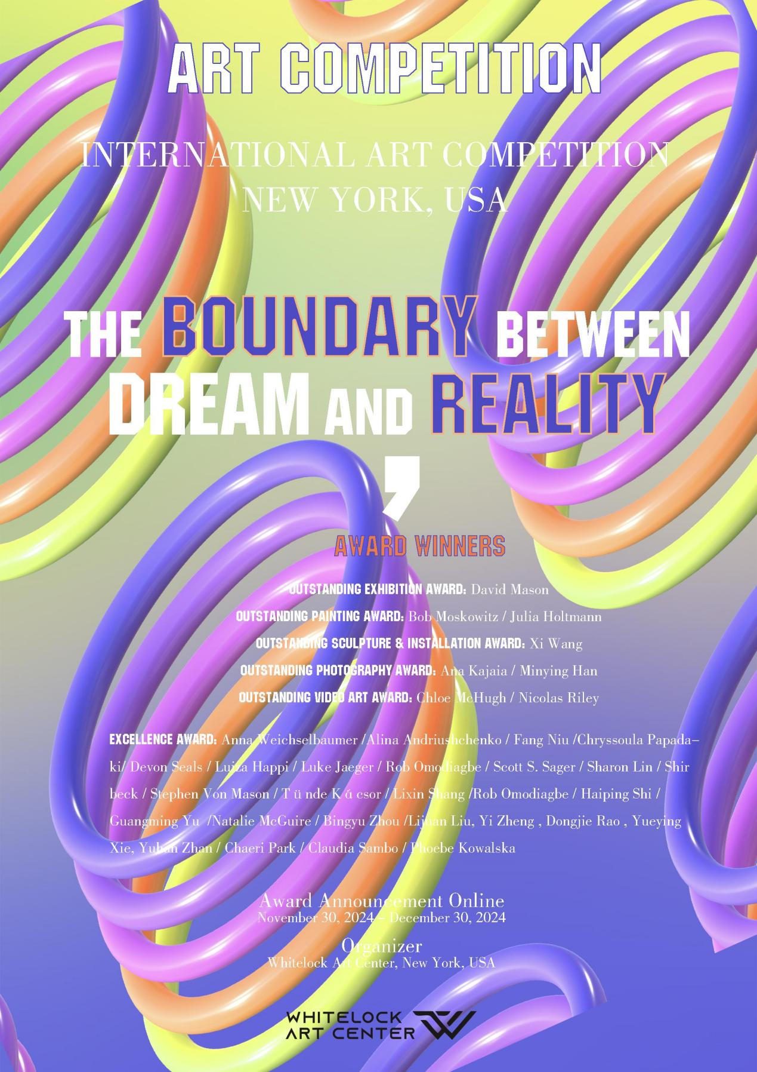

Whitelock Art Center in New York, USA, is pleased to announce the list of artists awarded in the "The Boundary Between Dream and Reality — 2024 International Art Competition, New York, USA." This competition, hosted by Whitelock Art Center, aims to bring together the most creative and imaginative artists from around the world to explore the elusive and intangible boundary between visual dreams and reality through art. The purpose of this competition is not only to examine the forms of contemporary global art in 2024 but also to encourage and inspire artistic innovation for the year ahead.

The judging panel at Whitelock Art Center adhered strictly to the evaluation criteria, emphasizing that the artworks should range from surrealistic illusions to realistic representations, or a combination and conflict between the two, showcasing a high level of abstract thinking. The panel encouraged artists to break free from traditional creative frameworks and conventions, expressing their unique perspectives on the dialogue between dreams and reality in distinctive ways. Within just over a month, Whitelock received numerous submissions from artists worldwide. After a rigorous selection process, the final award-winning artists were chosen.

The awarded artists come from the following countries and regions: the United States, the United Kingdom, Germany, Ireland, Italy, China, Romania, South Korea, Ukraine, Greece, Hungary, Jamaica, and Taiwan.

**Award Winners:**

**Outstanding Exhibition Award:** David Mason

**Outstanding Painting Award:** Bob Moskowitz / Julia Holtmann

**Outstanding Sculpture & Installation Award:** Xi Wang

**Outstanding Photography Award:** Ana Kajaia / Minying Han

**Outstanding Video Art Award:** Chloe McHugh / Nicolas Riley

**Excellence Award：**Anna Weichselbaumer /Alina Andriushchenko / Fang Niu /Chryssoula Papadaki/ Devon Seals / Luiza Happi / Luke Jaeger / Rob Omodiagbe / Scott S. Sager / Sharon Lin / Shir beck / Stephen Von Mason / Tünde Kácsor / Lixin Shang / Haiping Shi / Guangming Yu /Natalie McGuire / Bingyu Zhou /Lijuan Liu, Yi Zheng , Dongjie Rao , Yueying Xie, Yuhan Zhan / Chaeri Park / Claudia Sambo / Phoebe Kowalska

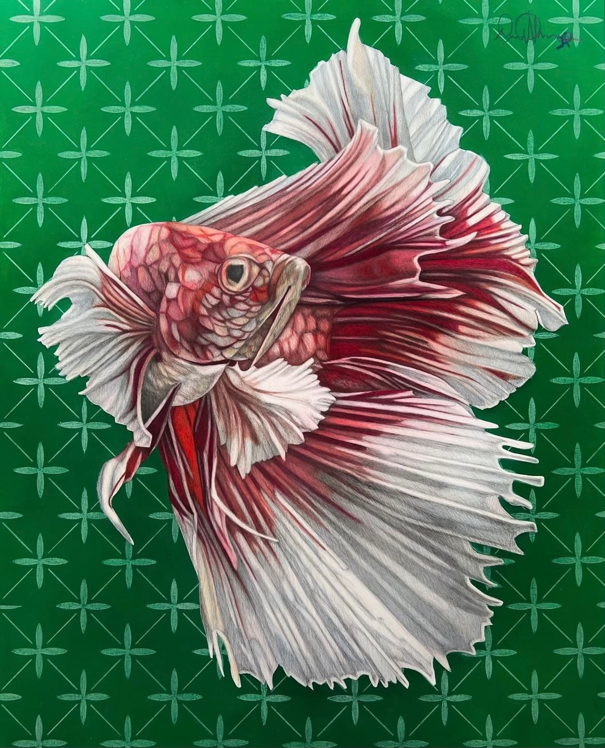

David Mason “DanceLikeAButterlfly”

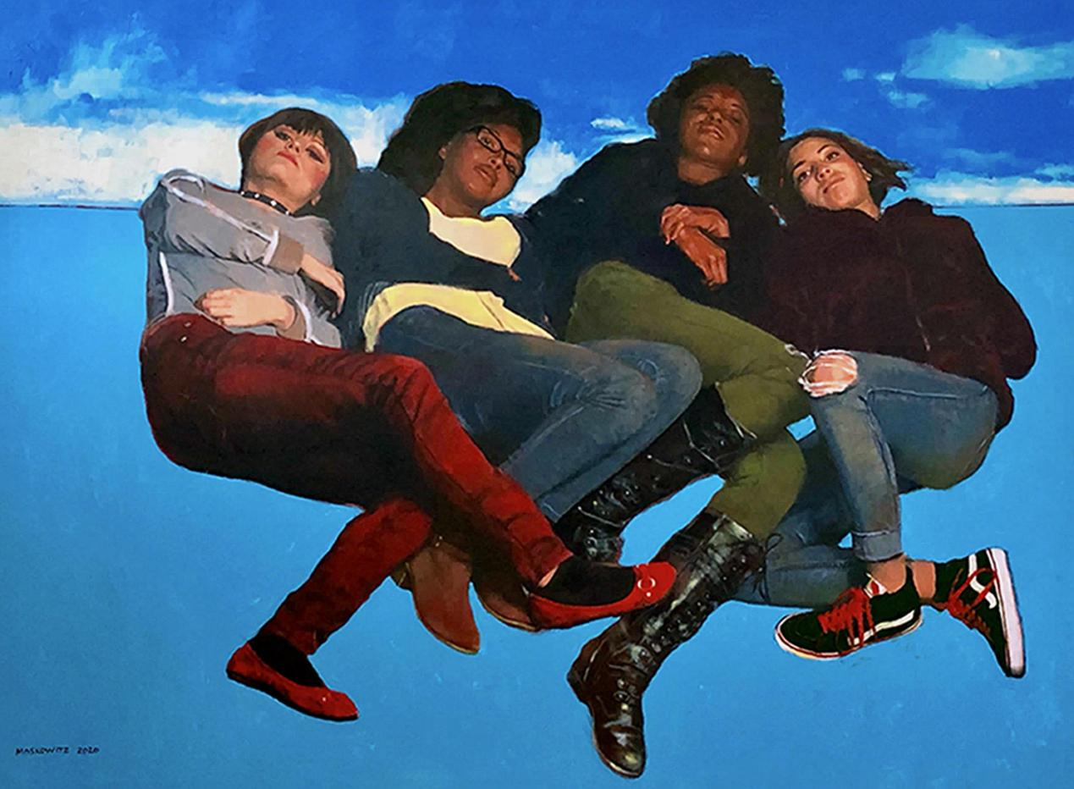

Bob Moskowitz “ Waiting copy 3”

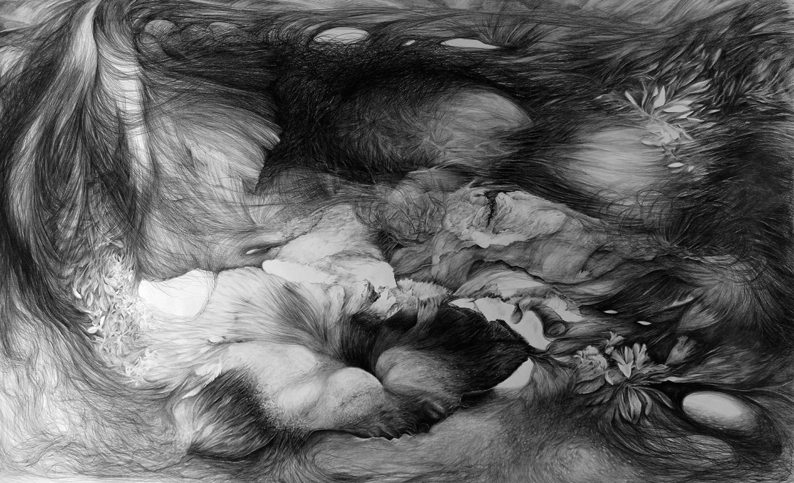

Julia Holtmann “Aufbrechen ”

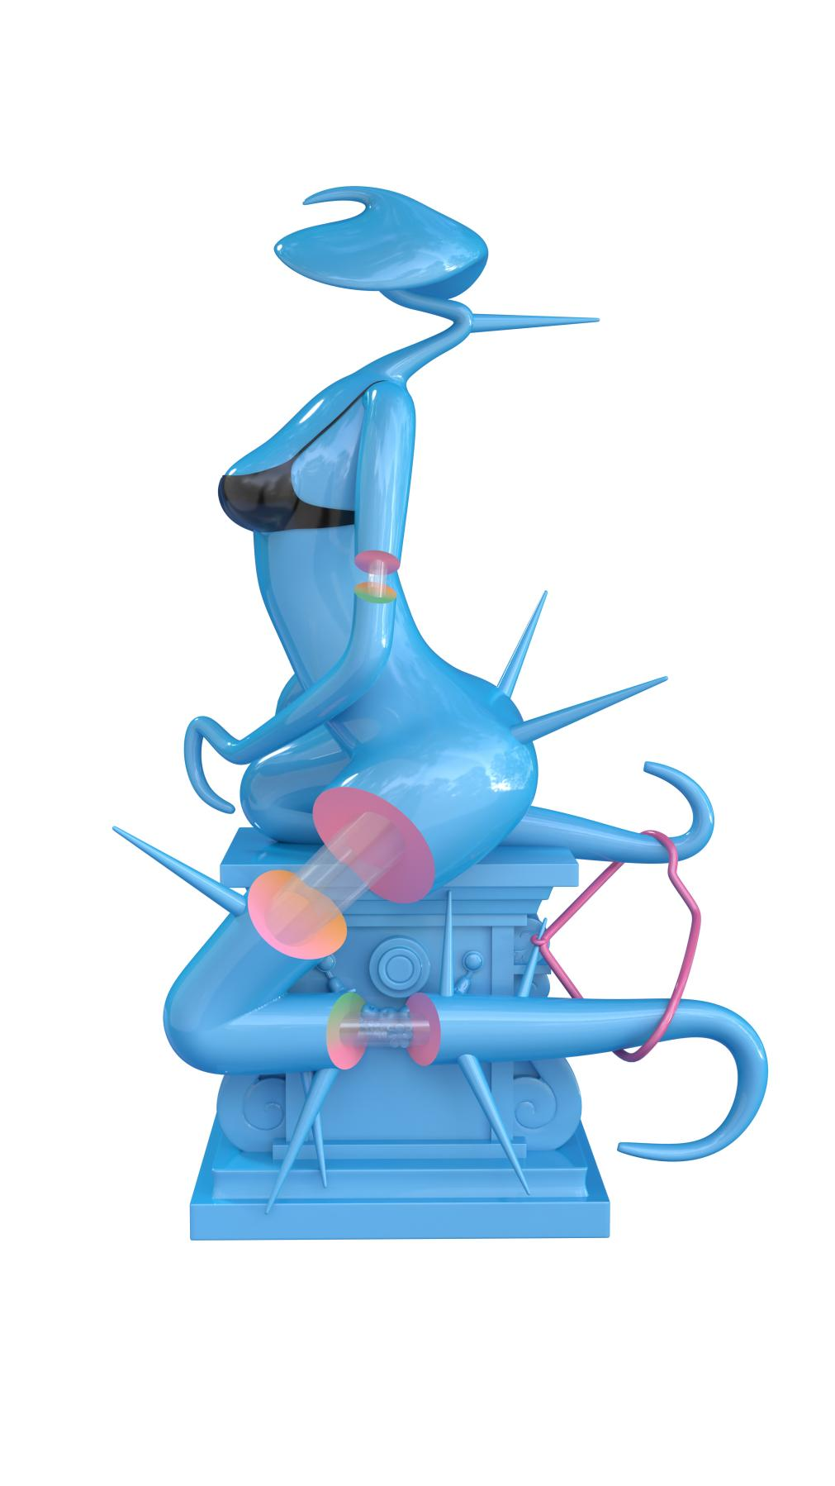

Xi Wang “ Song of Birds”

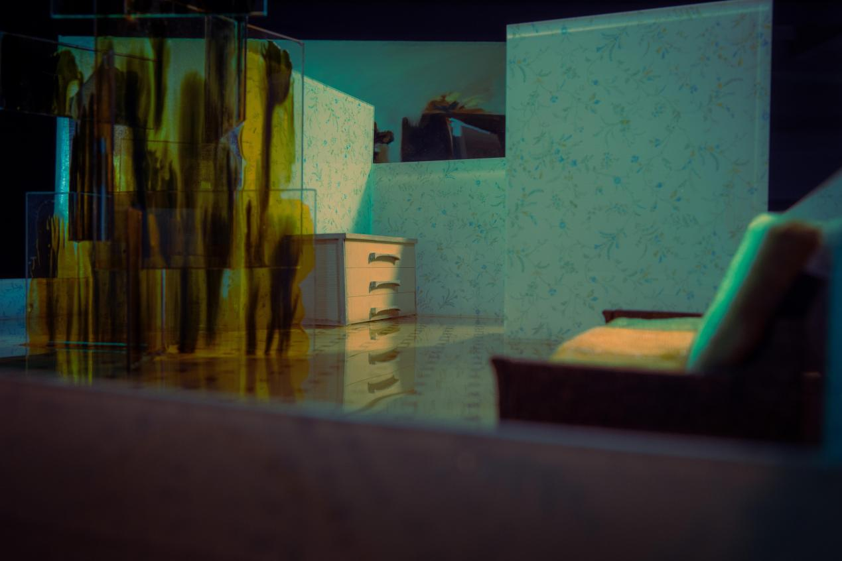

Ana Kajaia “ Reverie”

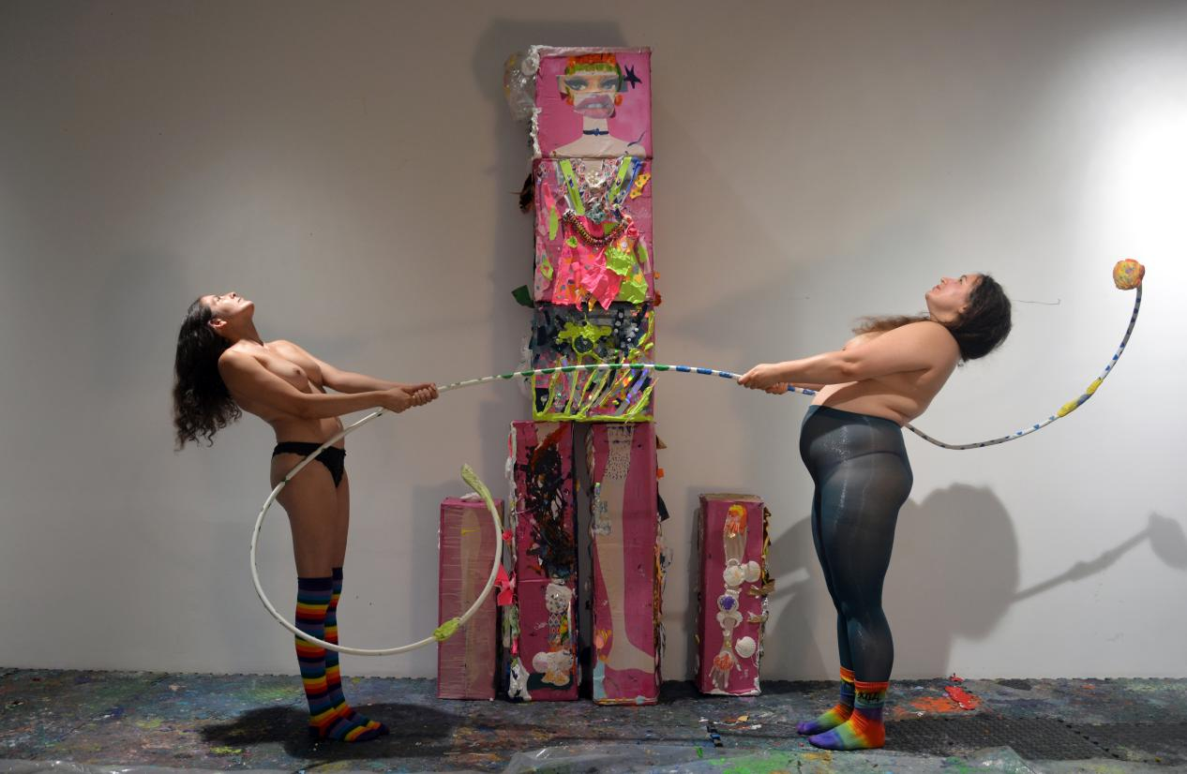

Minying Han “ The Perfect Barbie - Balance”

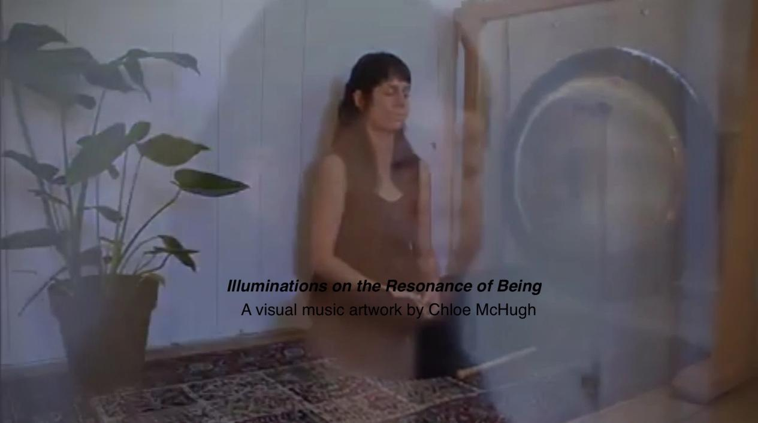

Chloe McHugh “Illuminations on the Resonance of Being”

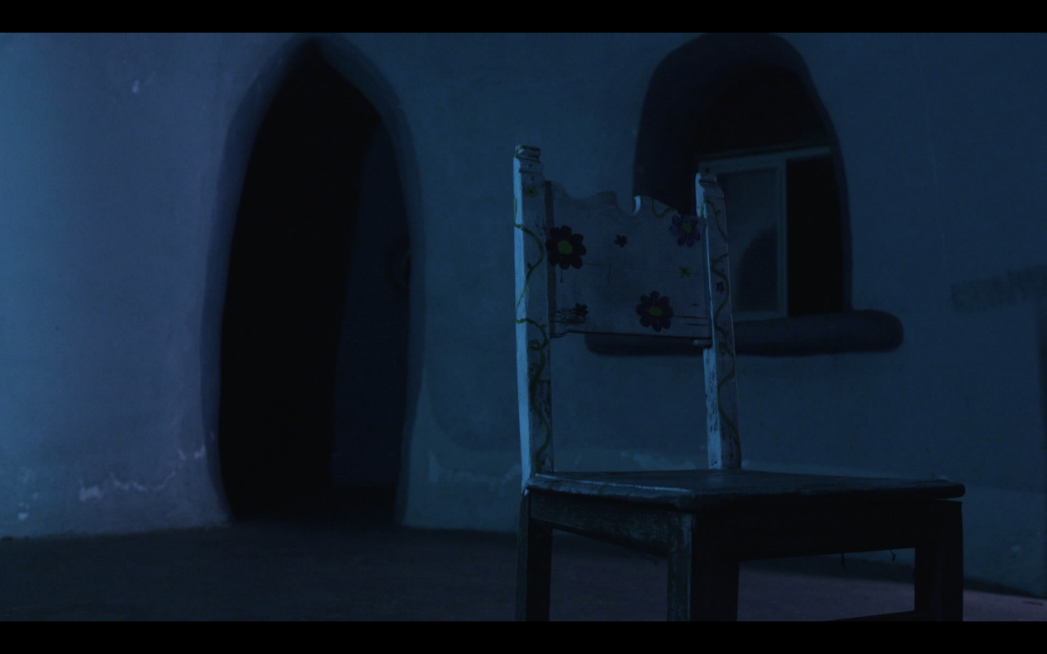

Nicolas Riley“ODE”