OPEN CALL INVISIBLE ATLAS
at Friends In The Arts Magazine

Friendsinthearts.net/

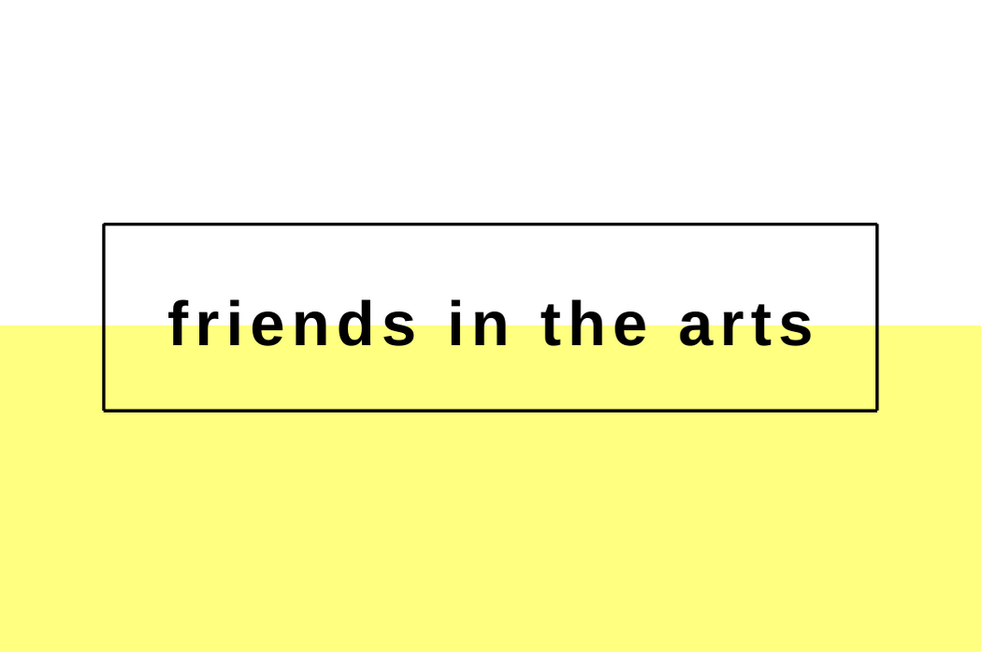

Lisbon, 3 February 2021 – Friends In The Arts Magazine opens the international call INVISIBLE ATLAS by welcoming submissions of essays, interviews, reviews, podcasts, videos, photographs, poems, short stories, short articles, artist projects and art investigations concerning contemporary art in all disciplines from friends in the arts around the world at any career stage.

Friends In The Arts presents the theme INVISIBLE ATLAS for FITA’s first international art magazine created by the Friends In The Arts community, to promote creative individuals and cultural organizations working exceptionally in the arts. We are committed to explore the best being produced around the globe and select the most impressive analysis of contemporary art forms in our bi-annual editorial magazine published in March and September.

Opportunity

In this exclusive Open Call for submissions, FITA is inviting all friends to send proposals that address the ways in which we live, move and connect as individuals. Drawing from the book “Invisible Cities” by Italo Calvino, where navigation to map the invisible is key and “the shortest distance between two points is not the straight line but a zigzag” (Calvino, 88: 1974), we open to discussion: What is the purpose of connecting invisible cities around the globe? Who is drawing frontiers in the world cartography? Where can border lines be traced? How are we moving forward as spaced coordinates? Why do we keep fighting concepts of abstract space? We also welcome proposals concerning educational material to help friends enter the art market profession.

Candidates

Friends from all around the world can send their submissions as individuals or groups of individuals. The digital platform Friends In The Arts is supported primarily by yearly membership quotas. Authors are urged to subscribe to the yearly program at Friends in The Arts Contempo page and ask their institutions and friends to do the same.

Submissions

Submissions should be in English language, should be based on original research and deal with the work of living artists. Except in particular circumstances, previously published material in print or online is ineligible for consideration. Submissions over 5,000 words will be returned to the author.

All article submissions must be in Microsoft Word 12-point, Times New Roman font, and double spaced. Submissions may be accompanied by a list of (max 20) illustrations (always with captions, include details) and a cover sheet with a biographical statement of no more than 100 words. Captions should include, figure number, artist’s name, title of work (date), medium, size in meters, photo credit or other credits. We welcome film and audio content in addition to images that could be placed in the form of QR codes in the magazine. Do not use any unnecessary capital letters. Use Chicago-Style when referencing. Friends In The Arts does not accept hard-copy submissions.

Submit your work as email attachments at magazine@friendsinthearts.net after signing in the Friends In The Arts yearly membership quota. Membership is not refundable as explained in our terms and conditions. Make sure to proofread your submission before sending. All the selected works will be integrated in the Friends In The Arts’ collection, being able to be published and managed by this cultural platform.

Submissions deadline is March 3, 2021.

All submitted work is reviewed and if deemed suitable for the publication’s issue is accepted. The selection will be performed with the utmost attention and respect for all submissions, through our knowledgeable and competent team, which has stood out in the world of arts and culture. All questions related to the open call should be directed to the editorial team and sent to magazine@friendsinthearts.net.

Magazine

Friends In The Arts Magazine is an international published art magazine that communicates artistic research from all disciplines.

Your friends are here for you.
Friendsinthearts.net/

