Taiwan Collateral Event of Biennale Architettura 2023
Diachronic Apparatuses of Taiwan – Architecture as on-going details within landscape Makes Debut

TAIPEI, TAIWAN, February 17, 2023 - Organized by the National Taiwan Museum of Fine Arts (NTMoFA) under the Ministry of Culture, Diachronic Apparatuses of Taiwan – Architecture as on-going details within landscape, curated by the Architectural Department of Tunghai University for the 18th International Architecture Exhibition – La Biennale di Venezia, will be exhibited at Palazzo delle Prigioni in Venice, Italy, from May 20 to November 26, 2023. The project made its debut at an event today (February 17) which saw the trial assembly of full-scale mockups of the exhibits in real-time. NTMoFA Director, Jen-I LIAO, jury members Prof. Kwang-Tyng WU, Jiahn-Min HUANG(architect), Prof. Ming-Song SHYU and Prof. Kuo-Chang LIU, curator of the 15th International Architecture Exhibition – La Biennale di Venezia, Prof. C. David TSENG, as well as representatives from the Architectural Department of Tunghai University, including curator Wei TSENG, co-curators Sheng-Chieh KO, Jeong-Der HO and Meng-tsun SU, were in attendance. Through an inventory of agricultural landscapes across different altitudes and latitudes in Taiwan, this year’s presentation illustrates how people have used their knowledge and technology to shape diverse building forms in a bid to tame the environment. The objective is to initiate a dialogue between synthetic and real ground, and also to relearn from the countryside.

The curation of Diachronic Apparatuses of Taiwan – Architecture as on-going details within landscape echoes the 18th International Architecture Exhibition – La Biennale di Venezia’s theme of The Laboratory of the Future. It posits that the next chapter of the 21st century may require us to take a detour, along which we must pay attention to and restore the surroundings that have been forgotten in the wake of progress. The curatorial team revisited Taiwan’s geography to look for signposts pointing to a brighter future in “real life”.

In Diachronic Apparatuses of Taiwan – Architecture as on-going details within landscape, the curatorial team examines Taiwan’s agricultural landscapes at varying altitudes through a “cross-sectional” perspective, discovering the “modified” aspects to them. Be it the oyster farm shelters off the coast of Chiayi, the greenhouses on the Chianan Plain, or the tea plantations in Lishan, they can all be considered humanity’s tectonic responses to the environment, “modifications” resulting from the identification and understanding of, as well as adaptation to, the characteristics and timing of the solar terms and other natural processes. The curatorial team has proposed six key words, namely “negotiator”, “duality”, “prosthesis”, “domesticity”, “intermediary” and “filter”, in response to how people clash with nature and also make compromises to facilitate mutual prosperity across different landscapes in Taiwan, thereby unearthing possibilities for the future development of Taiwanese architecture.

It is worth mentioning that this year’s team has taken a school-centric curatorial approach and adopted a joint participation model for the first time in the form of a “Teaching Alliance”. In addition to having close ties with the architectural education scene, the main works of the exhibition are jointly completed by the teachers and students from the Architectural Department of Tunghai University. Furthermore, the renowned architecture faculties of National Cheng Kung University, Tamkang University, Feng Chia University and Chung Yuan Christian University have also been invited to participate, enabling more dynamic experimentation and execution. All the exhibits will be showcased alongside each other in this year’s Taiwan Collateral Event.

Palazzo delle Prigioni, where the Taiwan Collateral Event will be located, is a unique historic structure and former prison. The curatorial team will divide the interior into four exhibition areas, namely “Landscape Documents”, “Threshold Corridor”, “Video Projection” and “Studio Propositions”, according to its architectural space. The venue’s vertical central wall and a horizontal black line will demarcate the boundaries of the four areas, while a big table will expand and unify these divisions as one spatial construct. Recorded audio and video will also be played in the exhibition space, with the sounds of Taiwan’s natural environment, newly arranged music and curated footage becoming instruments that can measure time and space, thus enabling viewers to open up their senses and experience the flow of real life in Taiwan.

Press materials can be downloaded at this link: https://reurl.cc/LN1zG9

Media Contact:
Odele Tseng  International Media Manager  Hao Liao Creative CO., LTD.  + 886 923 668 078  odeletseng@gmail.com | May Yan  National Taiwan Museum of Fine Arts  + 886 4-23723552 ext.123  may523@art.ntmofa.gov.tw

Appendix.
For all captions, please kindly use the following information.
By downloading images from this press kit you agree to the following restrictions: these images are available for editorial press use only. They must not be cropped, altered, montaged, overlaid with text or manipulated in any way. Images must be used with supplied captions and copyrights.

1. About Taiwan Collateral Event of Biennale Architettura
The Biennale Architettura is widely regarded as one of the most significant international arts events in the world. Each edition of this event has attracted hundreds of world-renowned architects to present their latest architectural concepts and techniques in their ongoing search for the best possible environment for human living. With organizational assistance from the National Taiwan Museum of Fine Arts, Taiwanese architects took part in this event in 2000 for the first time, as architects Zuyuan LEE and Chung-Ping WANG, joined by artist Hsiao Chin, represented Taiwan Collateral Event in the Biennale Architettura 2000 with their project entitled Life City. This has proved to be a major milestone for the architectural community of Taiwan, significantly facilitating the connection between the Taiwanese and international architectural communities. Exhibition titles of recent editions include Township Domestic Parts: Made in Taiwan, Everyday Architecture Re: Made in Taiwan, Primitive Migration from/to Taiwan, and Diachronic Apparatuses of Taiwan for this time.

2. About National Taiwan Museum of Fine Arts
The National Taiwan Museum of Fine Arts (NTMoFA) was founded in 1988. The NTMoFA is dedicated to the education and promotion of visual arts by collecting and exploring unique characteristics of modern and contemporary Taiwanese arts. Since 2000, NTMoFA has organized the Taiwan Exhibition at the Biennale Architettura. Representative projects have been selected through open calls for proposals from 2002 onwards, with nationally and internationally renowned architects and scholars serving as members of the judging panel. NTMoFA hopes that through the continual participation in the Biennale Architettura, we will be able to help cultivate a broader vision for the theory and practice of architecture in Taiwan, and establish a more balanced, responsive and mutually beneficial relationship between Eastern and Western culture.

3. Full list of the 39 participating exhibitors
Curator: Wei TSENG
Co-Curators: Sheng-Chieh KO, Jeong-Der HO, Meng Tsun SU

Participating Exhibitors:
(Department of Architecture, Tunghai University) Wei TSENG, Ming-Hao HSIEH, Ding-Che MA, Yung-Yu CHENG, Jeong-Der HO, Yong-Xuan LI, Han ZHENG, Huan-Lun CHEN, Sheng-Chieh KO, Ciao-Ming SHU, Yun-Hsi WU, Ci-Jhen LAI, Cai-Hui LIN, En-Yu JIAN, Tzu-Ching CHEN, Hsuan-Ting CHEN, Yan-Jun LU, Tsung-Yenh SIEH, (Department of Architecture, National Cheng Kung University) Cheng-Luen HSUEH, Yen-Chih CHEN, Ying-Tse WU, Ting-Ta HO, Wei-Lun CHEN, Li- Siang HUANG, Pak-Hei WONG, (Department of Architecture, National Cheng Kung University) Chueh-Chih GUU, Tzu-Yu HUANG, (School of Architecture, Feng Chia University) Po-Jen CHENG, Yu-Wei KUO, Jr-Jiun WANG, Yi-Hu CHEN, (Department of Architecture, Chung Yuan Christian University) Xuan-Cheng CHEN, Ning CHANG, Yun-An LAI, Yen-Chieh CHI, (Department of Architecture, Tamkang University) Kerby Shuh-Sien CHOU, Min CHANG, Cheng-Yang HUANG, (Department of Music, Tunghai University) Tak-Cheung HUI

Exhibition Space Design: Tsung-Yen HSIEH, Yi-Chien LEE
Structure Advisor: Ming-Chang LAI

4. Details of curatorial keywords
no | image | Credit＆Informatin
1 | 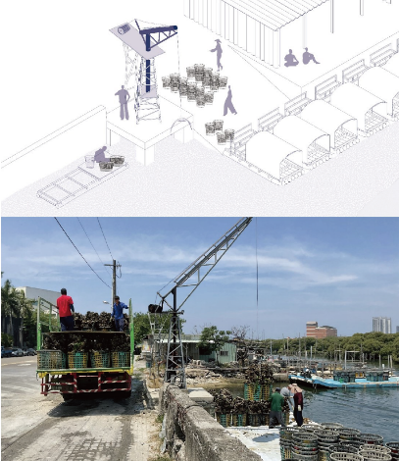 | Curatorial Keyword of the Landscape Models: Negotiator.  (Courtesy of National Taiwan Museum of Fine Art)  Workers' shelters and the piers in the oyster farm turn into social spaces during recess. Oyster farmers' instruments in the field further shape the transitions between the land and the ocean. This interplay between work and social behaviors reveals a negotiation mechanism that regulates the interweaving of fixation and mobility.
2 | 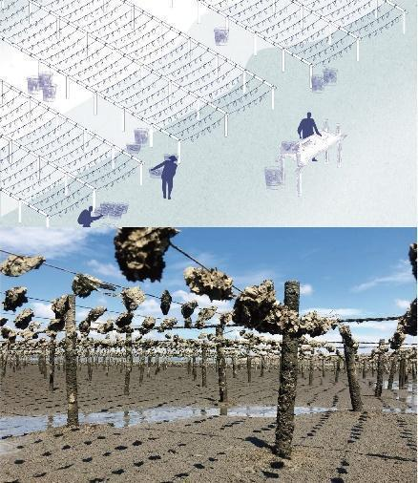 | Curatorial Keyword of the Landscape Models: Duality.  (Courtesy of National Taiwan Museum of Fine Art)  The simple shelters made of recycled bamboo from oyster farms become recreational venues for the farmers. During the harvest season, they serve as cooking areas for visitors. Modified motor tricycles adapt to the tidal beach of the flood plain. The unique landscape of the moving machine is a part of the productive system and recreational vehicles serving the visitors.
3 | 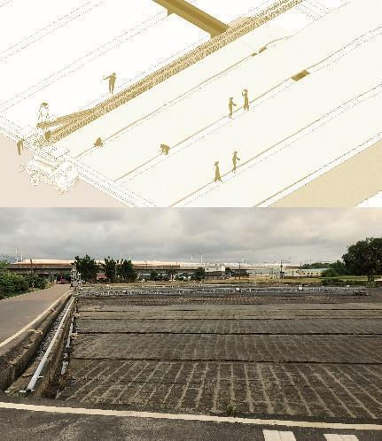 | Curatorial Keyword of the Landscape Models: Prosthesis.  (Courtesy of National Taiwan Museum of Fine Art)  The infrastructures that carry the transportation and irrigation channels are prosthetics of the land, acting as a double-edged sword that assists the production and exchange of farm products while directing the relationships between the field from the outside world.
4 | 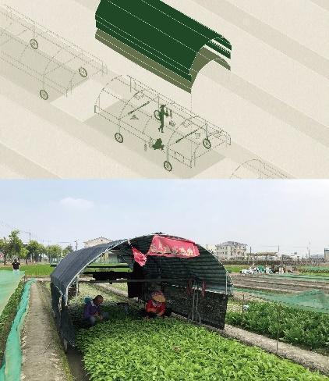 | Curatorial Keyword of the Landscape Models: Domesticity.  (Courtesy of National Taiwan Museum of Fine Art)  The tectonic thinking of net houses and winder houses in the countryside also yields new categories that engage with the dialogue between human labor and the environment. For example, where net houses are not feasible, farmers construct moving sunscreens in work areas to fend off the fierce sunlight. This interiority also creates domesticity in the landscape.
5 | 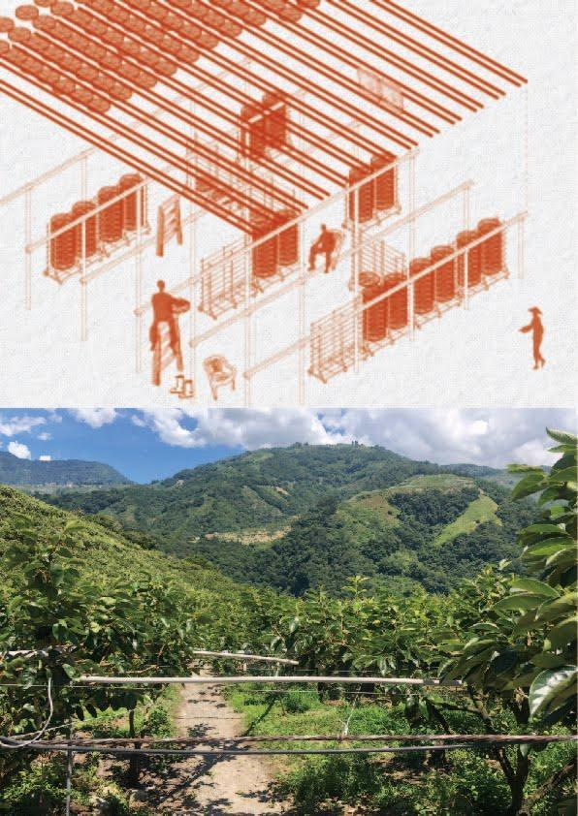 | Curatorial Keyword of the Landscape Models: Intermediary.  (Courtesy of National Taiwan Museum of Fine Art)  The drying processes of farm products create gaps and spaces in between. For example, the scaffolding for drying citruses leaves unique patterns of shadows that serve as social spaces. The drying of orange daylily flowers occupies the rooftop, which will be turned into a working venue and a productive element.
6 | 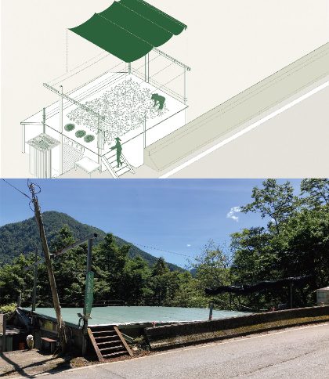 | Curatorial Keyword of the Landscape Models: Filter.  (Courtesy of National Taiwan Museum of Fine Art)  The orchard in the mountainous area combines human scale with the need for the growth of plants. The mountainous tea farms also cover the plants with shade nets. The wilting process that increases the fragrance of tea leaves during the tea harvesting season also protects the building with shade nets to regulate the intensity of sunlight.
7 | 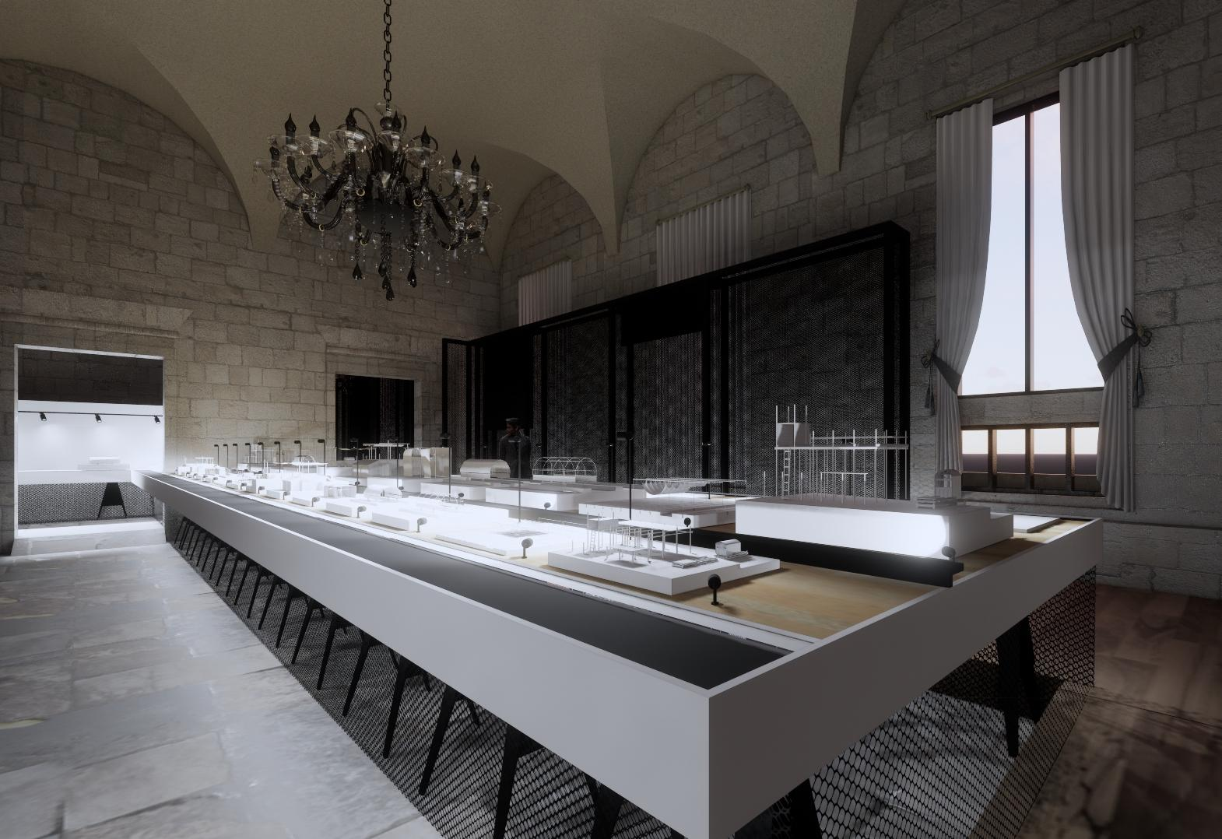 | Simulation photo of the Taiwan Collateral Event at Palazzo delle Prigioni. (Courtesy of National Taiwan Museum of Fine Art)  The exhibition will take place in the interior space of Palazzo delle Prigioni. The vertical central wall and a horizontal black line acknowledge and demarcate the four major areas — Landscape Documents, Threshold Corridor, Video Projection, and Studio Propositions.
8 | 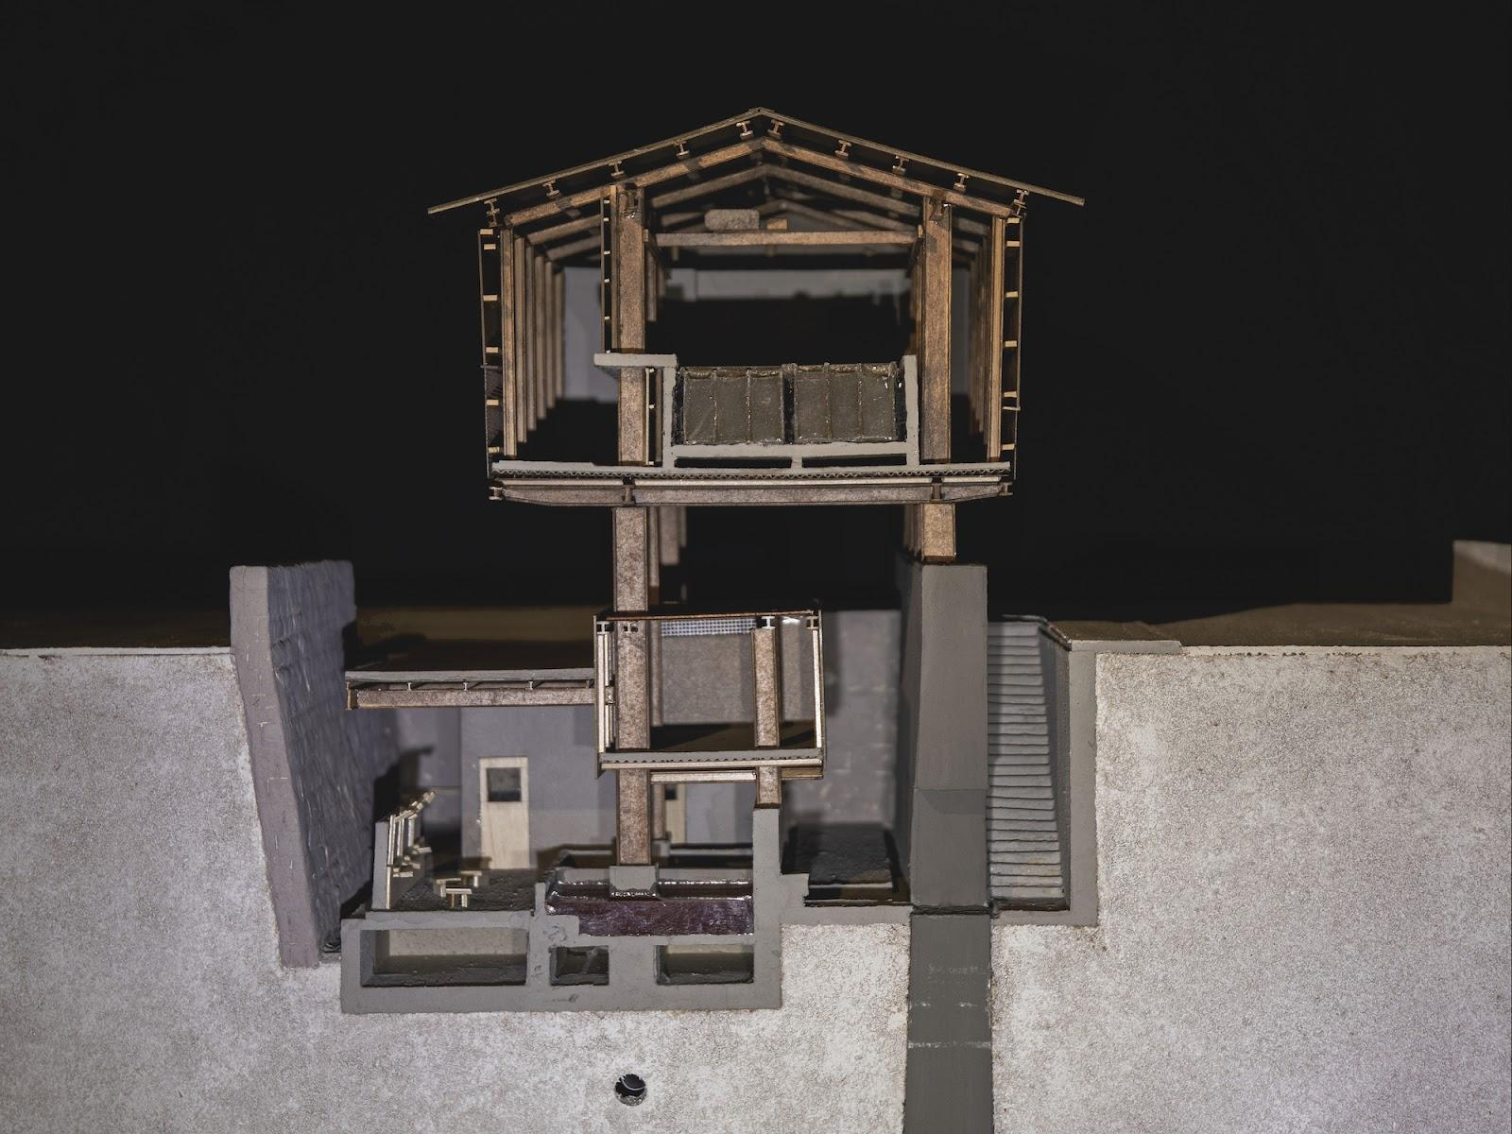 | Wei TSENG, Ming-Hao HSIEH, Redistribution of temperature in the fishing port – Bath of wasted heat, 2023, paper, wood, poly, 114 x 58 x 52 cm. (Courtesy of National Taiwan Museum of Fine Art)  As the north of Taiwan, Matsu is an island with extremist climate. Han nationality had developed well-functional types of house to against climate within the hundred year history of immigration. Nowadays, foreign laborers working and living on fishing boats are people who are still facing the climate.  ARGUMENT : Strength and fragility of the mind while facing different temperatures is the essence of Matsu island. STATEMENT : By Redistributing wasted temperature of ice factory, I aim at creating a mechanism of temperature for fishing laborers to rely on. STRATEGY : ice factory/ engine room/ balneary are three enclosed spaces of temperature, and Blank between them are spaces of diffusing temperature. PROPOSAL : Warm air from the engine room creates rest space in winter; cold pipe from ice pool creates rest space in summer.
9 | 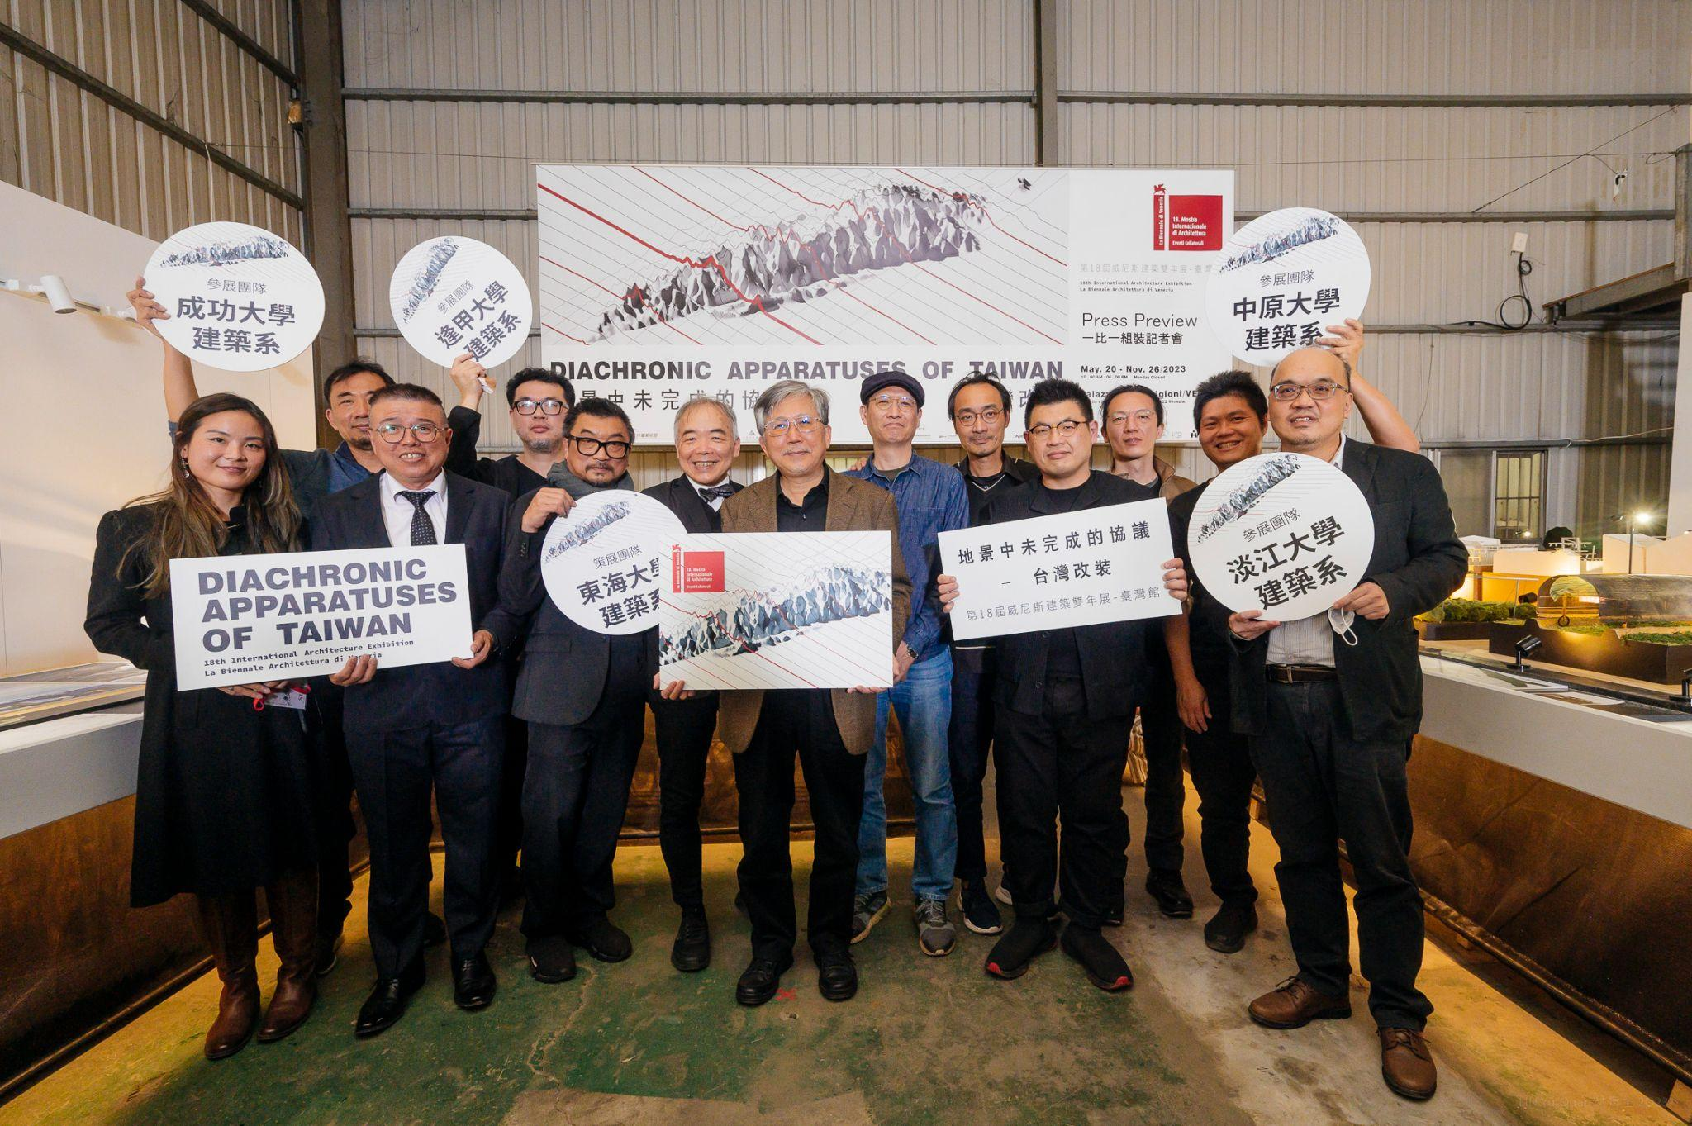 | Group photos of the curatorial team at the press preview conference. Taiwan Collateral Event of Biennale Architettura 2023, Diachronic Apparatuses of Taiwan – Architecture as on-going details within landscape. (Photo by Yu-Quan LIN. Courtesy of National Taiwan Museum of Fine Art)
10 | 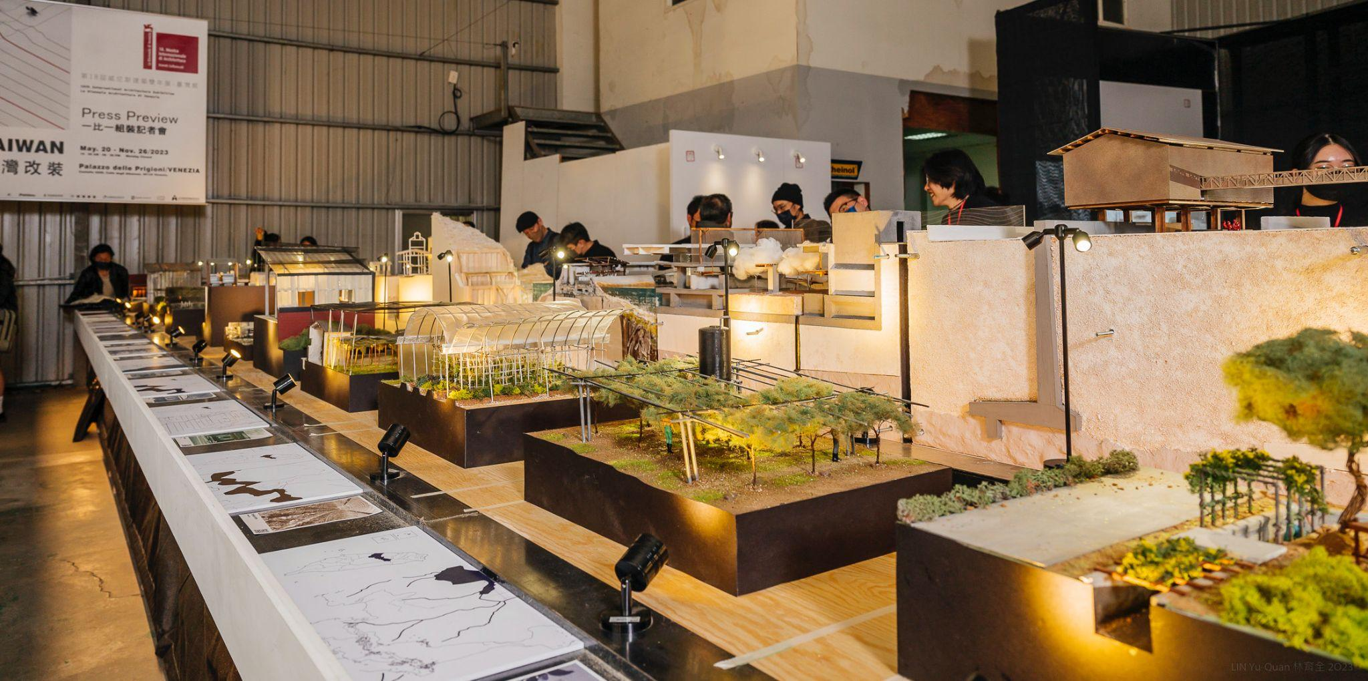 | The mockups of the exhibits made their debut. (Photo by Yu-Quan LIN. Courtesy of National Taiwan Museum of Fine Art)

