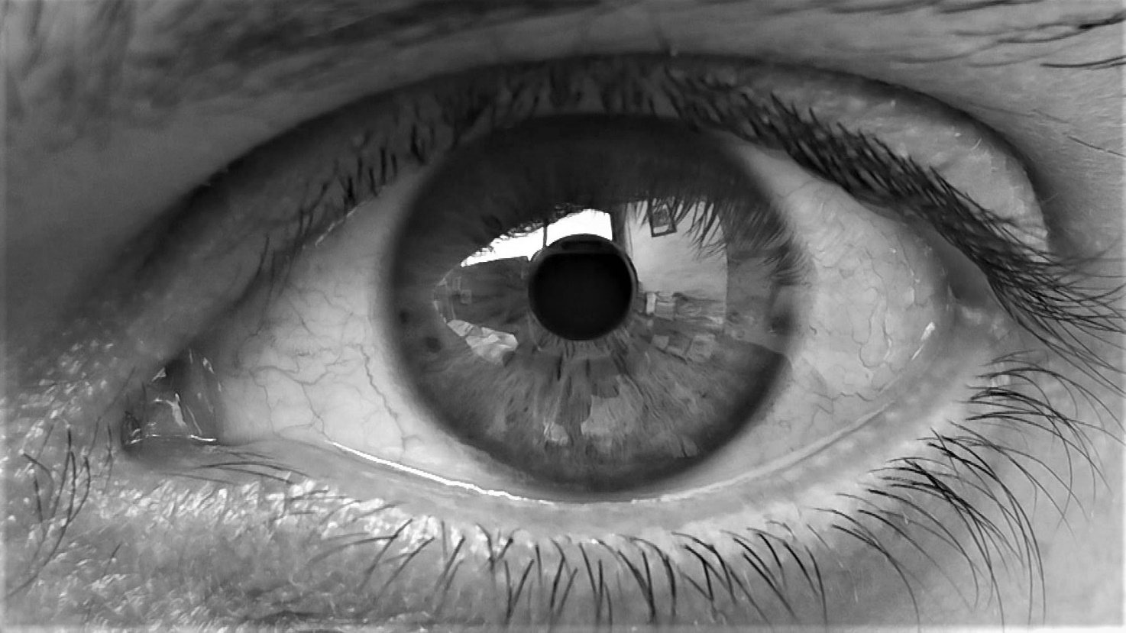
Regina Hübner, Dear Cell (eyes), Videostill, 2019. Protagonist Mauro Gaya, Chargé de Recherche, Group Leader, CIML

REGINA HÜBNER
DEAR CELL
MANIFESTA 13 – LES PARALLÈLES DU SUD
Regina Hübner at MANIFESTA 13 – Les Parallèles du Sud.
Solo Exhibition by Regina Hübner, Austrian artist based in Rome, at MANIFESTA Biennial in Marseille (FR).
Dear Cell gives an insight into the personal relationship between researcher and object of research and reverses it. The ambientation shows the artwork in its whole version and interacts with the visitor. Research is explored. Text by Arnulf Rohsmann, research and eros published on the occasion. https://www.reginahuebner.net/words/texts/arnulf-rohsmann-forschung-und-eros/

MANIFESTA 13 Under the High Patronage of Mr Emmanuel MACRON President of the French Republic.

Title: Dear Cell / MANIFESTA 13 – Les Parallèles du Sud
When: 6 – 28 November 2020 Vernissage: Friday 6. November 2020, 17 – 19
Where: Espace Fernand Pouillon, 3 Place Victor Hugo, 13331 Marseille, France
Opening hours: Monday – Friday from 10 to 19. Saturday from 10 - 13
Free entrance with reservation:
https://docs.google.com/forms/d/e/1FAIpQLSfZnphCUAO8pJcjLDYpSQdgWdWdorRxxLOFnhA0SVmDWj4bJg/viewform Due to the current national decisions, no more than 30 visitors are allowed simultaneously.
Website Manifesta: https://manifesta13.org/projects/dear-cell/
Further info: https://www.reginahuebner.net/times/recent-shows/manifesta-13-dear-cell/

PARTNERS
With the support of IMéRA Institute for Advanced Study of Aix-Marseille University, RFIEA French Network of Institutes for Advanced Studies, CIML Centre d’Immunologie Marseille-Luminy (CNRS, Inserm, UNI-AMU), AMU Aix-Marseille University, Region Sud Provence-Alpes-Côte d'Azur; Departmental Council of Bouches-du-Rhône, Austrian Cultural Forum Paris, Federal Ministry of the Republic of Austria, Federal State of Carinthia, The City of Villach.
DEAR CELL

Dear Cell is part of the interdisciplinary project Perception of Self and Nonself in Life, which was developed by Regina Hübner in 2019 at the Institute IMèRA, in cooperation with the Institute of Research for Modern Immunology CIML (https://imera.univ-amu.fr/en/resident/regina-hubner) and further, with the Institute for Neurobiology (Inmed http://www.inmed.fr/en/).
17 researchers from CIML and Inmed took part in the project and are the so-called Protagonists. Their contribution was constitutive.

CONCEPT
The distinction between self and non-self as a fundamental principle of immunology, is transferred to the relation between researcher and object of research. This relationship is reversed, and the new perception is visualized. Research reveals intimacy, the observer has the possibility to identify himself.

WORK DESCRIPTION
Dear Cell consists of 4 independent videos:
Dear Cell (letters), Dear Cell (transcriptions), Dear Cell (cells) and Dear Cell (eyes).

Dear Cell (letters) and Dear Cell (transcriptions)
The researchers wrote a personal letter to the object of their research (Letter from ME-researcher to YOU-object). They wrote a just such personal letter from the object’s point of view addressed to themselves, in which they gave up their usual position and interpreted the object’s personification (Letter from YOU-object to ME-researcher).
Dear Cell (letters) shows the live recorded handwriting. The growing line reminds of a living organism, calligraphy is the seismograph of our inner status.
Dear Cell (transcriptions) shows the transcribed manuscripts. A typed letter is legible, it documents and conveys the message.
All letters: https://www.reginahuebner.net/words/texts/dear-cell-transcriptions/
Dear Cell (transcriptions), excerpt: https://youtu.be/fFlEU7UIzmg

Dear Cell (cells)
The researchers provided photographs and videos of their objects of research, which they produce through confocal, multiphoton and light sheet microscopies.
The molecules, proteins, neurons, cells and organisms are impressively beautiful. Their aesthetics is independent from their subjective value. The image is reality and evidence.
Dear Cell (cells), excerpt: https://youtu.be/l1f6iBbxZZQ?t=1244

Dear Cell (eyes)
Even though the researchers use high observation technology, it’s their eye – the most beautiful and unique organ, with which they see, discover and evaluate. The researchers’ eye shows in precise detail its structure, its movements, and reflections.
The eyes are the window to the soul, one glimpse could destroy, one glimpse could make you fall in love.
The observer looks into those eyes. The observer become the observed.
Dear Cell (eyes), excerpt: https://youtu.be/l1f6iBbxZZQ

FURTHER INFORMATION

PROTAGONISTS
17 Research Directors, Group Leaders, Researchers and Professors from CNRS – French National Centre of Scientific Research, Inserm - French National Institute of Health and Medical Research, UNI-AMU Aix-Marseille University. (In order of appearance.)

Jean-Pierre Gorvel (Research Director, Group Leader, CIML), Host Pathogen Interaction; Philippe Pierre (Research Director, Group Leader and Director CIML), Dendritic Cells and Pathogens Sensing; Philippe Naquet (Professor, Group Leader, CIML), Immunology; Pierre Milpied (Chargé de recherche, Group Leader, CIML), Integrative B Cell Immunology; Sandrine Roulland (Research Director, Group Leader, CIML), Cancer Biology; Didier Marguet (Research Director, Group Leader, CIML), Membrane Dynamics and T Lymphocyte Signaling; Agnès Baude (Senior Scientist, Inmed), Neuroscience; Marc Dalod (Research Director, Group Leader, CIML), Type 1 Conventional Dendritic Cell; Dario Armando Leone (Researcher, CIML), Endolysosomal Trafficking in Immune Cells; Sandrine Sarrazin (Researcher, CIML), Stem Cell and Macrophage Biology; Serge van de Pavert (Research Director, Group Leader, CIML), Development of the Immune System; Mauro Gaya (Chargé de recherche, Group Leader, CIML), B-Cell Immunology to Infection; Françoise Muscatelli (Research Director, Group Leader, Inmed), Function of the Brain during Development; Sophie Ugolini (Research Director, Group Leader, CIML), Innate Lymphoid Cells and Neural Regulation of Immunity; Michael Sieweke (Research Director, Group Leader, CIML, Stem Cell and Macrophage Biology; Bertrand Nadel (Research Director, Group Leader, CIML), Genomic Instability and Human Hemopathies; Evelina Gatti (Research Director, CIML), Dendritic Cell Biology.

IMéRA – CIML – Inmed

IMéRA Institute for Advanced Study of Aix-Marseille University, is member of RFIEA (Réseau Français des Instituts d’Etudes Avancées), of NETIAS (Network of European Institutes for Advanced Study) and of the worldwide UBIAS (University-Based Institutes for Advanced Study), with the goal to challenge interdisciplinarity.
CIML, world class research institute of modern immunology, with 185 scientists coming from 27 different countries and 13 laboratories provided with top technologies, under the direction of directors of research and group leaders.
Inmed, world class institute of neuroscience, with 130 international scientists and professors of 9 research teams, which researched the evolution and plasticity of the brain.
CIML and Inmed are institutes of CNRS, the French National Centre of Scientific Research, of Inserm, the French National Institute of Health and Medical Research and of UNI-AMU Aix-Marseille University.

ARNULF ROHSMANN
Arnulf Rohsmann, art historian and science author. Professor for Modern Art at the Universities of Graz, Klagenfurt and Linz, Director of the Kärntner Landesgalerie from 1987 to 2002.
Among numerous publications, author of Manifestationsmöglichkeiten von Zeit in der bildenden Kunst des 20. Jahrhunderts, Olms and Zeit/Los, Zur Kunstgeschichte der Zeit, Kunst Halle Krems, Dumont.
forschung und eros, exclusive Text for Dear Cell, 2019.
Translations German/French and German/English by AMG Traduction.
Text: https://www.reginahuebner.net/words/texts/arnulf-rohsmann-forschung-und-eros/

REGINA HÜBNER
Born in Villach, lives in Villach, Austria and Rome, Italy. Independent artist.
Experimental photography, video, performance, subjects and objects, text, concept. Cooperation with scientists and artists from literature, music, art and special key-figures, the so-called Protagonists.
Guest researcher at IMéRA Institute for advanced Study, University Aix-Marseille (2019).
International exhibitions since 1989. Award winner, e.g., Memorial to Paul Watzlawick, Villach (2020).
Biography: https://www.reginahuebner.net/times/biography/

Solo Exhibitions and Solo Events (selection)
MANIFESTA 13 Marseille; Nuit Blanche Paris 2018; Vilnius National Museum, Dinzlschloss Villach; MMKK Museum Modern Art Carinthia, Austrian Cultural Forum Rome; Italian Cultural Institute Vienna; EXPO 2015 Milano; Cinecittà Studios Roma, The White Night Rome, MLAC Museo Laboratorio Arte Contemporanea dell’Università La Sapienza Rome, Austrian Cultural Forum Milan, Nuova Icona Venice, change+partner contemporary art Rome and Bracciano. Solo Shows: https://www.reginahuebner.net/times/solo-shows/
Newest Exhibitions: https://www.reginahuebner.net/times/recent-shows/

Group Exhibitions and Festivals (selection)
AMIDEX Marseille, VIDEOFORMES Clermont-Ferrand;,BIM Buenos Aires, Now & After Moscow, OVER THE REAL - Lucca Film Festival, ADAF Athens, Goethe Institut Dubai, Analog Room Dubai, Jameel Arts Centre Dubaï, Gamma Festival Moscow, Auckland Live Digital Stage, Videodrome Paris – TIK TAK Antwerp, Vilnius National Museum, Čiurlionis National Museum Kaunas, Mandel Center Tel Aviv, FIAV Casablanca, Friuli Venezia Giulia Fotografia, WAC Bordeaux - CAPC Bordeaux, State Archive Turin, Goethe Institut Rom, VIDEOFORMA St. Petersburg, TIME is Love.10 - ZKM Zentrum für Kunst und Medien Karlsruhe, Addis Video Art Festival, FIVAC Camagüey, Lange Nacht der Museen, Istituto Polacco Roma, Galerie Freihausgasse.
Group Shows: https://www.reginahuebner.net/times/group-shows/

Television reports
ORF Österreichischer Rundfunk and ORF Kärnten, Portrait Regina Hübner, Helga Suppan; ORF Österreichischer Rundfunk Kärnten; Regina Hübner und der Milchtropfen, Iris Hofmeister; ORF Ö1 Radio, Regina Hübner – Nuit Blanche Paris, Christophe Kohl; Corriere TV Corriere della Sera, Allattare è un’arte: l’opera di Regina Huebner a CasaCorriere EXPO Milano 2015, Maria Luisa Villa; Subbiano TV, FulgorAzione con l’arte di Regina Huebner, Stefanella Baglioni.

Symposia and conferences: https://www.reginahuebner.net/2/symposia/
Texts (selection): https://www.reginahuebner.net/words/texts/

EXHIBITIONS DEAR CELL
2019 A*Midex Aix-Marseille Université Initiative d’Excellence, FRAC Marseille (Conference)
2019 IMéRA Marseille; Mandel Center Tel Aviv; National Museum Vilnius; Čiurlionis National Museum of Art Kaunas. (Previews)
Scheduled exhibitions
2021 - VIDEOFORMES International Media Arts Festival, Clermont-Ferrand, France
2022 - KAUNAS 2022 Contemporary Capital, European Capital of Culture, Lithuania

KONTAKT / NETWORKS
E-mail: regina.huebner@reginahuebner.net Website: http://www.reginahuebner.net
YouTube: https://www.youtube.com/ReginaHuebner Twitter: https://twitter.com/reginahuebner
FB: https://www.facebook.com/regina.huebner IG: https://www.instagram.com/reginahuebnerart/
Hashtags: #Manifesta13Marseille #LesParellelesduSud #ReginaHuebner #DearCell

