**File for Advertisement**

**Of**

**Two Solo Shows**

**You are invited**

**First**

**Solo Show**

**In**

**Italy**

**See the flyer**

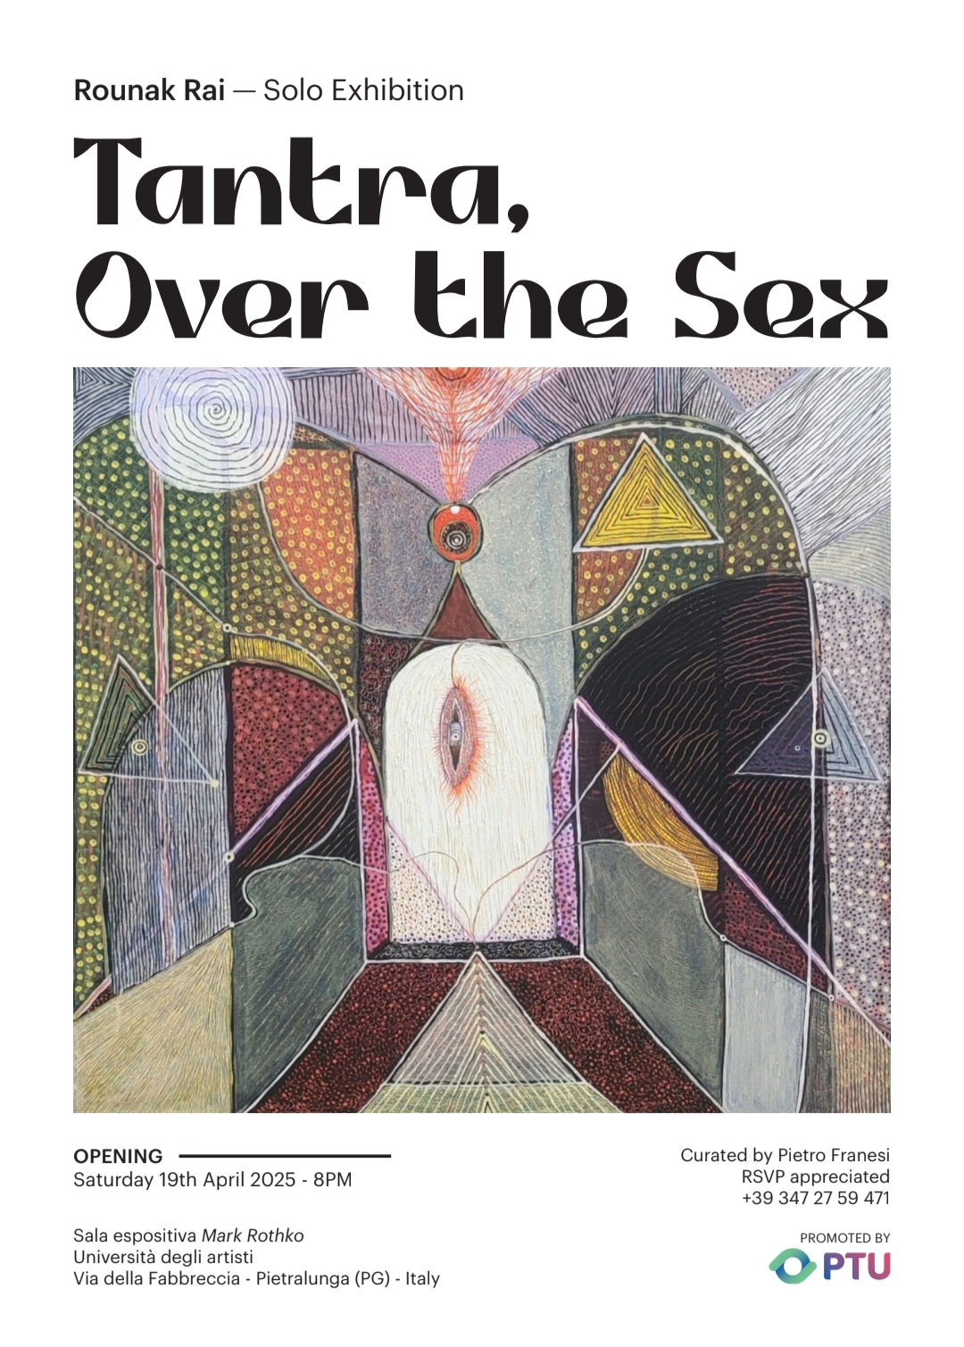

**Second**

**Solo Show**

**In**

**Germany**

**See the flyer**

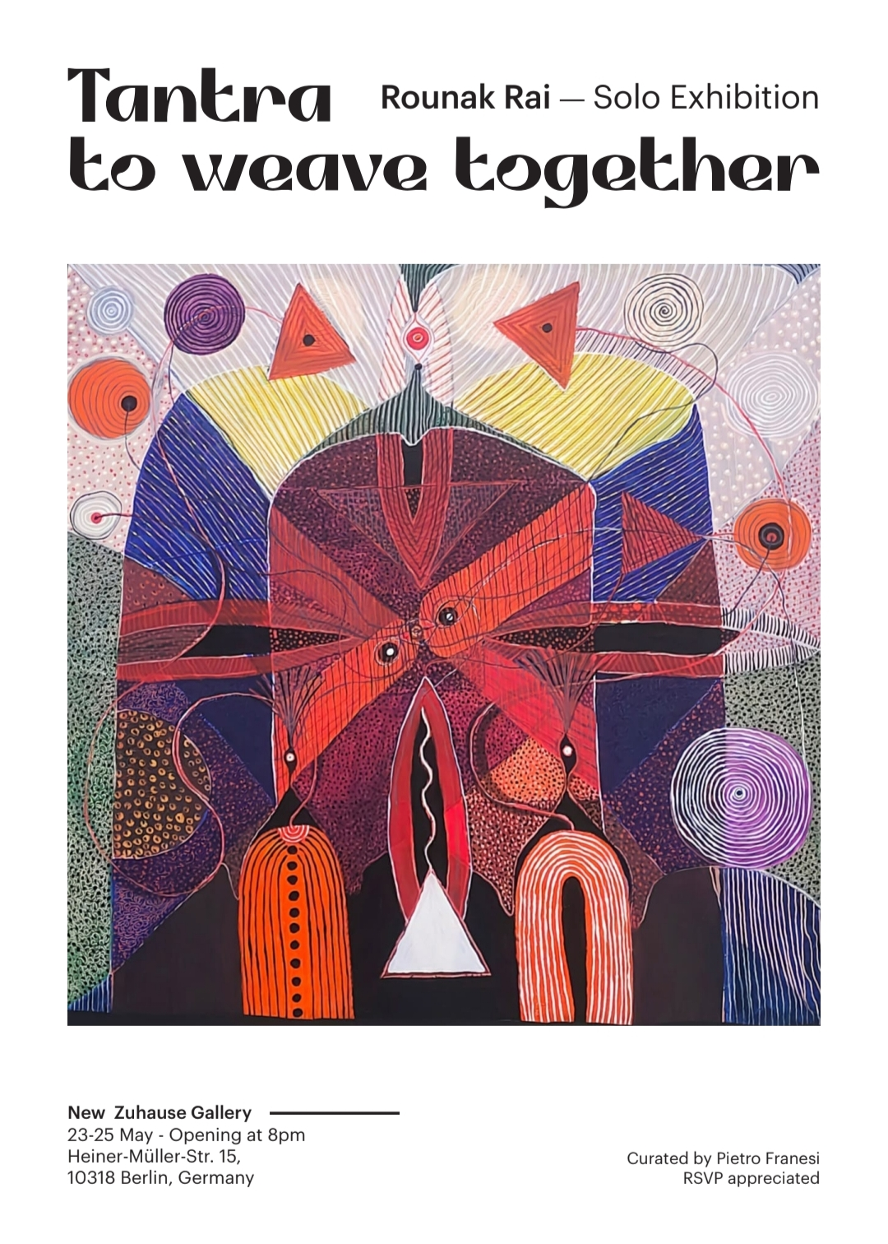

**See all details**

1. About My Art Curator

(Details send by my Art Curator)

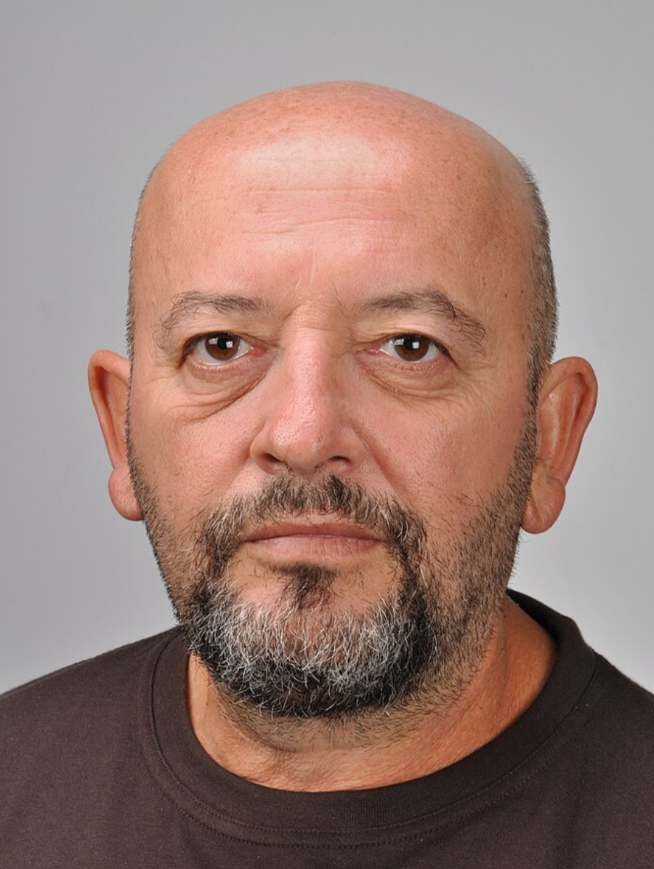

about me I have a degree in economics, with specializations in international marketing at SDA of the Luigi Bocconi University, in Milan, and in Social marketing at MYT in New York.

Until 2005 I was a consultant for Governments, the former USSR, the Ministry of Agriculture, the Municipality of St. Petersburg, where I lived for 11 years, starting to collect ancient and modern art.

Consultant for multinationals from the Montedison Group, to Proter & Gable from Finmeccanica, from the Giacobazzi Group, to the Italian Fashion Chamber, which represented all Italian stylists, and Coca Cola.

In 2004 I was a consultant for the European Commission, for the Culture program.

Since 2005 I have moved to New York, where I opened the NY1Art Gallery, at 511 25th Street, in Chelsea. I closed it after 2 months, because I had predicted the subprime mortgage crisis two years earlier.

In a 2005 interview, the magazine titled the article: Pietro Franesi, the oracle of the economy.

The crisis swept away the middle class and hundreds of galleries closed.

I invented the New York Art Biennial, and the Dubai Biennial, which I organized and directed until 2023.

I collaborate with the best international collectors, Russians, Chinese, Arabs.

I travel the planet looking for talents, then I organize their solo shows in which ONLY collectors participate.

I am missing 3 countries, Ivory Coast, Nigeria and Mali.

I do not sell works. I sell artists to collectors.

For many years I have known Rounak Rai who I consider one of the most promising talents on the international scene. I have other, few, Indian artists that I follow.

Rounak Rai is ready for the big collecting and with the exhibitions in Italy and Berlin I am sure that they will offer him a contract.

The market is full of artists. Every year, about 2 million new artists come out of universities and academies. If we add to these the artists who have other degrees or are self-taught, we get to about 8 million every year.

The competition is very high.

Those who create quality works but above all unique either for technique or concept win.

Rounak Rai is one of these, approaching the Indian tradition of sexuality with a contemporary eye.

Completely different from the Western vision.

Sex practiced to reach nirvana.

A mystical, almost religious vision, that only those who can imagine the parallel world, the immaterial one, where the ideas of the greats who have changed the various disciplines with revolutionary ideas coexist.

About me I recommend viewing:

<https://franesipietroart.blogspot.com>

<https://thechurch2023.com>

<https://artauctiononline.net>

1. About Me and My Paintings from the Point of View of My Art Curator

Presentation. This curatela is aimed to analyze Rounak Rai'spainting through the develop of the Tantrism concept. The main pathos of Indian Neotantrism was that modern achievements in the exact sciences, perceived as an integral part of the modernized Eurocentric civilization, had long been known to Indian Tantric mystics. For example, the fact that both sound and colour, according to the data of modern physics have the same – wave – nature, in Neotantrism, was predicted by the fact that the mantra (oral, pronounced formula, i.e. sound) and yantra (the visual equivalent of this formula) are similar. The idea that the modern view of the world was foreseen in the distant Indian antiquity, inspired those artists and thinkers who were raised on the idea of the hegemony of Western values, but sought to free themselves from its oppression, but very timidly and using forms that recalled Western abstraction or surrealism. Unlike the historical Indian exponents of Neotantrism, Rounak breaks with the logic of representing Indian culture using the symbols of Western culture. Rounak is the witness of an India that does not feel inferior to Europe and the West, that proudly defends the symbols of Tantrism as it feels them internally and not on the basis of symbols, as if it had to hide the true nature of Tantra. Consciously and provocatively he uses the universal symbols of sex, female and male, but he does it with grace and delicacy, defending the values ​​of his culture in a universal vision, where everyone can recognize themselves. He is the heir of P. T. Reddy, G. R. Santosh, Biren De, Om Prakash, S. H. Raza, Mulk Rāj Ananda and Ajit Mookerjee', and he does it with the awareness of his extraordinary creative force. A unique artist in the international panorama of emerging artists. I am honored to represent him.

Link of this Article

here you find my presentation of your exhibition

<https://franesipietroart.blogspot.com>

1. My Interview by My Curator

**good morning mr Raunak, could you introduce yourself?**

My name is Raunak Rai, and I am a resident of a small town, Karera, in India. I completed my Master of Fine Arts in 2011 from the nearby city of Gwalior. Since then, I have participated in several group exhibitions and a few solo exhibitions across India.  
Now, with the support of Mr. Pietro Franesi, I am about to hold two solo exhibitions abroad—one in Berlin, Germany, and the other in Italy. My friendship with Mr. Pietro spans over ten years. A few years ago, he interviewed me on his blog, discussing my Ramayana series paintings. As a final question, he asked about my future aspirations, to which I replied that I wished to hold a solo exhibition abroad.  
Today, it is he who is turning my dream into reality—not just with one, but with two solo exhibitions! For this, I am immensely grateful to him.

**What is the concept that would you like to develop in art?**

In the early years, I was deeply fascinated by figures, particularly nude women. However, my artistic interests extended beyond that—I painted extensively on **many** themes from the Ramayana, Mahabharata, and various deities, including Goddess Kali. I found great joy in illustrating stories, as painting was not merely an act of creation for me but also a means to convey emotions, narratives, and personal reflections.  
Over time, my artistic journey took a spiritual turn. I became increasingly inclined toward emotions rather than physical forms. Instead of idol worship, I found myself drawn toward Tantra. The act of creation became a Tantric ritual—a form of divine worship. This realization brought me immense satisfaction, and I embraced it as a path to attain the Divine.  
In Tantra, I was particularly drawn to Bhairavi Tantra, a practice that allows one to move toward spiritual enlightenment while simultaneously experiencing sensual bliss. This path fascinated me because it involved the sacred union of lovers, where love and devotion were the essence. The process of Tantric lovemaking is prolonged, requiring physical, mental, and spiritual discipline. However, through proper dedication, I discovered that it is a **potent** ritual, bringing about deeply positive transformations within me.

**QUESTION 3  
What is Tantra for you, it almost seems like you paint to perform a religious rite. I understand devotion but art cannot become a religion, it is and must remain a free interpretation of reality. The artist cannot become a Guru. Do you agree?**

Although I do not identify as a Tantric, I firmly believe that every true artist is a Tantric—whether they acknowledge it or not. Every artist is a seeker, consciously or unconsciously worshiping the Divine through their art.

As my paintings are set to be exhibited in Germany and Italy, I would like to discuss their three distinct categories, each representing a different aspect of spiritual and artistic evolution.  
1. The Pitfalls of Lust  
The first category of my paintings consists of figures, but more than the physical form, the symbolism within them holds greater significance. These artworks depict the consequences of being consumed by lust—of being so obsessed with sexual pleasure that it leads to self-destruction.  
Through these paintings, I emphasize a profound truth:  
Love is not lust. Lust must be transformed into love.  
Sex should be experienced, but without losing one's vital energy. One must not wander aimlessly in carnal desires but instead strive to attain higher awareness.  
One of my paintings features a snake emerging from a woman’s yoni, biting a man—a metaphor for the dangers of uncontrolled sexual desire. The world is obsessed with physical pleasure, but very few understand its true essence. Only those who undergo rigorous spiritual discipline can harness this energy for higher consciousness. Sex is a form of penance—if wasted in mere lust, life itself will be wasted.  
2. The Path of the Intermediate Practitioner  
The second category of my paintings illustrates the experiences of intermediate-level Tantric practitioners—those who have not yet attained ultimate spiritual enlightenment but have begun to experience divine bliss through Tantric practices.  
In these paintings, I depict how a successful Tantric practice fills the practitioner with intense energy. This energy is clearly visible in my artwork. While this level of Tantra may not lead directly to Divine realization, it is still deeply fulfilling and can make life profoundly meaningful.  
Though it does not grant liberation from the cycle of birth and rebirth, it allows one to be reborn with a heightened ability to experience bliss. Every human being possesses the potential to reach this stage, and I believe that everyone should at least practice to this level—for this is the tapasyā (spiritual discipline) that humans are naturally capable of undertaking.  
3. The Ultimate Divine Connection  
The final category represents the most evolved state—when a practitioner successfully completes Bhairavi Tantra and attains direct experience of the Divine. Through the awakening of Kundalini, their connection with the Divine becomes established. Even if this connection lasts only for a few moments, it is otherworldly—and nothing is more divine than this transcendental experience.  
After attaining this divine state, the practitioner becomes detached from worldly illusions (Maya). This is called Sahaj Sannyas—a state of effortless renunciation, where no earthly desire remains. The only longing that persists is to stay connected with the Divine. This sense of transcendence and divinity is deeply embedded in my paintings.  
Although these artworks contain elements of abstraction, they are not entirely non-representational. My journey toward this artistic and spiritual enlightenment was achieved through figures, just as spiritual liberation is attained through sacred union in Bhairavi Tantra. Thus, figures remain an essential part of my work, just as the act of lovemaking is integral to Tantric practice.  
These paintings depict union—the phallus and the yoni—yet they do not appear vulgar or obscene. Instead, they radiate love, devotion, and divinity, because the underlying intention has transformed. The emotions in these paintings have reached the highest state of consciousness.  
Even though these artworks are not entirely figurative, I believe they have the power to offer a direct experience of the Divine.

**QUESTION4**

**Would you like to conclude your thought for those who will visit the two exhibitions that we recall will be held in Italy and Germany?**  
My artistic journey is not just about painting figures—it is about exploring deeper emotions, spiritual transformation, and divine realization. Through my upcoming exhibitions in Germany and Italy, I hope to share these profound insights with the world.  
I invite you to witness my paintings—not just as an artistic object but as a spiritual experience.

Link of this interview on YouTube as a Video

<https://youtu.be/3FSNG4gYZ30?si=ruJ2Xl6UZt3DISCc>

Link of another video on YouTube Related to this interview

<https://youtu.be/SVCgyaGq9Cg?si=ZPZpPSEGDQJpscMn>

Link of A Old Interview by My Curator

<https://franesipietroart.blogspot.com/search?updated-max=2020-02-07T13:56:00Z&max-results=7&start=30&by-date=false>

Video related to my paintings on Ramayana

<https://youtu.be/aGr605litR4?si=SD6kRu3bxiKpikkg>

Thank you

1. My Biodata

**Bio Data**

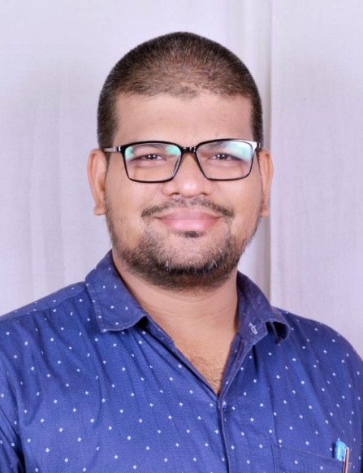

**Rounak Rai**

15/158 Yadav Mohallah

Karera

Distt- Shivpuri ( MP ) – 473660

Mobile no – 9109897352

Email ID – [rounakraii786@gmail.com](mailto:rounakraii786@gmail.com)

DOB – 25/05/1988

Birth place – Karera , Distt – Shivpuri ( MP ) - 473660

**EDUCATION**

MFA (Painting) from Government Institute of Fine Arts, Gwalior (MP) in 2011

**AWARDS (As Preference)**

1) "J. Swaminathan" Award – MP State Award at Khajuraho Festival - 2015

2) "Best Drawing" Award given by Gujari Mahal , Gwalior (MP) - 2010

**Books (Achievements)**

1. "Corona Se Atmgyan" - Poems and Drawings – 2020

<https://amzn.in/d/35RsTeI>

1. "Santusti - Corona Se Atmgyan - 2" - Poems and Drawings – 2021

<https://amzn.in/d/grdpMxj>

1. Shaadi Se Santushti – 2024

<https://amzn.in/d/8OXNiNK>

**SOLO ART EXHIBITIONS (As Preference)**

1) "Innocent Feelings" at Lalit Kala Academy, New Delhi – 2015

2) "Ramayana ki Atma" at Canarys National Art Foundation, Indore - 2019

3) "Few Drawings and Emotions" at Canarys National Art Foundation, Indore – 2016

4) "Few Drawings and Emotions" at Ujjwal Art Gallery, Goa -2017

5) "Angry Goddess" at Pritamlal Dua Sabhagar , Indore – 2016

6) A solo art exhibition of Painting, sculptures and installations by Rounak Rai at Tansen Kala Vethika , Gwalior – 2010

( Two upcoming Solo Shows in abroad one in April 2025 in Italy and another in May 2025 in Berlin Germany )

**GROUP ART EXHIBITIONS (As preference)**

1) "18 Oct" – 2013 at Visual Art Gallery, New Delhi

2) "Abhivyakti" - 2014, Range of Vision -2013, Uddipan – 2012, Parikrama - 2012 and Abbozzo – 2023 at Lalit Kala Academy, New Delhi

3) "Parikrama" – 2012 at Open Palm Cort Art Gallery, Indian Habitat Centre, New Delhi

4) "Sparsh" – 2012 at Convention Foyr, Indian Habitat Centre, New Delhi

5) "Parikrama" – 2012 at Art Chamber Art Gallery, Goa

6) "Art Promo india" -2012 (A Travelling Show) at Lakshamana Art Gallery, Shree Parvati Art Gallery and then at Cholamandalam , Chennai

7) "Aarambh" – 2012 at AIFACS, New Delhi

8) "Tarq" – 2015 at Exhibition Hall, MS University, Vadodara

9) "Rang Of Vision" – 2016 - 2019 and 2022 at Tebran Hall Gallery, Shimla

10) A Group Show – 2015 at Regional centre of Lalit Kala Academy, Lucknow

11) "Range Of Vision" – 2013 - 2015 at Chitra kala Parisad, Bangaluru

12) "Rang Of Vision" – 2013, "Studio 11" – 2013, "Krati" – 2013, "Parikrama" - 2012, "Krati" – 2012 at Jawahar Kala Kendra, Jaipur

13) "Creative Capers" – 2015 at Hotel Crowne Plaza , Mayur Vihar, New Delhi

14) "108 Vinayak/kala Nayak" – 2016 (A Travelling Show) at White Sanctum Art Gallery, Bangaluru then Bhilwara then Vadodara

15) "Studio 11" – 2013 at Dengle Art Gallery, Pune

16) "Hastakshar Samuh" Part 1 and 2 – 2012 at Artizen Art Gallery, New Delhi

17) "Roza" -2008 At Tansen Kala Vethika, Gwalior

18) "Bundelkhand Art Community" 1, 2, 3 art exhibition 2018 - 2020 and 2022 (2020 Online) at Jhansi Museum Art Gallery, Jhansi

19) Visual Confluence 1,2 Art Exhibition 2023 & 2024 at Ram Chhatpar Shilp Nyas, Varanasi & Academy of Arts kolkata

(Visual Confluence 3 is coming in June 2025 at Chitrakala Parishad Bengaluru)

**PARTICIPATIONS (As Preference)**

1. All India Art Exhibition Dhoomimal Art Gallery, New Delhi – 2010
2. All India Art Exhibition AIFACS Art Gallery, New Delhi - 2024

3) All India Art Exhibition North South Zone Cultural Centre Nagpur – 2010

4) All India Art Exhibition Amritsar – 2008 & 2024

5) MP State Exhibition, Gwalior – 2008-09-10 and 2015

6) Raza Puruskar MP State Exhibition, Gwalior – 2006

7) Agnipath All India Art Exhibition, New Delhi – 2006

8) Annual Art Exhibition, Institute of Fine Art, Gwalior – 2006-07-08-09

9) Annual Art Exhibition, Raja Mansingh Tomar Music and Art University, Gwalior – 2010-11

10) Art Exhibitions by Kalaneri Art gallery in 2012 and 2013

11) Art Exhibitions by Ujjwal Art Gallery in 2017

**CAMPS (As Preference)**

1) National Art Camp at Jhansi Museum – 2013

2) Sanskar Bharti National Art Camp, Gwalior – 2008

3) Kalarang-kalasang National Art Camp, Gwalior – 2008

4) Art Today Art Camp at Rani Sati Temple, Jhnujhunu – 2017

5) Range of Vision Art Camp Gwalior - 2019

**ANY OTHER**

Three year working experience at Graphic Studio Bharat Bhawan Bhopal as Professional Artist – 2012-14

**COLLECTION**

Delhi, Jaipur, Goa, Indore, Gwalior, Vadodara, Jhansi in India

&

Italy, Russia, France, New York & Germany

With Thanks and Regards

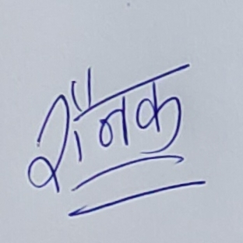

**Rounak Rai**

21/03/2025

Karera, Distt – Shivpuri (MP)

1. My Views About My Paintings

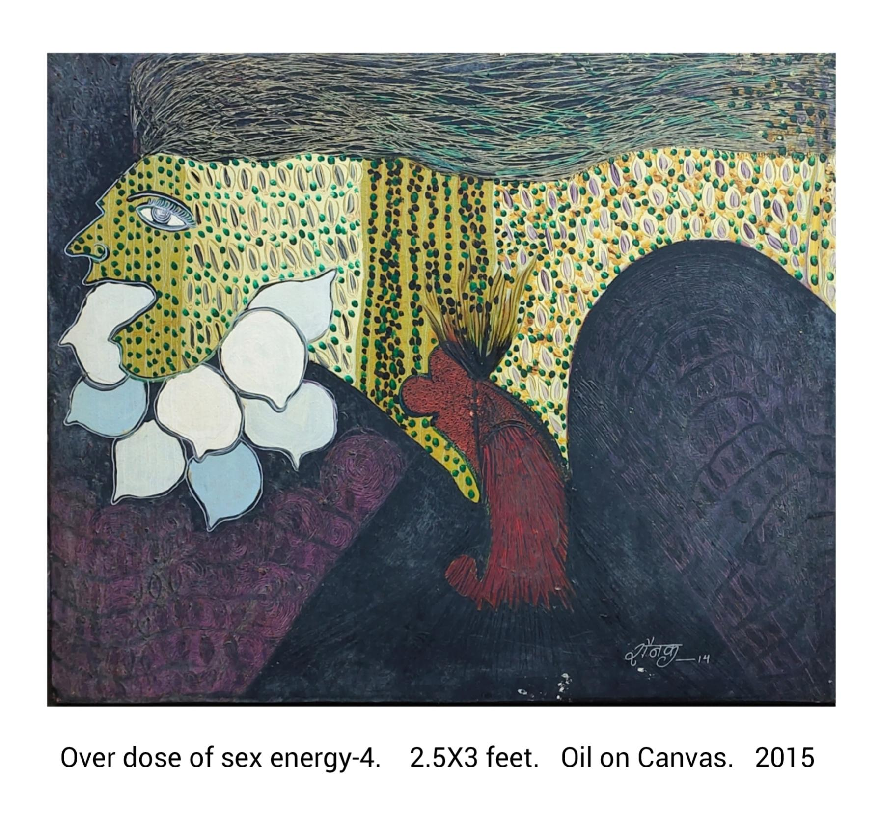

Part 1 Low Level of Sex Tantra

Sex and Society (Risks & benefits of Sex Tantra)

Sex Tantra is a Spiritual Process to get Ultimate Salvation. It’s the highest state of Yoga and Meditation that wants Full dedication with Whole Sacrifices. This is the Awaking Journey of power (Shakti) towards God (Shiva) by uplifting from 7 power stations (Chakra) from backbone, called “Kundlini Jagran”. But most of the Societies are doing wrong practices of Sex Tantra or Bhairavi Tantra or Kamakhya Tantra etc. As They don’t have proper understanding of 5 Makaar (essential elements) and doing misuse, only for small benefits But they don’t know about Greatness and Real Meanings. Some teachers (Guru) are also confused. As Meat means Body (Health) not Non Veg. Fish means flow of energy not Fish. Alcohol means Nectar not Drugs. Money means Strength by Yoga not only Wealth. Sex means Cosmic Sex not p**********. Actually Yogi (Seeker) needs these 5 things, like – Healthy food, Kundalini Jagran, Tonics, Resources and Intercourse at initial stage to get a Powerful Spark but fools are doing wrong things as Assuming The Final Stage. By these Misunderstandings, Greed and Lusts, Idiots are becoming drug addict, hyper sexy and criminals as doing blackmailing, kidnapping, human tariffing, rapes, gang rapes and Killing etc. for only Maya (beautiful Girls) and physical satisfaction (Sex) but they gets only depression, frustration and other Mental Disorders as Desires Never Ends. But True Love can provide Full Satisfaction and Power Yoga with Deep Meditation can Fix Permanent Ecstasy. Only By Proper Channel an Yogi (devotee) can achieve Final and Ultimate Salvation otherwise Lusty will get only Madness or Death. I tried to Express these things with some Warnings and Good Wishes in my Paintings as I am also very Emotional Yogi (Artist).

Thanks a lot

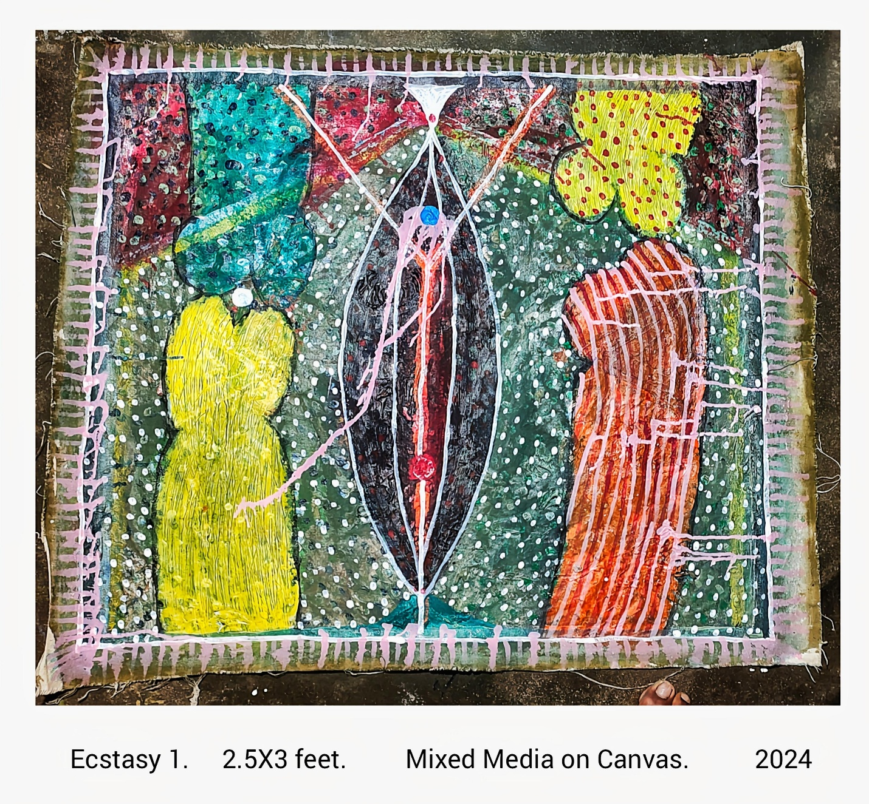

Part 2 – Medium Level of Sex Tantra

**Importance of Kamasutra and Khajuraho**

Kamasutra is a great Indian Book and Khajuraho is the great Indian Place; Both are very famous for their erotic topics but both are not belongs to only Sex. Kamasutra tells about how to Live with full of Enjoyments and Khajuraho explains about how to get Ultimate Salvation by proper channel; Both are Interconnected.

In Khajuraho, We can see many great sculptures based on the daily life Activities, As Sex (Intercourse) is also main part of daily routine, so we can see many erotic sculptures on the outer walls of temples but not inside. This type of symbolic depiction explore about the Correct Route towards God. First disown illusions (Maya) like Sex but on the correct Time (after getting full Satisfaction to leave happily).

Sex is the necessary thing like water and food as everybody has a natural hunger to getting pleasure from Sex but only some people knows, “how to Sex properly to get ultimate happiness (Ecstasy)” and only few people knows about the real importance of “Sex Tantra” as Sex Tantra is the easiest way to get Ultimate Salvation.

Kamasutra and Khajuraho explains these all things in full details. In kamasutra we find Sex as Yoga and 64 Sex Positions Like Yoga Postures. Mostly Positions are very different to apply but very useful when performing Tantric Sex. Some great Pyramids of these Positions (Tantric Sex in Groups) we can see in Khajuraho’s Sculptures. Importance of foreplay and after play along with main Play is also explained beautifully But most important thing is The “True Love” because without Love Nobody can Enjoy. My paintings are also dedicated to these all things. I Expressed my Pure Love with full of Free Emotions to Beauty my paintings.

So, Please Fall in Love as Life along with My Paintings are very Beautiful.

Thanks a lot

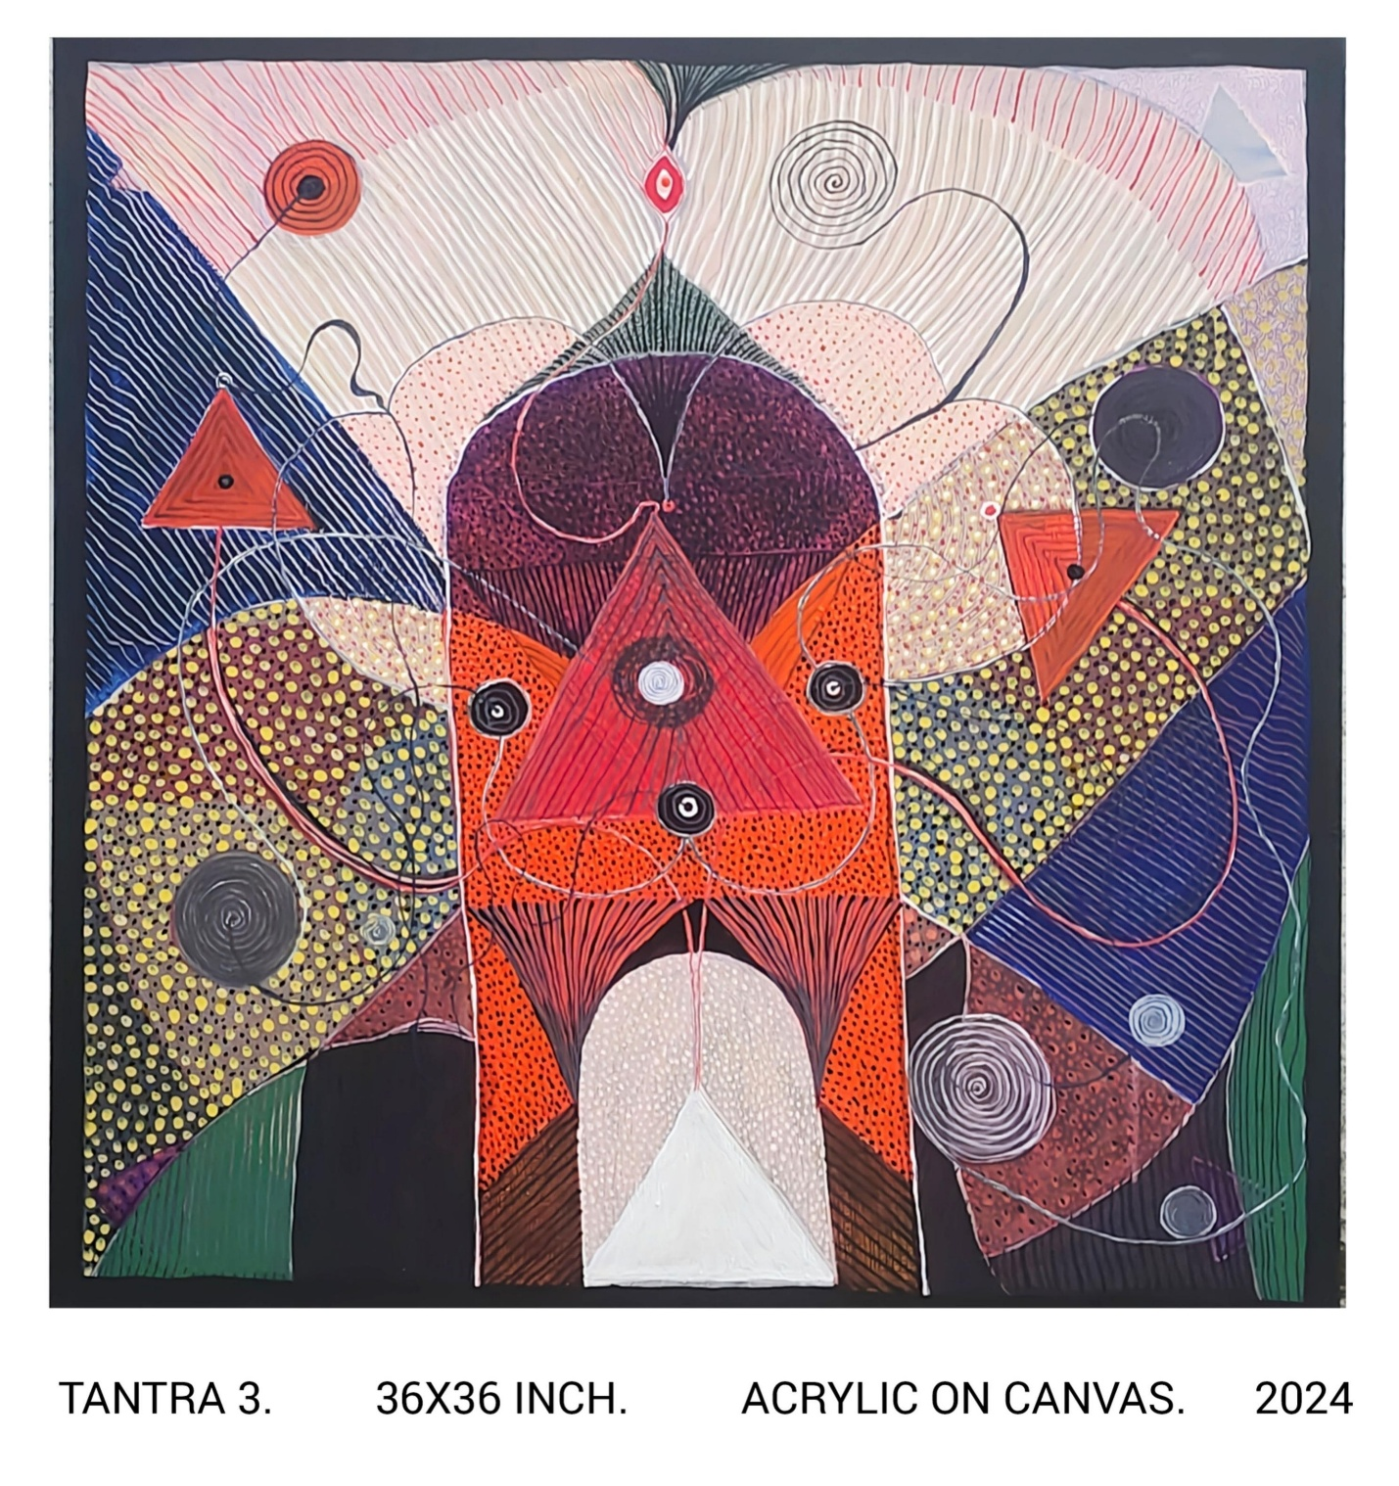

Part 3 – Higher Level of Sex Tantra

**Sex and Tantra** Sex is a Tantra. Humans can achieve Ultimate Salvation by this. This is also known as Bhairavi, Kamakhya and Kaal Chakra Tantra. In this Process Male and Female comes together and start intercourse (Yoga) like a journey to connect with God (Shiva) in the proper guidance of well trained teacher (Guru). Sex provide a initial spark to start this jou of Spiritual Awaking (Kundalini Jagran) and here Sex Energy (collective energy from both bodies) becomes like a necessary fuel to complete this. All Human have a sleeping power (Shakti) at their sex organs and can activate this power to uplifting towards Shiva by Sex Tantra But regular pumping of this power is also necessary at every upcoming pumping stations. Route of this physical to spiritual journey starts from Sex organs and ends at upper side of head. Here Backbone support this Process by uplifting of this controlled sex energy (power) towards Shiva. second pumping station (Chakra) at reproductive organs (for Extension), third chakra at stomach (for Strength), forth Chakra at heart (for true Love), fifth Chakra at throat (for communication power), Sixth Chakra in third Eye (at the middle part of both eyes for supernatural powers to get complete knowledge) and the final stage at Lord Shiva’s Home (Power Centre for everything). When controlled Power (Shakti) meets with Super Power (Shiva - the God’s Energy) then Physical and Spiritual both Sex becomes to Cosmic Sex (for infinity) to provide unlimited and ultimate Salvation. I tried to paint benefits and Risks this tantra like A Play in my Paintings as this Sex Tantra is totally depend on controlled Sex Energy but if, this Sex Energy becomes uncontrolled then it can destroy everything. So please be Aware and Enjoy.

Thanks a lot.

**Now**

**You all are invited for my solo shows**

**I am very happy to share flyers of my Solo Shows**

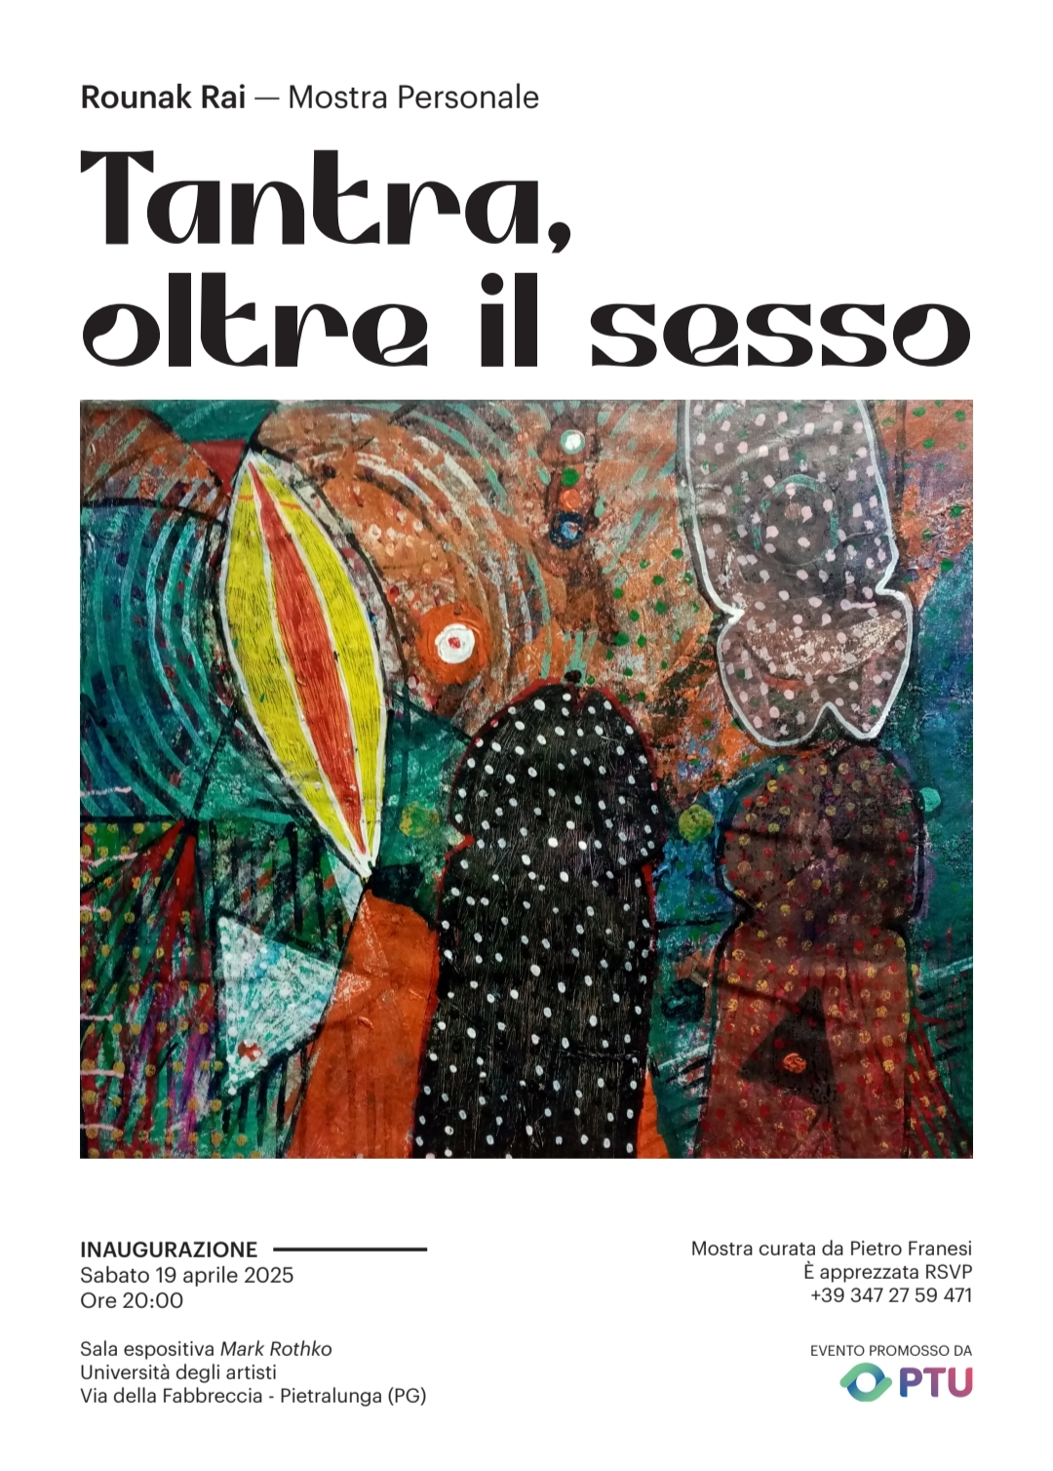

**Please Visit**

**Thanks**

**Again**

**&**

**Again**