***The Lost Vision – 2025 London Contemporary Art Review Exhibition***

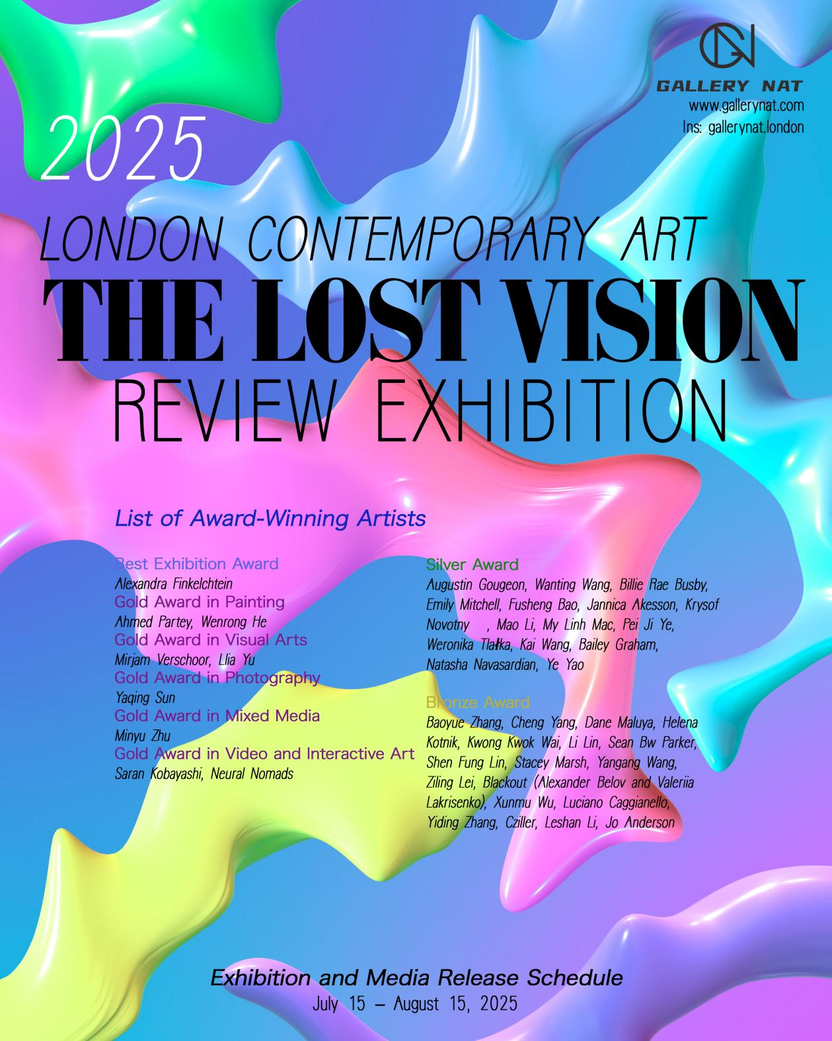

Hosted by Gallery NAT, the winning artists of the UK international art competition “The Lost Vision – 2025 London Contemporary Art Review Exhibition” were officially announced on July 15, 2025.

This international art competition, organized by Gallery NAT, received submissions from artists across dozens of major countries and regions around the world. The final results were determined by a panel of academic reviewers from Gallery NAT, alongside invited independent jurors — including renowned artists, professors, interdisciplinary creators, and curators from countries such as the United States, United Kingdom, France, and Switzerland — who evaluated the works independently.

According to the final scoring system, 42 professional artists from 18 countries and regions — including the United Kingdom, United States, Canada, the Netherlands, France, China, Spain, Poland, Finland, Italy, Japan, Czech Republic, Ireland, Portugal, Vietnam, Ghana, Hong Kong (China), and Taiwan (China) — were honored with awards.

The jury adhered to a strict evaluation standard that placed no restrictions on nationality, residence, ethnicity, or sexual orientation. The evaluation focused solely on the overall quality of the submitted works, the artist’s résumé, and academic or professional influence within the art industry.

Additionally, the artworks were assessed in relation to the exhibition’s theme “The Lost Vision” — exploring abstract concepts such as individual emotion and poetic aesthetics, works that express philosophical depth and emotional resonance. Originality and unique artistic expression, breaking away from conventional frameworks or established aesthetic norms, were key considerations. Innovation could be reflected through material usage, structural form, and expressive techniques.

Based on these criteria, the Gallery NAT curatorial team nominated Gold, Silver, and Bronze Award candidates in each category. The academic review panel then independently scored the finalists in the Gold Award categories. Categories included: Gold Award for Painting, Gold Award for Visual or Digital Art, Gold Award for Photography, Gold Award for Mixed Media, and Gold Award for Moving Image & Interactive Art, alongside corresponding Silver and Bronze Awards. The highest average score among all categories was awarded the “Best in Exhibition.”

“The Lost Vision” – 2025 London Contemporary Art Review Exhibition was established to explore a growing sense of absence and disconnection in today’s world. As the core theme of this exhibition, The Lost Vision reminds us that the loss of vision is not just the fading of sight — it also signals a neglect of past memories and values, and a growing regret toward the future.

Through painting, sculpture, photography, video, installation, and other media, the artists guide the audience into a world that is both real and imagined — revealing the cultural heritage, natural landscapes, and spiritual values we are gradually leaving behind.

**List of Award-Winning Artists**

**Best Exhibition Award**: Alexandra Finkelchtein

**Gold Award in Painting**: Ahmed Partey, Wenrong He

**Gold Award in Visual Arts:** Mirjam Verschoor, Llia Yu

**Gold Award in Photography:** Yaqing Sun

**Gold Award in Mixed Media:** Minyu Zhu

**Gold Award in Video and Interactive Art ：**Saran Kobayashi, Neural Nomads

**Silver Award:**

Augustin Gougeon, Wanting Wang, Billie Rae Busby, Emily Mitchell, Fusheng Bao, Jannica Akesson, Kryštof Novotný, Mao Li, My Linh Mac, Pei Ji Ye, Weronika Tlałka, Kai Wang, Bailey Graham, Natasha Navasardian, Ye Yao

**Bronze Award:**

Baoyue Zhang, Cheng Yang, Dane Maluya, Helena Kotnik, Kwong Kwok Wai, Li Lin, Sean Bw Parker, Shen Fung Lin, Stacey Marsh, Yangang Wang, Ziling Lei, Blackout (Alexander Belov and Valeriia Lakrisenko), Xunmu Wu, Luciano Caggianello, Yiding Zhang, Cziller, Leshan Li, Jo Anderson

The exhibition period for “The Lost Vision – 2025 London Contemporary Art Review Exhibition” will run from July 15 to August 15, 2025. Gallery NAT will collaborate with leading global and art-focused media outlets to promote the exhibition in multiple stages, ensuring wide exposure for the 42 award-winning artists from 18 countries and regions. It is hoped that the spiritual power conveyed through their works will inspire and nourish many more people.

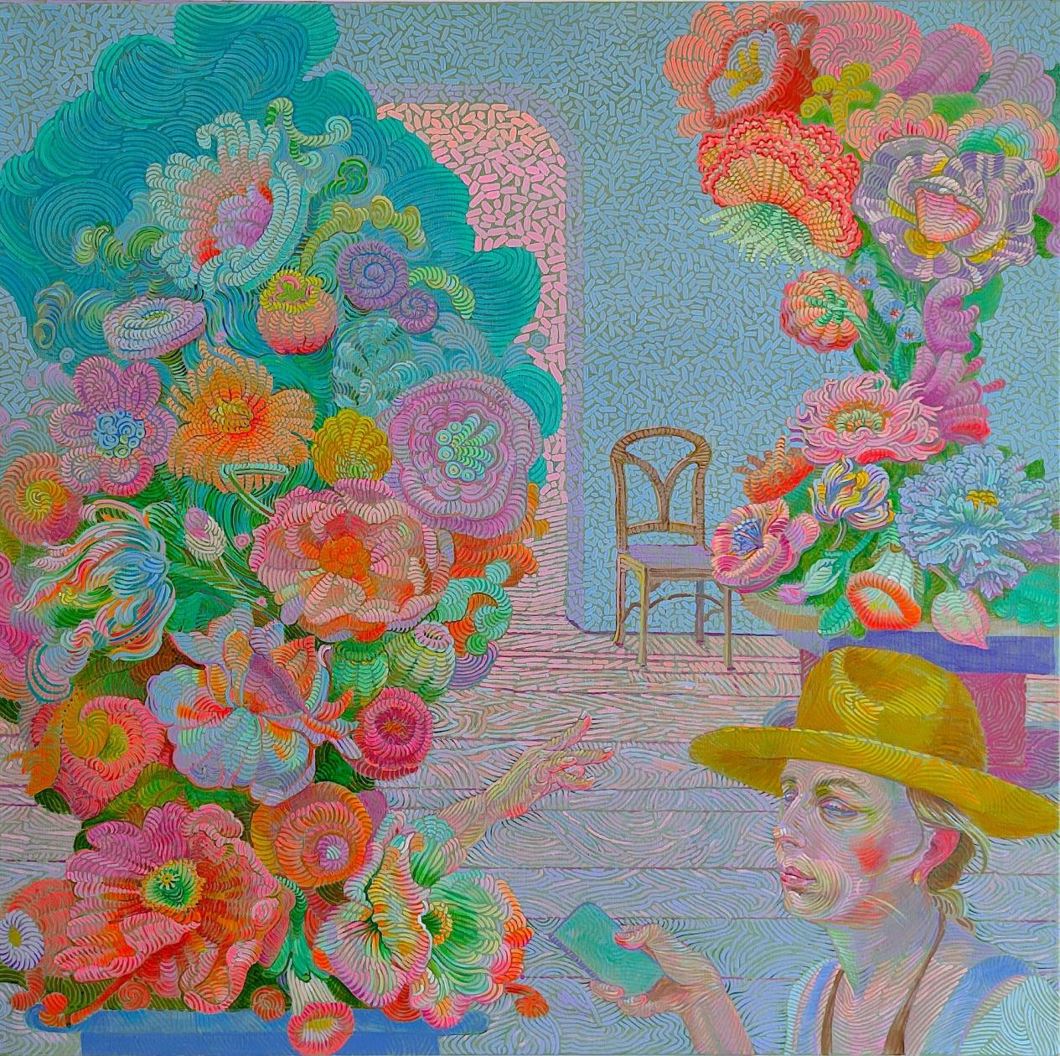

Alexandra Finkelchtein‘At Sculpture Hall’



Augustin Gougeon‘The Dawn of Silver’50 x 40cm 2025

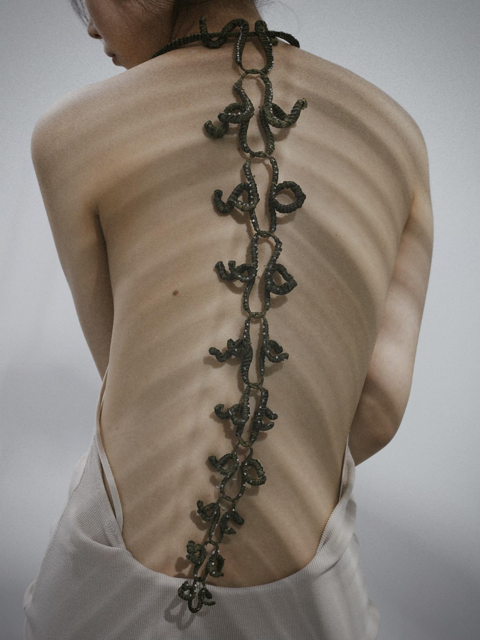

New Revolution of Palm Weaving Back KAI WANG

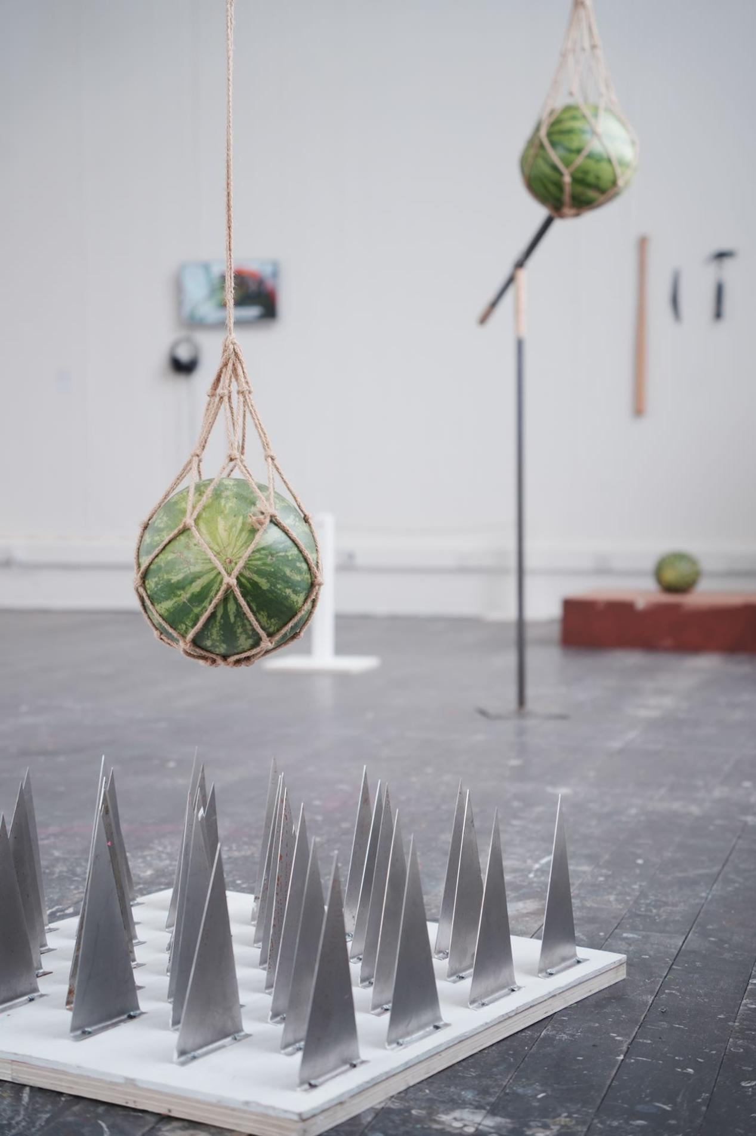

Ye Yao ‘who killed the watermelon3’installation/07.2024/10m2 space

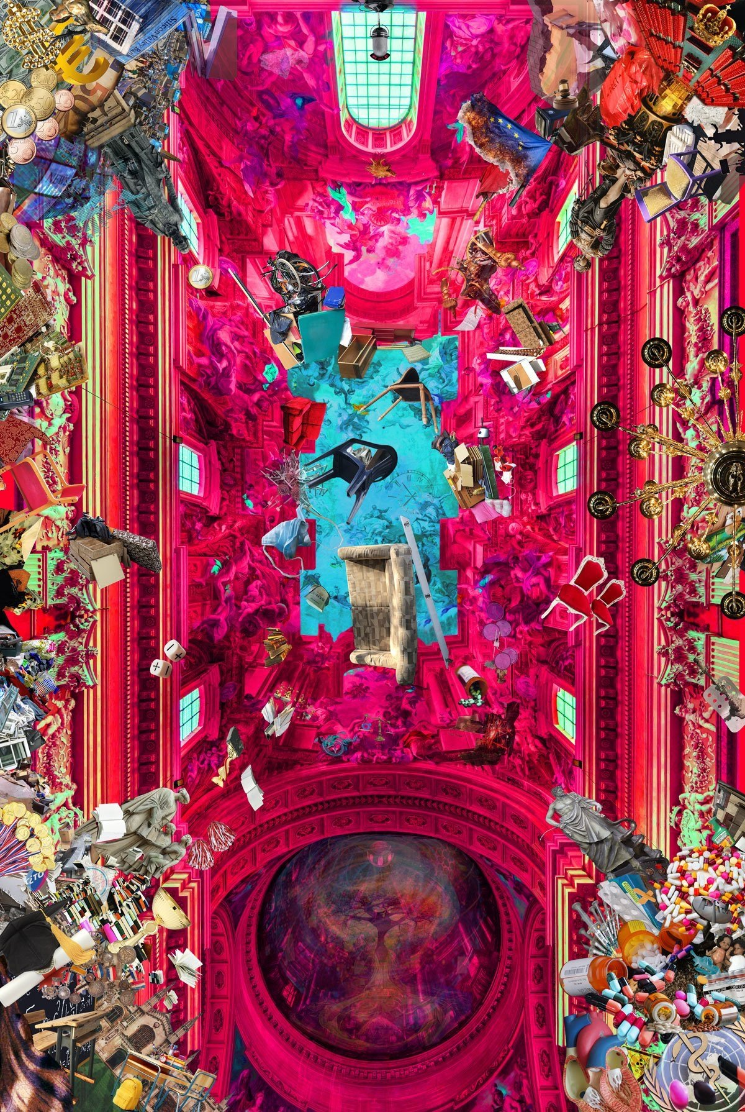

Mirjam Verschoor‘Seeiing behind the veil of illusion’