Thresholds
Shijie Hai New York Exhibation

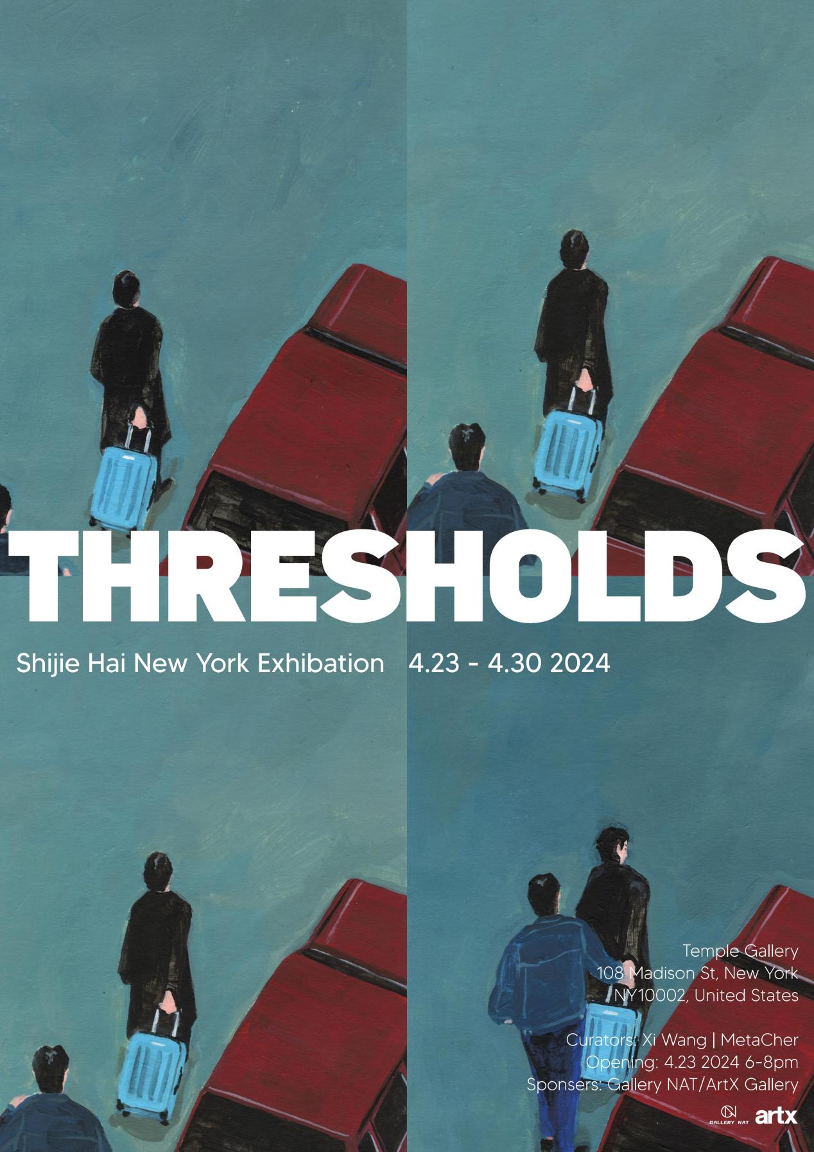

Exhibition Preface

The exhibition theme "Thresholds" symbolizes the transitions and transformations in life, reflecting the fleeting moments of rupture in the subtle relationship between humans and their environment. Haishi Jie's visual works will showcase two distinct yet interconnected series: "Territory" and "Fortikaĵo".

The "Territory" series originates from a graphic novel titled "Territory," set against the backdrop of London, exploring individuals' sense of belonging to their surroundings and interpersonal relationships. These works delve deep into the correlations between individuals and the urban landscape, intimate relationships, and how these connections undergo fissures over time and in different environments, revealing the potential disintegration of seemingly stable relationships in daily life. Haishi Jie, through nuanced emotional expression in visual art, presents the complexity and vulnerability of human emotions, prompting viewers to contemplate their own relationship with the surrounding environment.

The other portion of works stems from the "Fortikaĵo" series, which innovatively builds upon the foundation of "Territory" by employing CGI technology to construct a world imbued with primitive aesthetics. In this virtual realm, Shijie Hai explores the relationship between humanity, technology, and nature, triggering profound reflections on the interaction between human civilization and the natural world. These works possess both surrealistic imagination and a vision of exploring and envisioning the future world, leading viewers into a realm filled with unknowns and possibilities.

Shijie Hai's artistic creation is not merely an exploration of visual forms but also a profound reflection on contemporary society, culture, and human existence. He, with his unique perspective, examines the connections and separations between humans and the environment, provoking viewers to ponder identity, emotional resonance, and future development. This exhibition aims to stimulate deep reflections on contemporary society and the human condition through Shijie Hai's visual works, exploring the subtle relationship between individuals and their environment, as well as the challenges and opportunities humanity faces in a constantly changing world.

In this solo exhibition of Shijie Hai in New York, we invite you to explore his visual artworks—a globally traveling artist renowned for his unique creative perspective and profound contemplation of contemporary societal issues. Titled "Thresholds — Shijie Hai New York Exhibition," the exhibition will be held at Temple Gallery in New York City from April 23rd to 30th, 2024.

We warmly welcome you to attend this exhibition, to experience the visual and emotional impact of Shijie Hai's works together with us, to explore the intersection of art and life, and embark on a journey of thought about contemporary society and the meaning of human existence. The exhibition will commence with an opening reception at 6:00 PM on April 23rd, 2024, at Temple Gallery in New York and will run until April 30th. We look forward to your presence!

Exhibition theme

Thresholds —Shijie Hai New York Exhibation

Sponsors
Gallery NAT / ArtX Gallery

Opening Time

April 23, 2024, 6-8 PM

Exhibition Date

April 23-30, 2024

Curators

Xi Wang /Metacher

Artist

Shijie Hai

Exhibition Gallery

Temple Gallery, New York

Exhibition address

108 Madison St, New York, NY10002, United States

Exhibition Artworks Display:

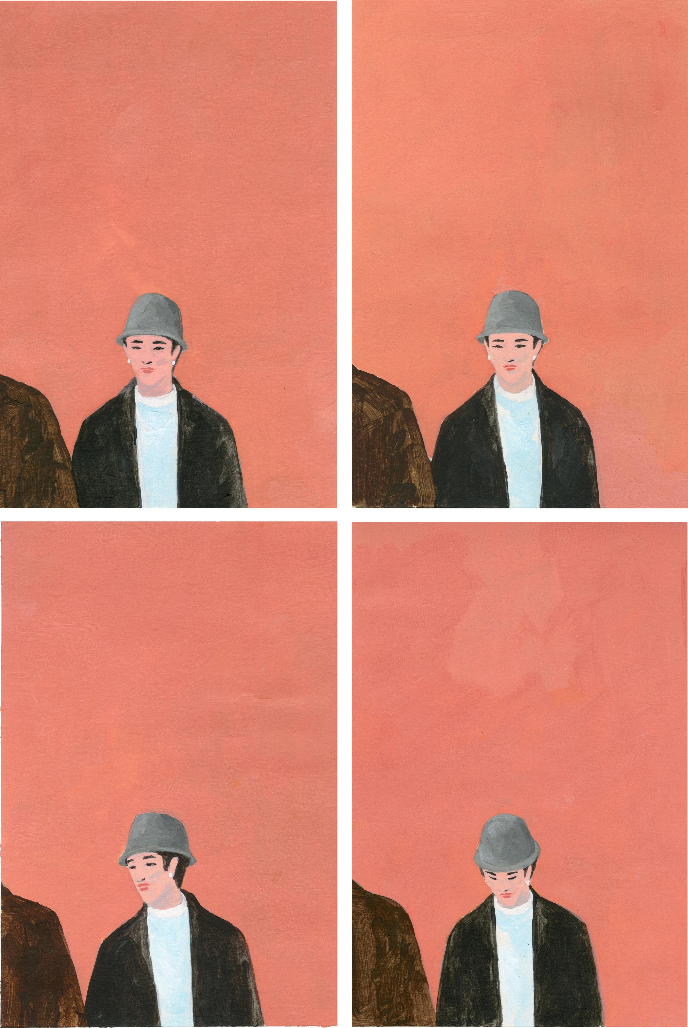
Shijie Hai‘Territory 5’35x50 cm Gouache Painting

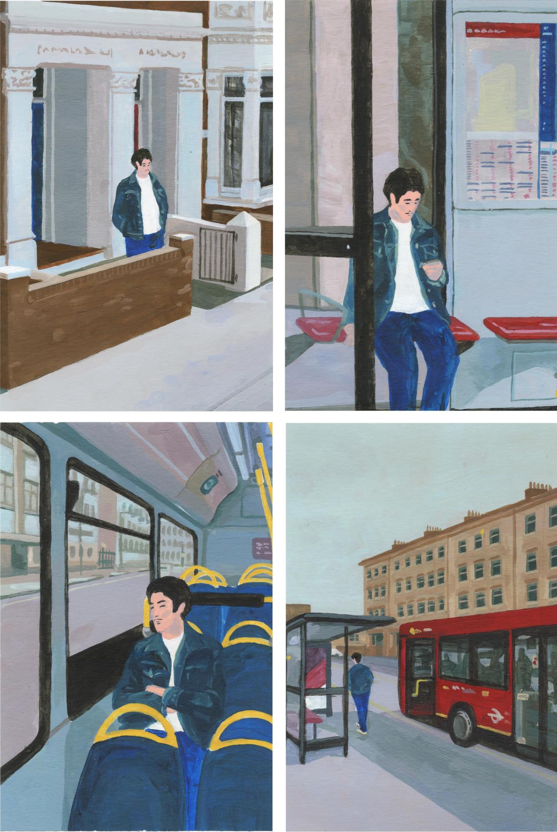
Shijie Hai‘Territory 6’35x50 cm Gouache Painting

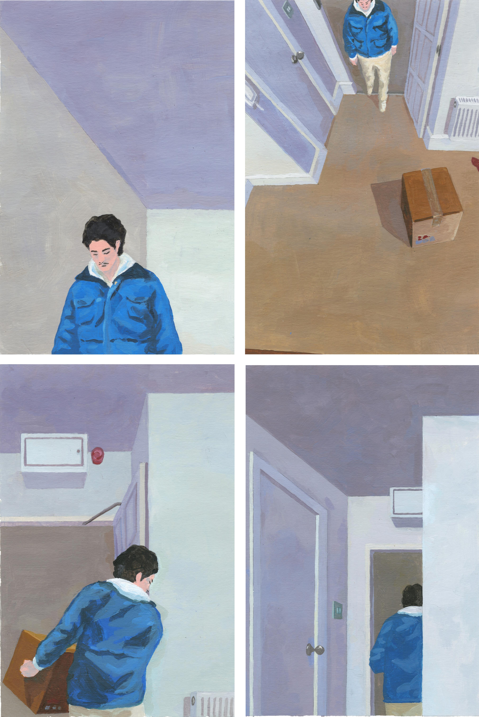
Shijie Hai‘Territory 7’35x50 cm Gouache Painting

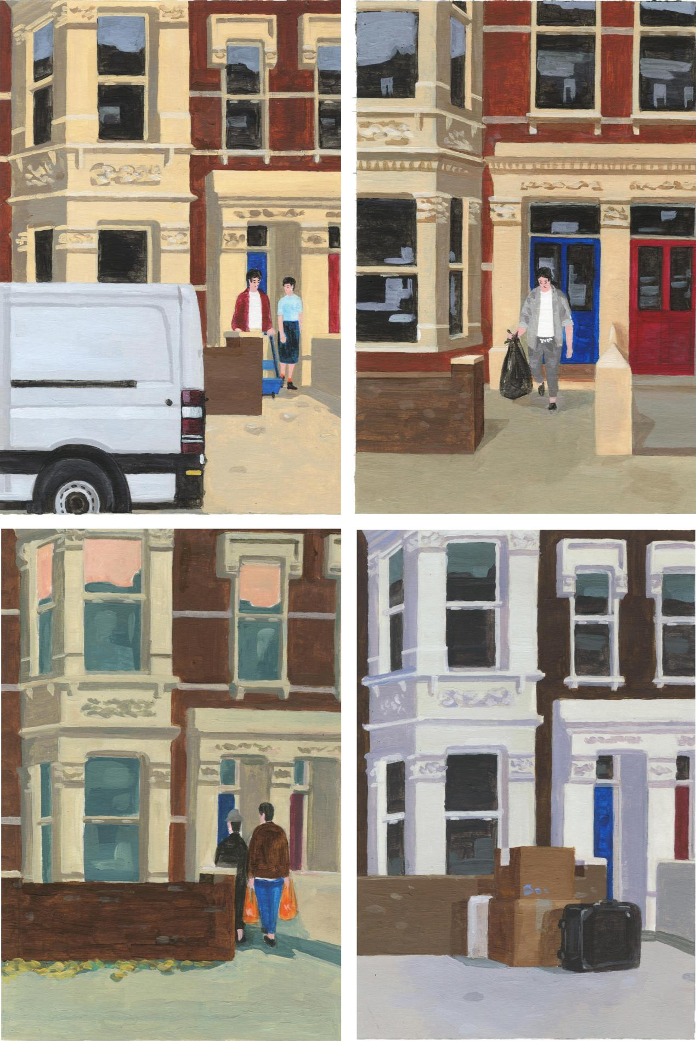
Shijie Hai‘Territory 8’35x50 cm Gouache Painting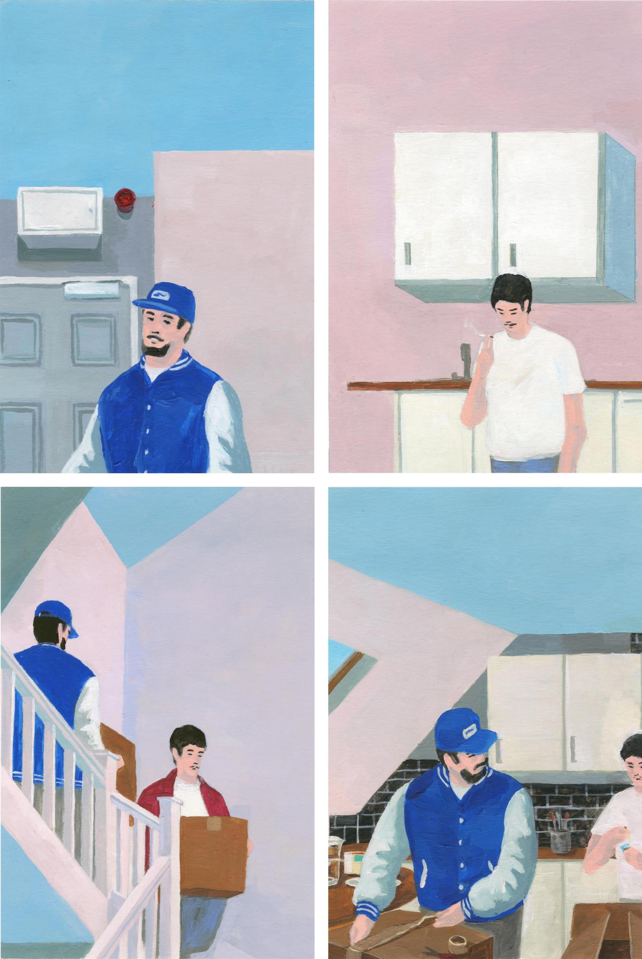
Shijie Hai‘Territory 12’35x50 cm Gouache Painting

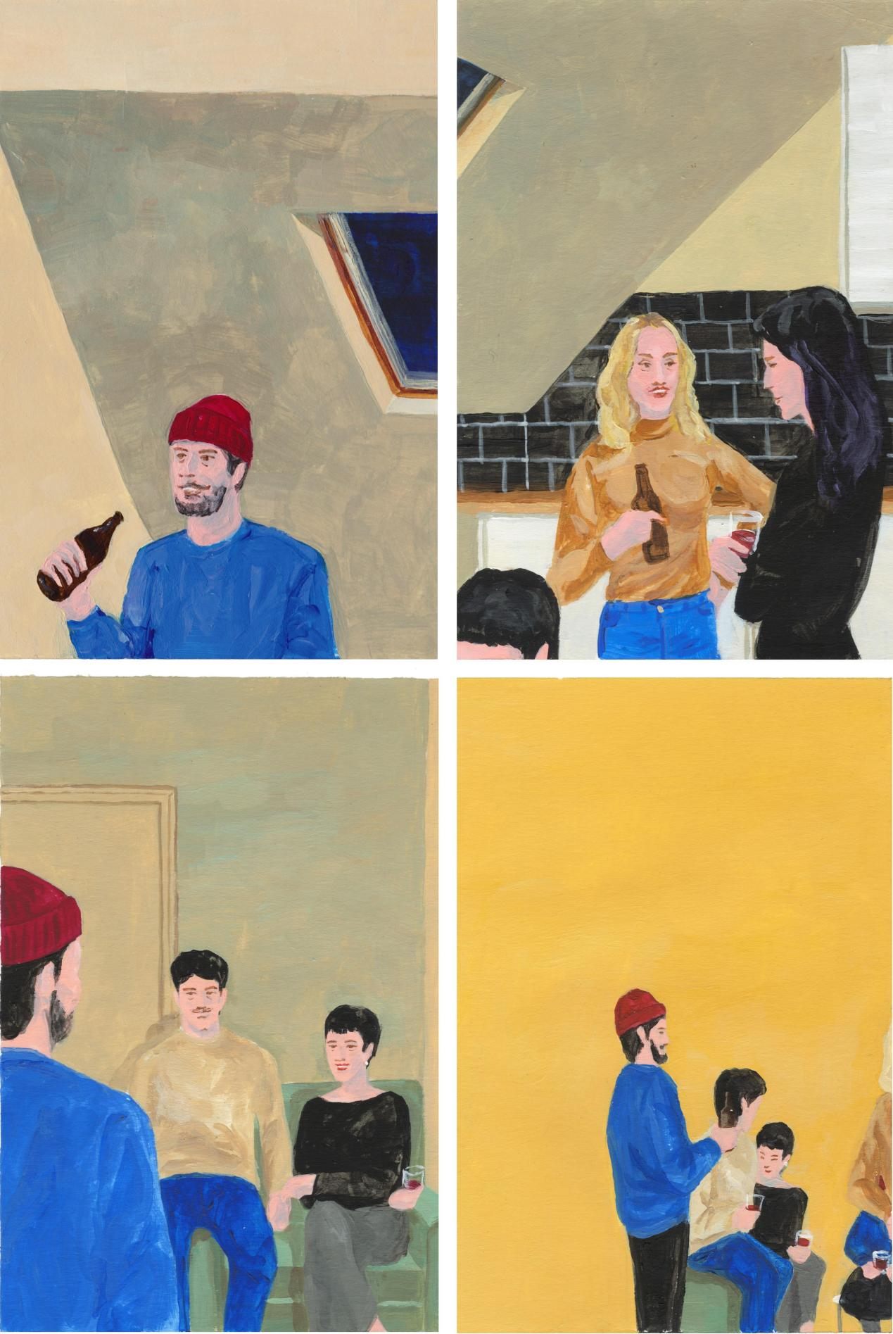
Shijie Hai‘Territory 13’35x50 cm Gouache Painting
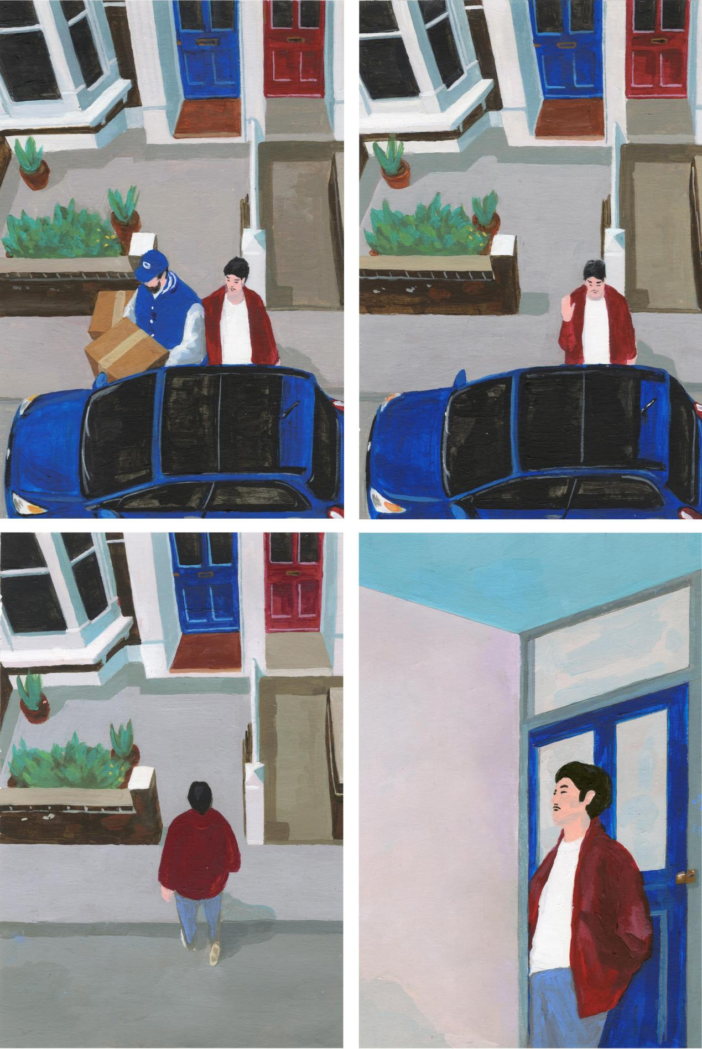
Shijie Hai‘Territory 14’35x50 cm Gouache Painting

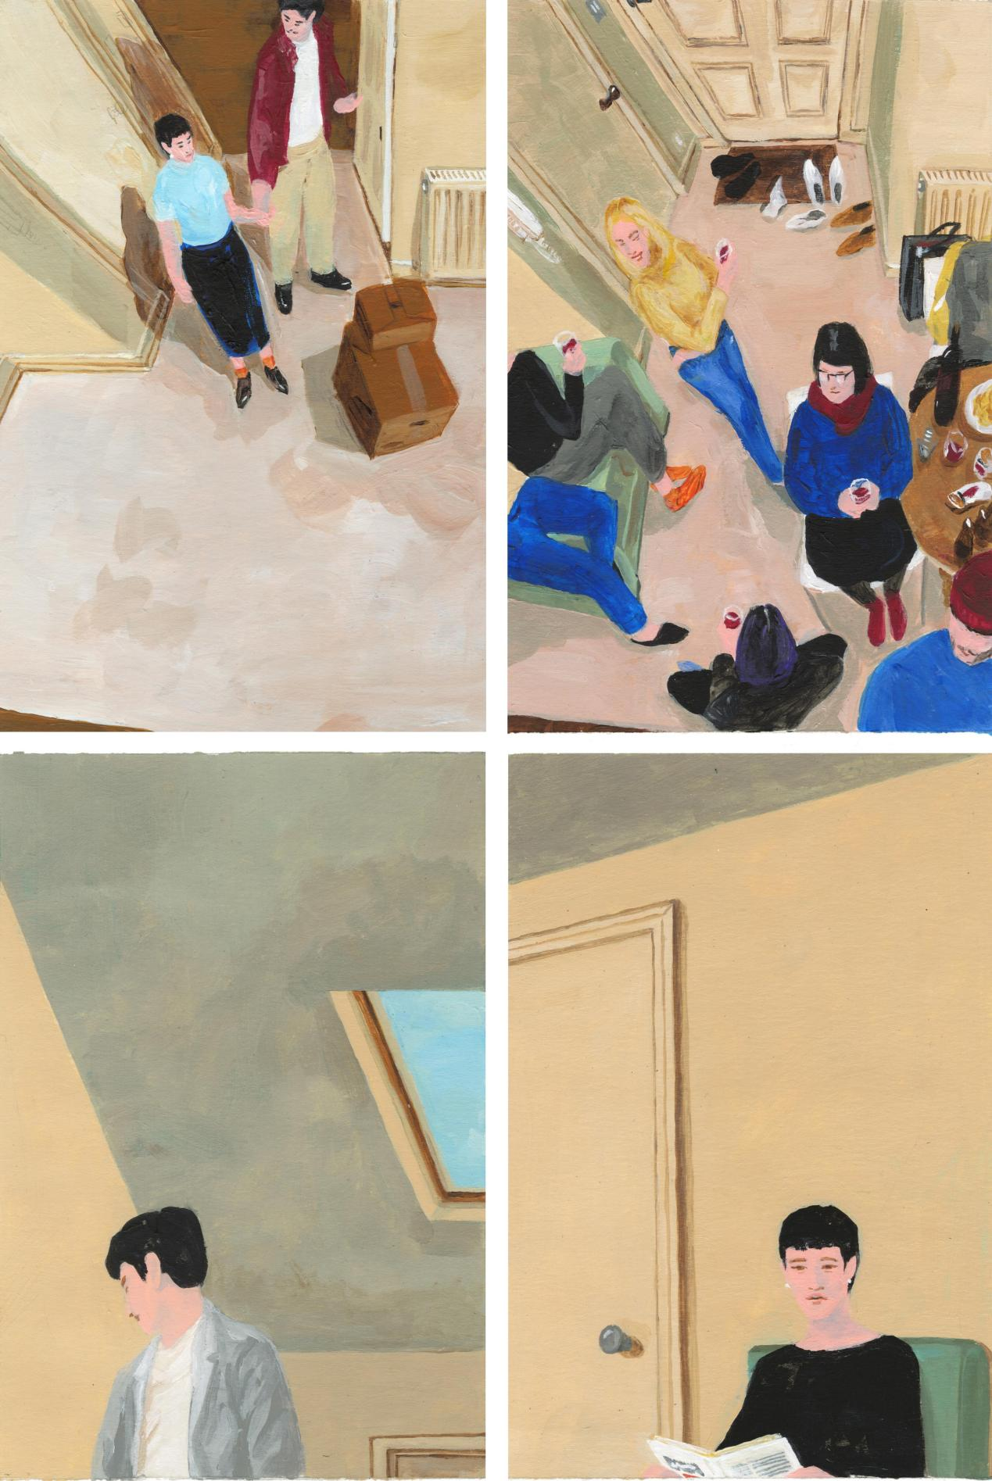
Shijie Hai‘Territory 15’35x50 cm Gouache Painting

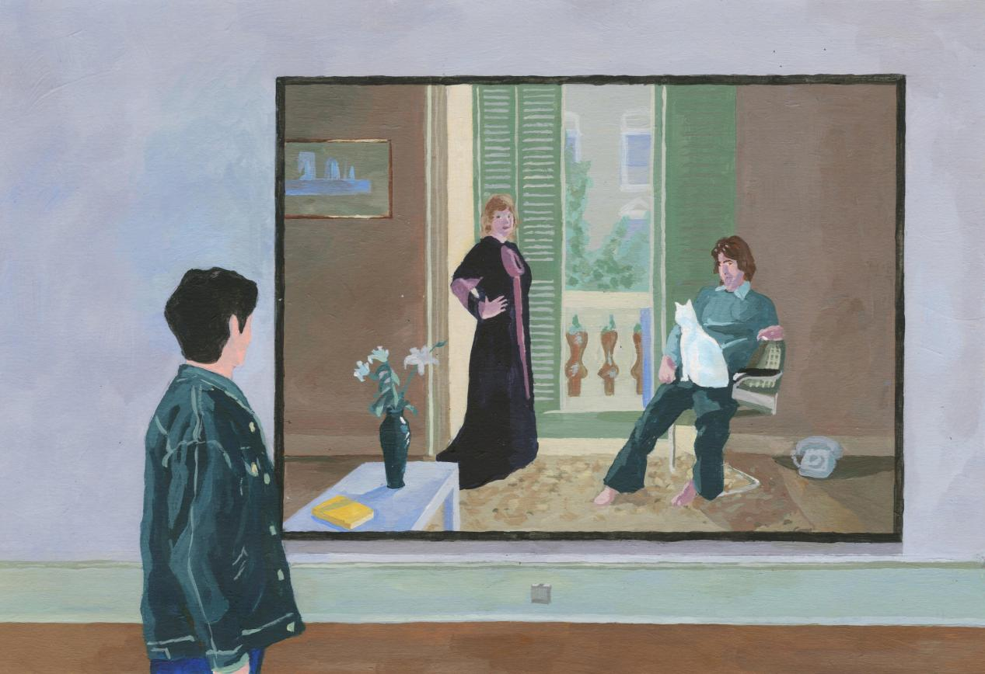
Shijie Hai‘Territory 16’35x50 cm Gouache Painting
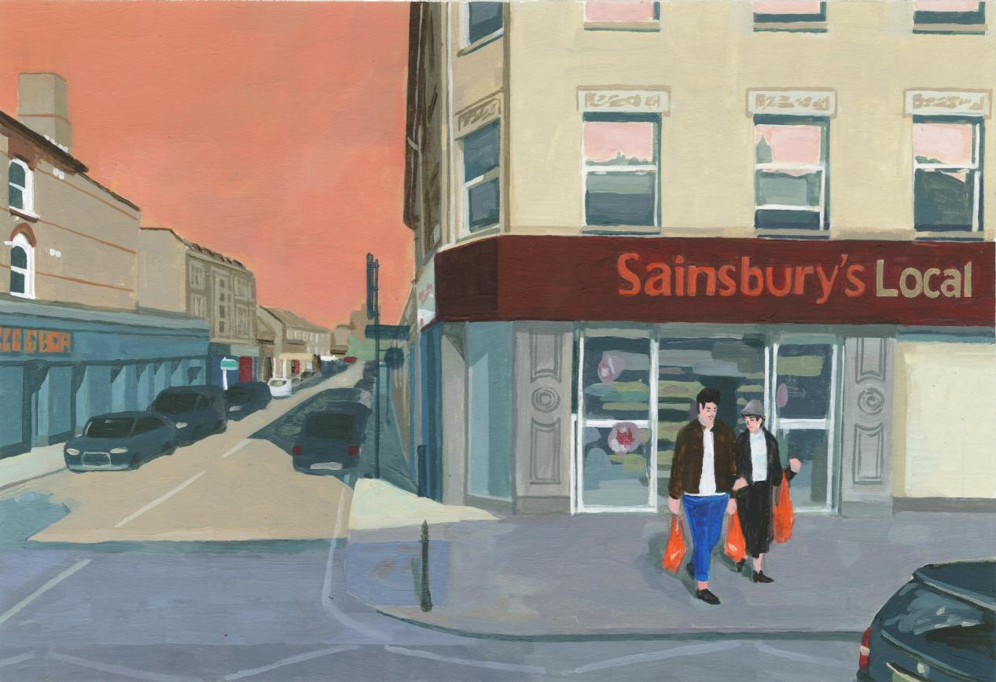

Shijie Hai‘Territory 17’35x50 cm Gouache Painting
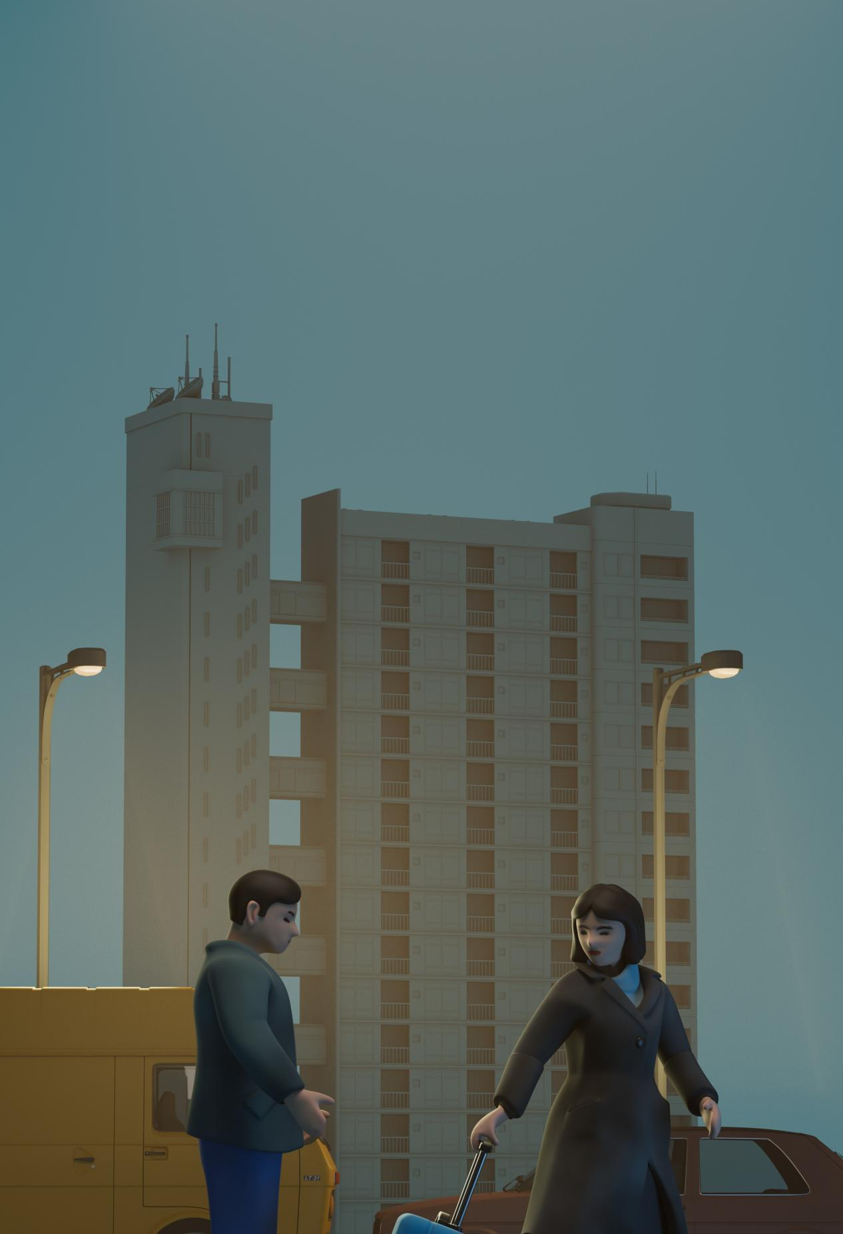
Shijie Hai‘Fortikaĵo 1’29.7x42cm Digital Print

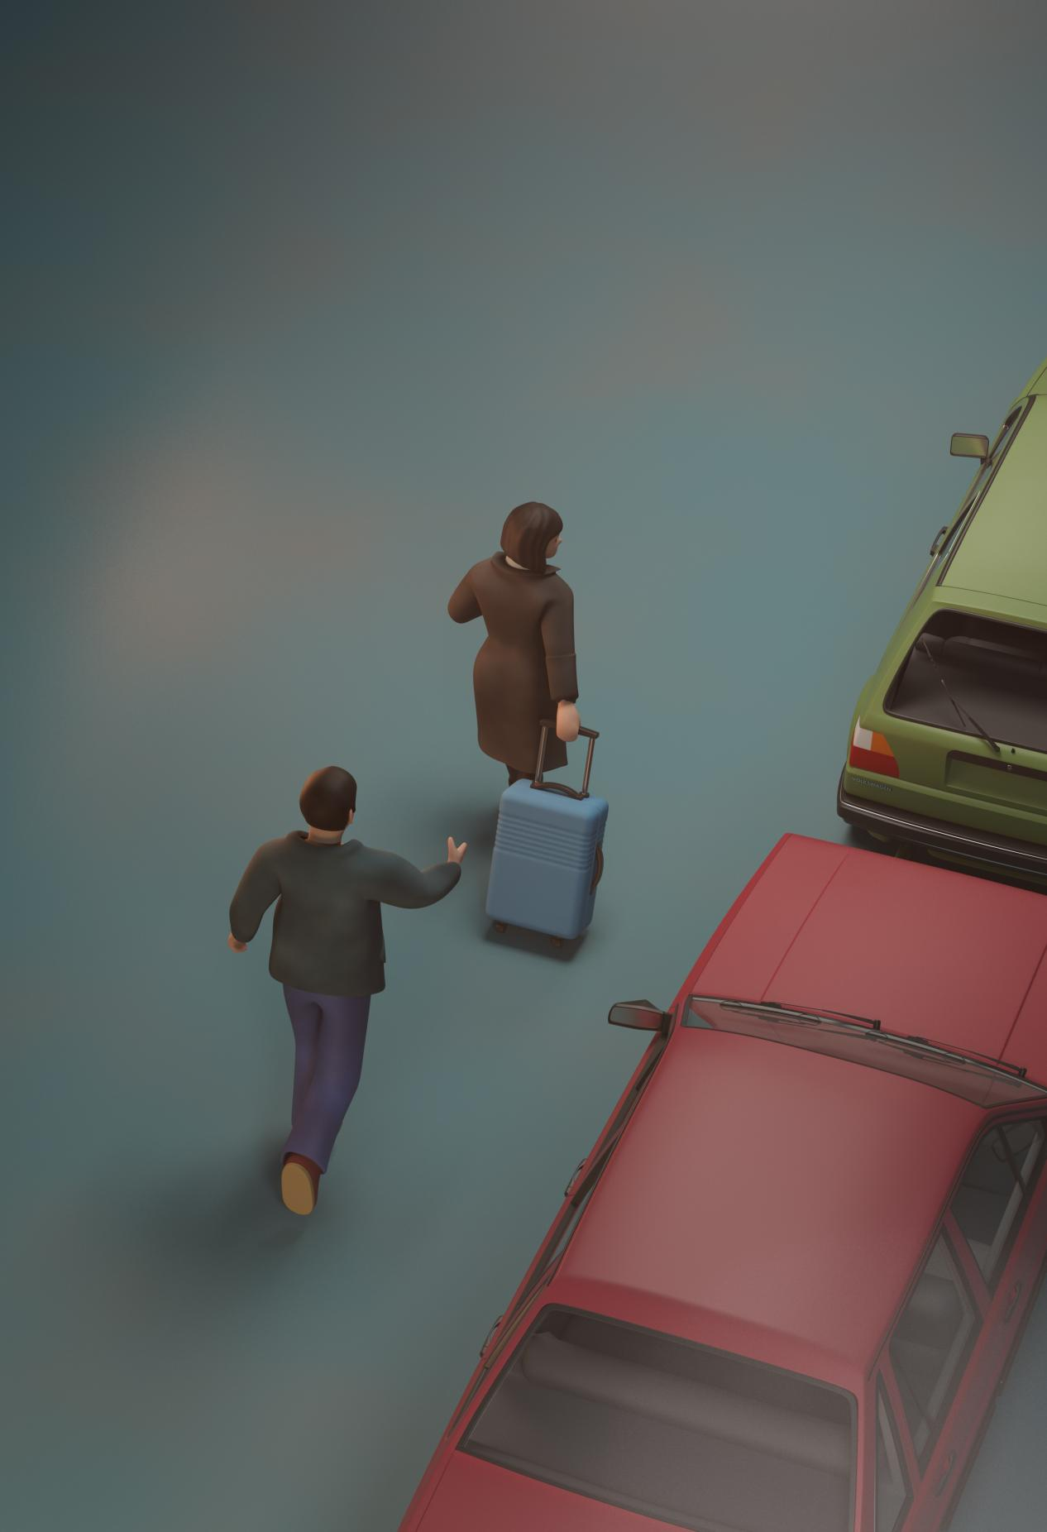
Shijie Hai‘Fortikaĵo 2 ’ 29.7x42cm Digital Prin

