Dystopia Project A - Paris Exhibition was successfully launched in France
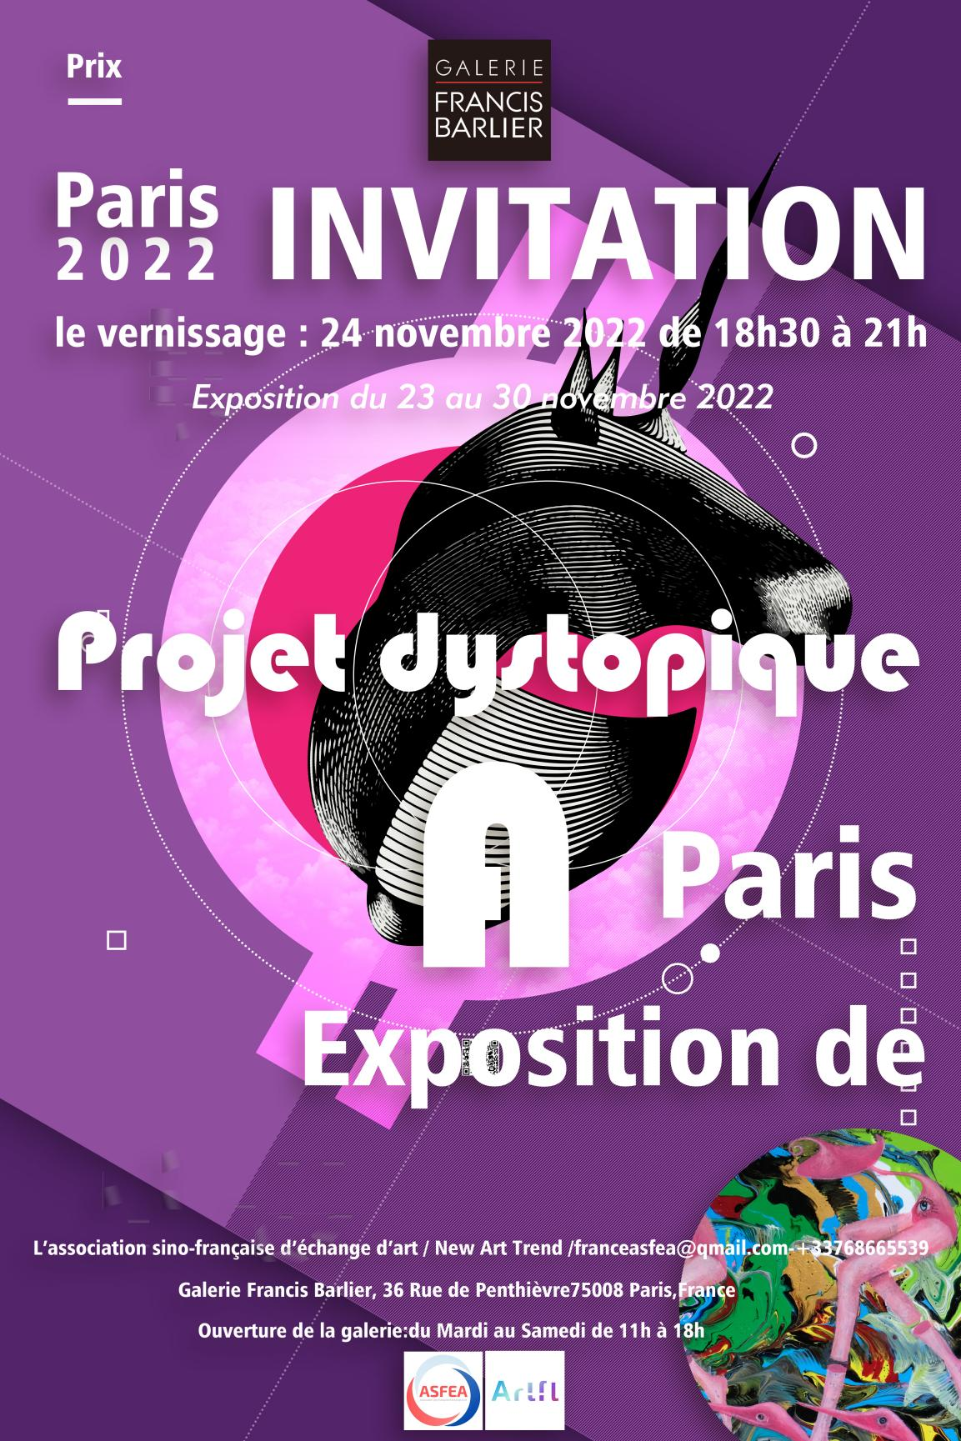

"Dystopia Project A - Paris Exhibition" will be successfully exhibited in Paris, France on November 23-30, 2022. The exhibition awards will be awarded on December 3 by the exhibition jury consisting of Dr. Patrick, director of the French Ministry of Education, Professor Bertrand GADENNE, curator Dr. André Fernandez; American art history critic Dr. Lara M. Evans, and art curator Niku Kashef. Selected from more than 350 artists from around the world, the exhibition awards + gallery exhibits the works of the artists.
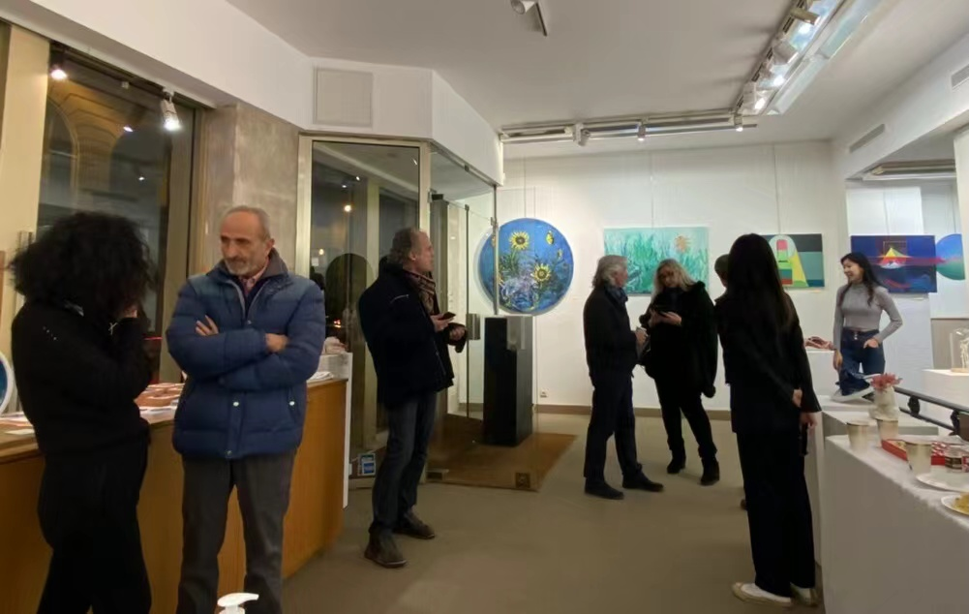

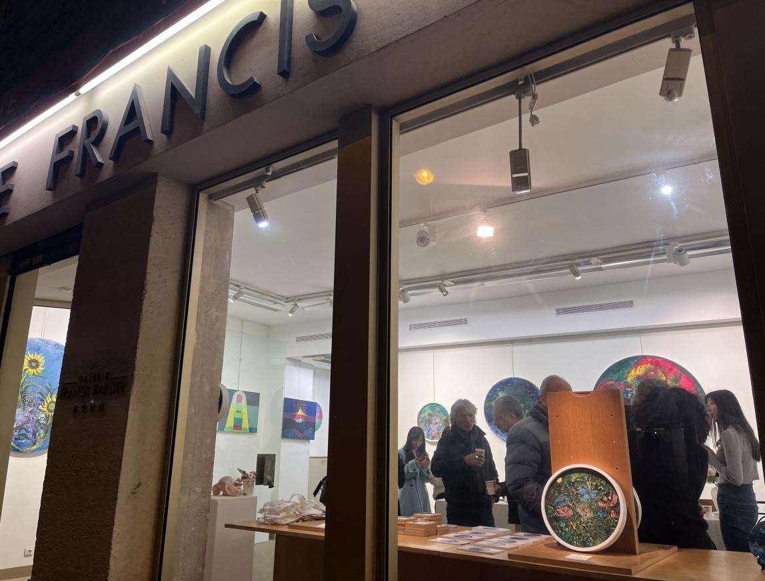
"Dystopia Plan A - Paris Exhibition" exhibited the award-winning works at Galerie Francis Barlier, a brand gallery on the famous Champs-Elysées in Paris. During the exhibition period, two exhibition receptions were held, and artists, art critics, art collectors and art lovers in Paris, France were invited to participate in the exhibition celebration reception.
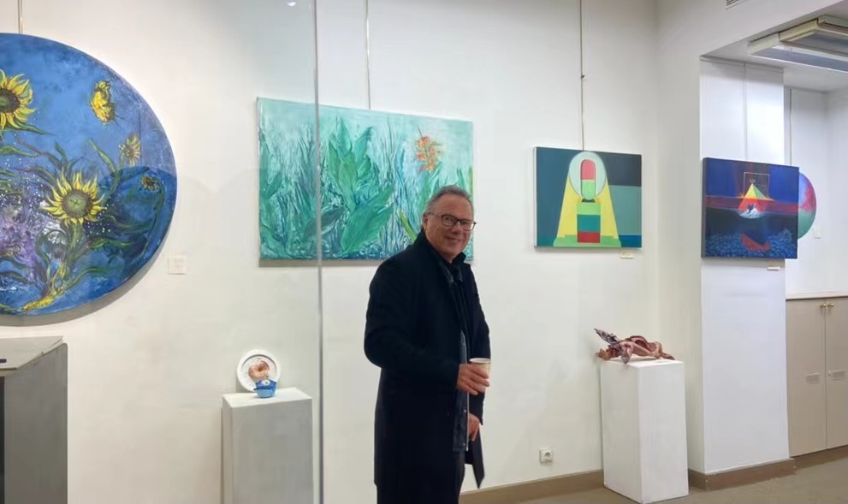
The exhibition is jointly organized by L’Association Sino-française d'Échange d'Art, Gallery NAT, Galerie Francis Barlier and New Art Trend. The exhibition is open to the public free of charge on the principle of fairness and justice, attracting a large number of fans to come to the exhibition. The exhibition discusses the current social environment, such as the Russian-Ukrainian war, epidemic control, terrorist attacks, environmental protection, energy crisis, poor population, unemployment rate and other social problems encountered in reality to discuss art criticism.

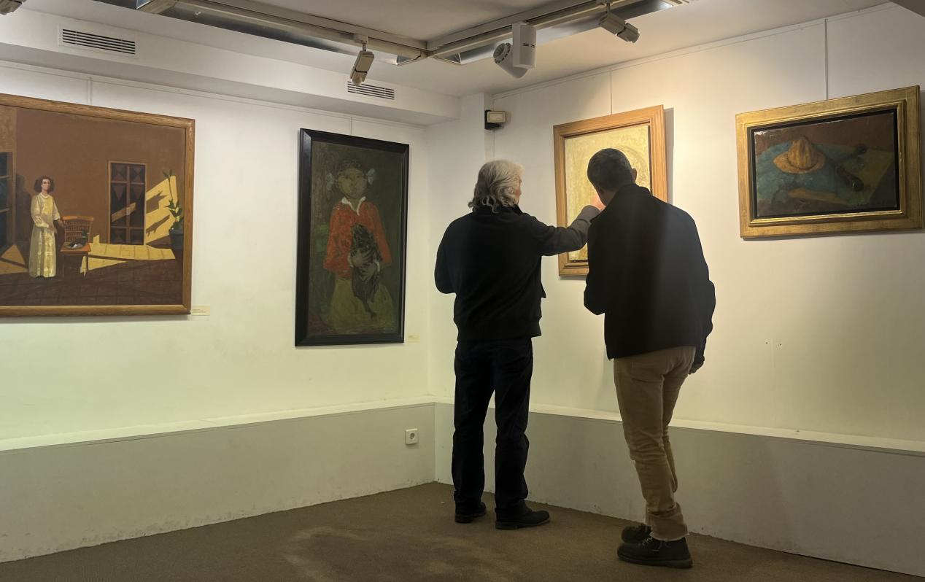

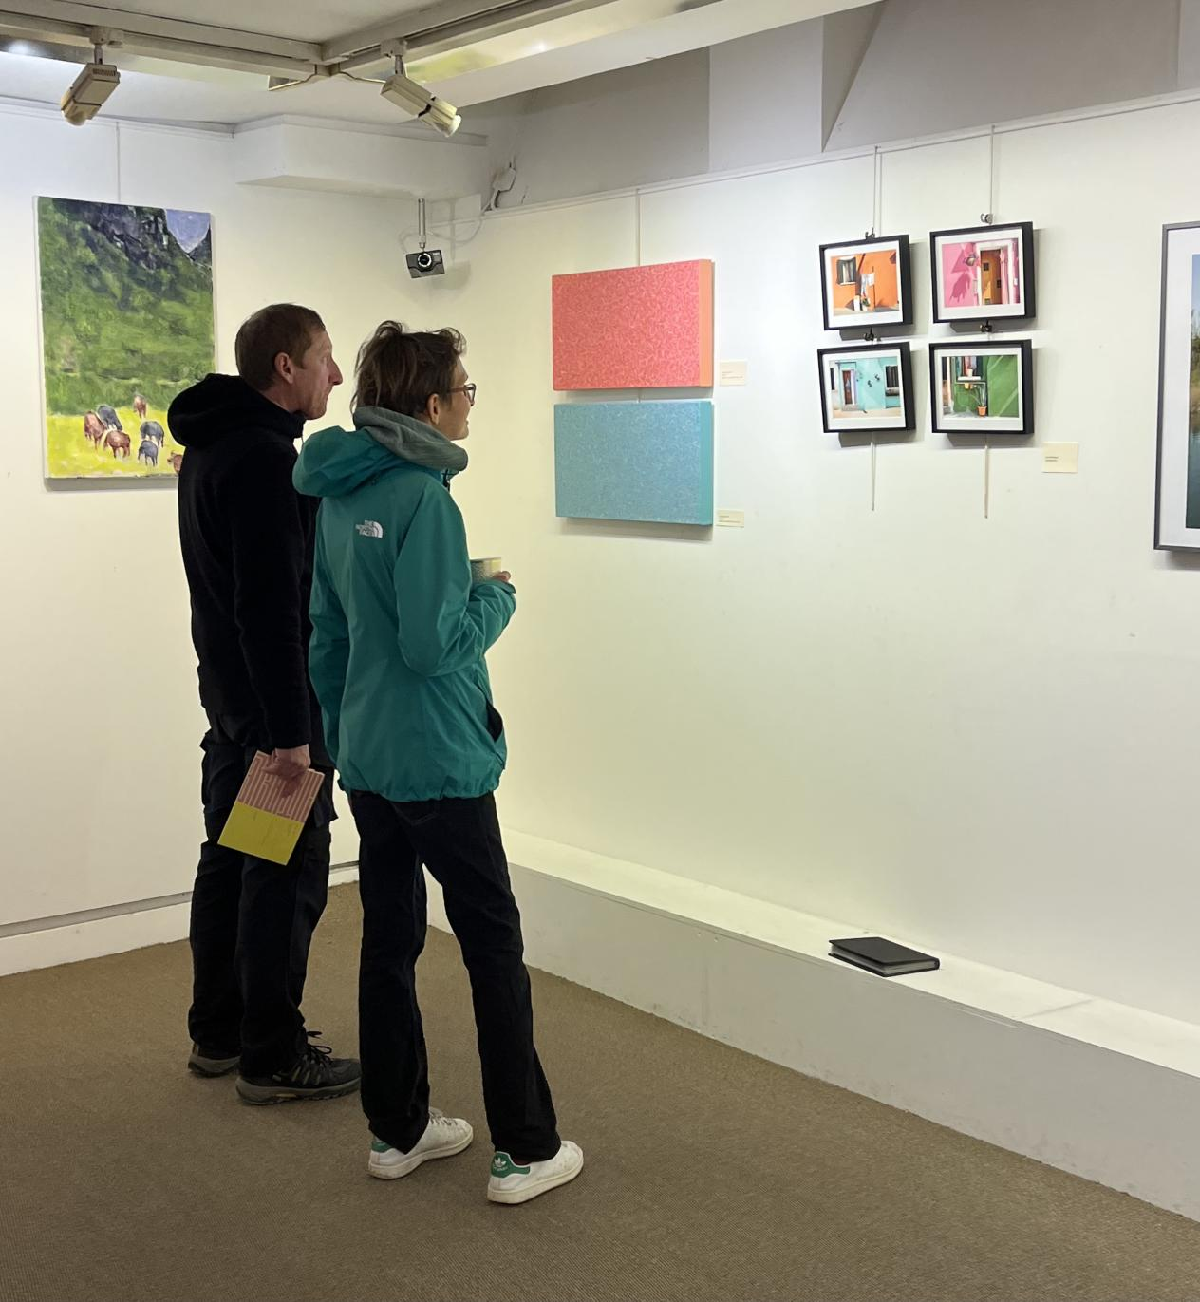
After the French and American juries and the exhibition started, various artists and curators who participated in the exhibition reception comprehensively selected the final awards of the exhibition and the list of winners of the artists was announced.

Here is a grand introduction to the list of award-winning artists for the exhibition "Dystopia Plan A - Paris Exhibition":
Gold Award: Emilio Trad /Junzhong ZHAO
Silver Award: André Cottavoz / Xi WANG / Michaël Leibovici /
Bronze Award: Igor Bitman / Christophe Giral / Anan / Arnaud d’Hauterives / Eugène Baboulène / Jessica Westhafer / Dayong DUAN / Fang NIU / Hui ZHAO / Guizi GAO / Yong ZENG / Xiaoyi LIU /

Exhibition dynamics

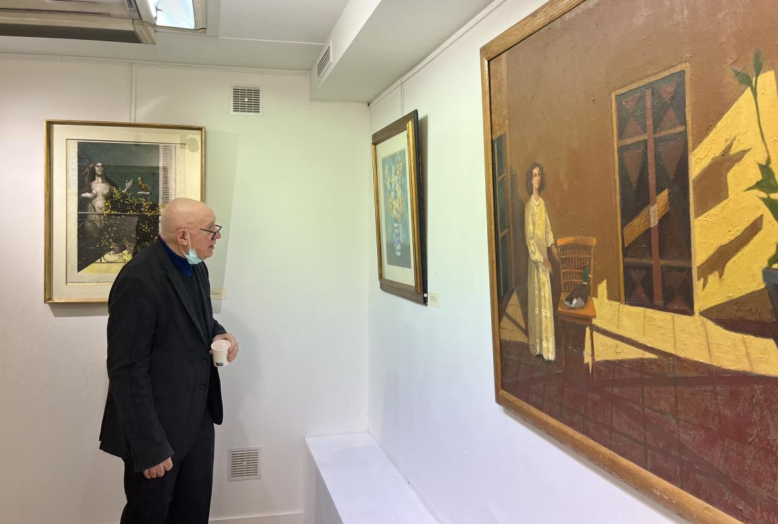

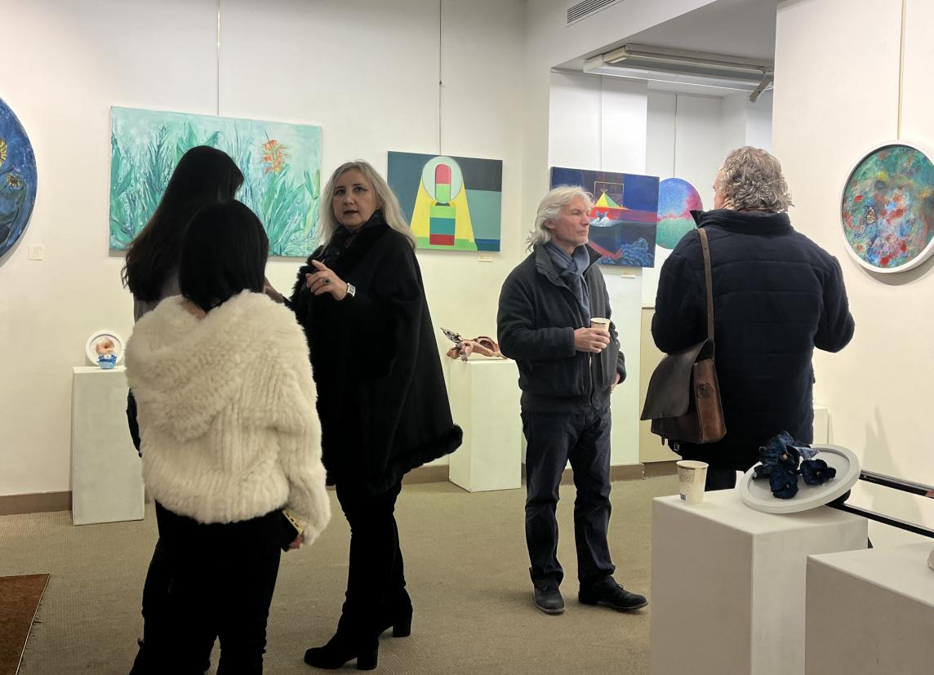

I am honored to announce my congratulations to the award-winning artists of this exhibition. After 3 months of public solicitation and selection from artists around the world, the award-winning artists have come to the fore. I hope your career as an artist will be more stable and long-lasting. Inspire better works of art to give back to society.

