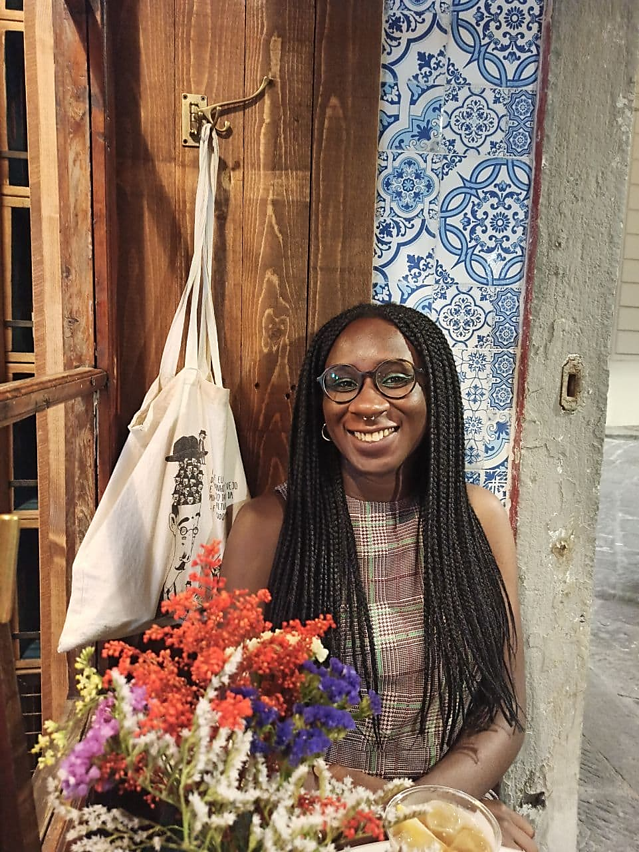**NATASHA DEBORA AIDOO**

Viale Francesco Petrarca 110

50124 Florence, Italy  
  
+393894798454

natasha.aidoo@sns.it

* EDUCATION

November 2020 – ongoing  **PhD scholarship in Political Science and Sociology**  
Scuola Normale Superiore - Institute of Political Science and Sociology, Florence, Italy  
Doctoral research project about “Feminist urban alternatives for the present? A comparative analysis of feminist identities and urban-spatial practices in Barcelona and Berlin”.

November 2019 – February 2020 **Postgraduate course in Diversity Management and Gender Equality (GEDM)** at G. Brodolini Foundation, Rome

Multidisciplinary competencies in the field of diversity management, equal opportunities, social inclusion policies and practices. Analysis, planning, evaluation and communication of diversity management and gender mainstreaming policies. Introduction to the key aspects of European project planning.

11 October 2019 **Winner of a scholarship** offered by the Brodolini Foundation to attend the postgraduate course in GEDM.

27 September 2019 **Winner of the 3rd edition of the prize**, sponsored by the Region of Tuscany, for master’s thesis and scientific publications about “Analysis and contrast of gender stereotypes”.

28 August–1st September 2019 **SIS summer school** in "*Fragile Democracies - Populism, Racism, Anti-feminism*"

29 July 2019 **Winner of the scholarship** for the 8th edition of SIS (Italian Society of Women Historians) Summer School in Fiesole, Italy.

October 2016 – December 2018 **MA in International Development and Cooperation**  
Faculty of Political and International Sciences   
University of Siena, Italy   
Master's Thesis titled "*Self-determination and female emancipation. The role of African women in the fights for national liberation*".       
Graduation with first-class honours (110 con lode).

September 2012–November 2015 **BA in International Studies**, Faculty of Political Science and Sociology   
University of Trento, Italy   
Bachelor's Thesis titled "*The United Nations organisation and the challenge of international cooperation for development*".   
Degree mark of 98 / 110.

* ACADEMIA

28th February 2024, Florence  
Lecture titled “***Post-colonial feminism and women’s struggles in once colonized territories***”. Within the course of Feminist theories and practices at Scuola Normale Superiore (SNS).

30 November – 1 December 2023, Berlin   
“*Practicing Intersectionality in Activism, Politics, and Research”* - International Conference & 5th Anniversary of the MA Program Gender, Intersectionality and Politics at Freie Universität Berlin.

9-10 November 2023, Florence  
*Territories and Identities: A Critical Perspective on Belonging* – Conference at Scuola Normale Superiore (SNS).   
Chair and discussant of the panel “Blooming Identities: Gender, Territory and the Struggle for Recognition”.

4-6 August 2023, Berlin  
(re)searching Urbanity Symposium at Floating University. Within the panel “Queer-Feminist cities” I presented “*Feminist  
urbanism. Feminist identities, practices, and discourses*”.

14-16th October 2022, Lund  
Presentation titled “*Decolonial Feminisms and knowledge*” at the “Feminisms and Degrowth Workshop”. Organized by Feminisms and Degrowth Alliance (FaDA) and the University of Lund.

7 - 8 July 2022, Barcelona   
BRIDGES International Conference “*Dismantling Walls, Building Bridges: Feminist Ant-racist Alliance for a Radical Education*”.

26 March 2022, Wien   
2nd Claiming Spaces* Conference – “*Whose history? Feminist perspectives in architecture and spatial planning*”.

26 July – 6 August 2021, Online  
IAAS SUMMER INSTITUTE 2021 by IFE (Institute of Advanced Studies). Virtual summer school on “*Research, Teaching* *and Service in an Uncertain Age*”.

12th May 2021, Florence  
Lecture titled “*Feminist approaches to the politics of representation*”. Within the course of Sociology of Culture at Scuola Normale Superiore (SNS).

* PUBLISHED WORK IN ITALIAN AND ENGLISH

March 2024 Article on the Berlin 180* flinta skate magazine - “*Looking at the city of Berlin through feminist lenses*”.

2021 Article on the Italian feminist magazine [DWF](https://www.dwf.it/autori/natasha-deborah-aidoo/) (Donna Woman Femme) – *Ghana.   
Le sfaccettature del movimento femminista.*  
Article on the Italian magazine of the publishing house [Gli Asini](https://gliasinirivista.org/autore/natasha-debora-aidoo/) – *Raccontare il femminismo in Ghana*.

2019 – 2022 Creative writer for [*WOMEN WRITING BERLIN LAB*](http://wearewwbl.com/online-magazine?author=5eb549d3d9659b055559d901#show-archive)*.*

Since 2020Writer for the online feminist magazine inGenere – [Perché non parliamo di femminismo africano?](https://www.ingenere.it/articoli/perche-non-parliamo-di-femminismo-africano)  
[*Mai più senza di noi, femministe in Cile.*](https://www.ingenere.it/articoli/mai-piu-senza-di-noi-femministe-cile)

2020 – 2021 Writer for the websiteIntersezionale –[*Afrofuturismo: spazio di resistenza nera.*](https://www.intersezionale.com/2020/11/12/afrofuturismo-spazio-di-resistenza-nera/)[*Identità fluide: intrecci diasporici tra Italia e Ghana.*](https://www.intersezionale.com/2021/02/17/identita-fluide-intrecci-diasporici-tra-italia-e-ghana/)

May 2020 [*QUARANZINE*](https://www.wearewwbl.com/wwbl-online-shop/quaranzine), digital magazine – Poems published within the global diverse perspective of women* during a pandemic.

* PROFESSIONAL - TRAINING EXPERIENCE

13th February 2024 **Presentation** of the book “*Il corpo nero*” by Anna Maria Gehnyei – The Recovery Plan, Florence.

2nd February 2024 **Talk** for Black History Month Florence - *Autodeterminazione ed emancipazione di genere. Il ruolo delle donne nelle lotte di liberazione nazionale in Africa.*  
The talk focused on my Master’s thesis work. Where I analysed the role of African women during decolonization and the re-conquest of independence in the 20th century. I also tried to understand if a connection between the national liberation and feminist movement from a local and international level existed. Talking about feminist African history means fostering a more complete vision of history. It means acknowledging the efforts of multiple women, left unknown. It means underscoring how feminist struggles are collective.

April – July 2022 **Traineeship** at UPC (Universitat Politècnica de Catalunya · Barcelona Tech)  
I worked under the tutorship of Professor Muxí at the Department of Urbanism and Territorial Order in ETSAB (Escola Tecnica Superiore de Arquitectura de Barcelona). I had direct access to literature regarding the interconnectedness between the Catalonian feminist movement and the urban movement. Regarding the development of a feminist approach to urban studies within and out of academia. Regarding the historical and political context where urban changes have been taking place. I referred to the expertise of Professor Zaida M. Muxí, one of the founders of Col·lectiu Punt 6. Architect and professor of urbanism at ETSAB-UPC. During the academic year of 2010-2011 she held for the first time, within the doctoral department of Urbanism, the course of Urbanism and Gender (Muxí, 2019: 5). I interviewed Professor Muxí as an expert.

22 January 2020 **Lecture** within the course of African History – University of Siena, Italy.   
The lecture dealt with a central topic of my Master's Thesis: the role of African women in the process of decolonization and national independence. I focused on the historiographic context of the history of African women; on the importance of an intersectional, afrocentric and a gender-based approach; on the heroines and their efforts; on the impact on the social-cultural community of historical collective amnesia.

July – September 2019 **Short term** **collaboration**, Tubo Fashion Stock, Valeggio sul Mincio (Italy).  
Administrative, social media, commercial and digital assistance in the international distribution of high-end fashion items. I dealt with shipments, organised orders, maintained relations with clients, worked on the creation of content for digital marketing purposes and supervised the online visibility on e-commerce platforms.

September – November 2018 **University internship**, Consorzio Archè and Cooperativa Sociale Pangea, Siena (Italy),   
Social and political study regarding local social cooperatives in the city of Siena through interviews and literature review. Sociological, legal, and political investigation of the Italian reception and integration system for migrants, especially women. I also realised a photographic project about the lives of refugees and asylum seekers with focus on women and children in a Tuscan Extraordinary Reception Centre in the province of Siena.

November 2015 – June 2016 **European Voluntary Service**, Association Sirinia, Ineu (Romania).   
Organisation of non-formal education after school activities regarding cultural and environmental awareness, planning and coordination of local sports events for children, preparation of Italian and English language courses for children and adolescents with mental, social, economic, or learning difficulties. Social media management and creative writing through a specific Facebook and blog page for the voluntary project. Photo, video making and editing for the communication purposes of Association Sirinia.

Volunteering activity

August – September 2015 **NGO Kompas**, Pančevo (Serbia).

Assistance in the organisation of activities and events. Logistic support, participation in community awareness about

events by the NGO and realisation of photographic work for the Facebook page.

* FURTHER EXPERIENCE AND SKILLS

**Adaptability, independence and teamwork** developed through travel organisation, budget management and activities organisation during the EVS project and the participation in Erasmus+ youth exchanges. Krakow, May 2015 – “Snapshot Of European Citizenship”; Trento (Italy), July 2015 – “Get Up” and Požega (Croatia), August 2015 – “Show your skills”.

**Social-political engagement** through the participation in the *School of Democracy*, organised by S&D EU Parliament political party in April 2017 and March 2019.

**March – May 2018** I took part in the photography course, organised by Siena Art Institute and the University of Siena Taught by the artist and photographer Jacqueline Tune. The workshops allowed me to better understand the key elements of photography, the specificities of the analogic process and enabled me to explore new artistic techniques.

* PHOTOGRAPHY

2021 – ongoing [I have multiple homes](https://phmuseum.com/projects/i-have-multiple-homes)

This project is about my diasporic identities and how the concept of home can be nuanced and multiple.

2015 – 2018 [Photography blog](https://natashaaidoo.wordpress.com)

Macro, landscape, nature, abstract, social commentary, and street photography.

2015 – 2016 [Blog about my EVS experience](https://evsineu.wordpress.com)

Photographic journal of my 8 months in Romania during my European Voluntary Service.

* COMPUTER SKILLS

Excellent knowledge of Microsoft Office perfected through the academic course of basic IT.

Good knowledge in Excel. Good knowledge in Joomla, Mailchimp and WordPress.

* LANGUAGE SKILLS

Italian – Native tongue

English – Native tongue

German – Basic level (A2) through university required courses.

Spanish – Intermediate level (B1) through university required courses.

Romanian – Basic level (A2) thanks to the Erasmus+ language course I attended during the EVS and the daily activities in the community.

* ORGANIZATIONS

Member of AWID – Association for Women's Rights in Development

Member of COSMOS – The Centre on Social Movement Studies

Member of the AESOP Young Academics Network – Association of European Schools of Planning