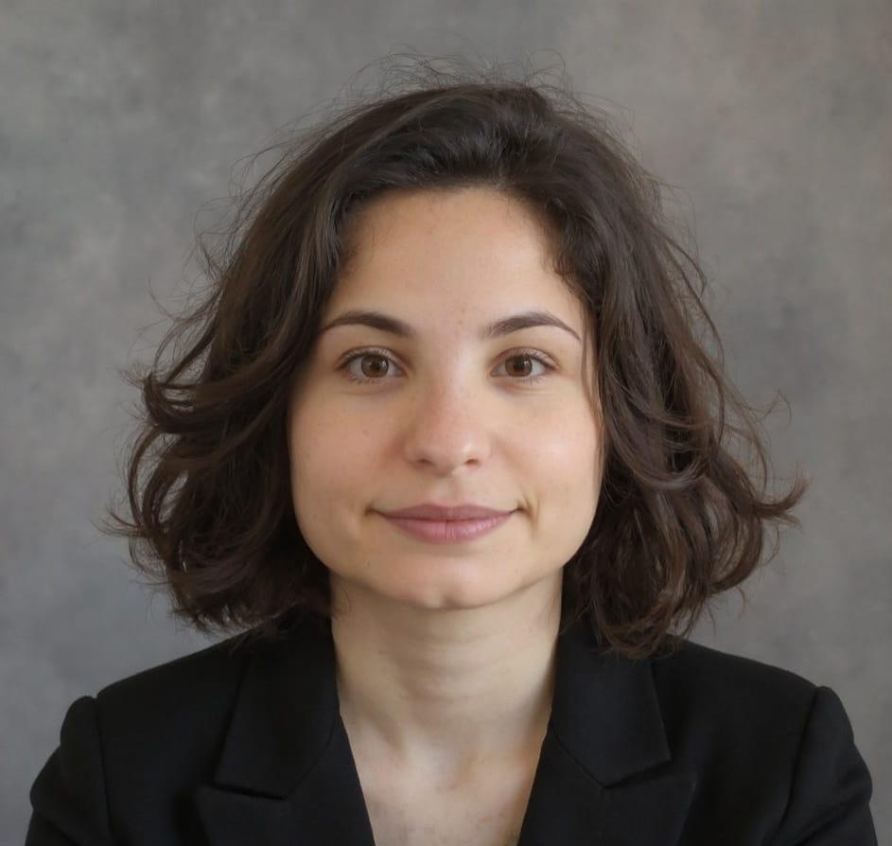=

ADA

**DASHI**

**EXHIBITION ASSISTANT**

PROFESSIONAL EXPERIENCE

**Exhibition Assistant**  
Venice Design Week *|* Venice, Italy

* Welcomed visitors and offered information on exhibitions and artists' work.
* Monitored exhibition spaces to ensure the safety and respect of artworks.
* Supported event logistics and helped coordinate daily activities.
* Served as a point of reference for both staff and guests, ensuring smooth communication.

October 2024

**Cultural Mediator**  
Venice Biennale *|* Venice, Italy

* Provided detailed explanations of artworks and their cultural significance in Italian, English, and Spanish.
* Fostered deeper connections between visitors and Mongolian art through guided conversations and contextual insights.
* Translated and adapted content to engage a diverse international audience, enhancing accessibility and cross-cultural understanding.
* Supported the promotion and sale of pavilion merchandise during the exhibition.

May - July 2024

PROFESSIONAL SUMMARY

I am an exhibition assistant with proven experience at top-tier cultural institutions like Venice Biennale and Venice Design Week. In these roles, I facilitated meaningful engagement with contemporary art, connecting diverse audiences to artworks in dynamic ways. I leveraged expertise in cultural communication to create inclusive, impactful experiences that drive audience engagement and deepen their connection to art. My ability to bridge the gap between art and audiences has consistently enhanced visitor experiences, making art more accessible and thought-provoking.

329-751-7529

ada.dashi@proton.me

Via delle Muneghe 7, int. 3

30173 Favaro Veneto (VE), Italia

CONTACT

PERSONAL INFORMATION

Date of Birth: 04/03/1998

Place of Birth: Durrës, Albania

Citizenship: Albanian

EDUCATION

**Master's Degree in European, American and Postcolonial Languages and Literatures**

Ca' Foscari University of Venice

2021-2025

**Bachelor's Degree in Languages, Civilisations and the Science of Language**

Ca' Foscari University of Venice

2017-2021

LANGUAGES

Albanian: Native

Italian: C1

English: C1

Spanish: B1

PROFESSIONAL EXPERIENCE (Continued)

**Human Resources Assistant**  
Ca' Foscari University of Venice*|* Venice, Italy

* Collected and verified employee course certificates for training documentation.
* Categorized records by training type and subject matter.
* Uploaded certificates into the U-Gove system with accuracy and attention to detail.
* Ensured data consistency across all records and internal databases.
* Completed assigned tasks ahead of deadlines, improving the overall workflow efficiency.

June - September 2022

October 2023 - January 2024

**Press Office Assistant**  
Ca' Foscari Short Film Festival *|* Venice, Italy

* Supervised and coordinated a team of 15 student volunteers.
* Assigned translation and press release writing tasks, ensuring timely and high-quality delivery.
* Wrote original press releases in English to support international outreach.
* Researched and contacted global media outlets to enhance the festival's visibility.
* Maintained internal workflow and effective communication across the team.

February - March 2023

EXPERTISE

Communication

Visitor engagement

Public speaking

Organization

Intercultural mediation

Teamwork

Multilingual interpretation

Cultural accessibility

Problem solving

Google Suite

Microsoft Office

INTERESTS

Art

Writing

Reading

Psychology

October - December 2019

**Library Assistant**   
BEC Library of Economics*|* Venice, Italy

* Organized and shelved books in line with the library's cataloging system.
* Assisted students in locating materials and accessing digital and physical resources.
* Provided technical support for copy machines and library equipment.
* Offered general guidance on library services, policies, and available materials to ensure a user-friendly environment.

**Customer Service Representative**  
Sky Italia*|* Durres, Albania

* Handled customer inquiries and concerns via phone in a fast-paced environment.
* Resolved technical and account-related issues promptly and efficiently.
* Provided clear information on subscription plans, billing, and services.
* Maintained up-to-date knowledge of company offerings and policies.
* Ensured accurate and confidential management of customer data.

June - August 2016